PARISH OF ST THOMAS MORE
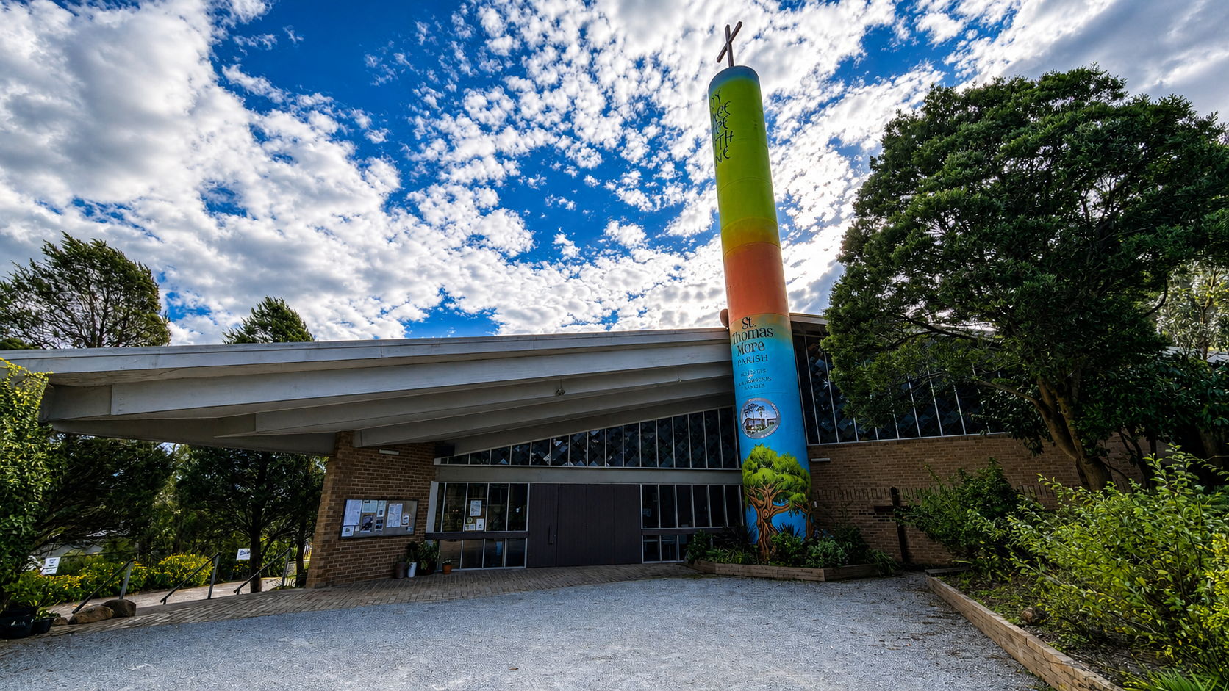
Belgrave, Victoria

A Parish History

Catholic Community of the Dandenong Ranges
Compiled for the Golden Jubilee — 1959 to 2009

PART ONE

Prior to 1959
The mountain years before Belgrave became a parish

A Brief History of the Parish of St John the Baptist, Ferntree Gully
(as told by one of our pioneers, Ellen Stevens, nee Winters)
The beginning of the Catholic Church in the Dandenong's began as a response to the needs of scattered Irish-Catholic families. From earliest times the mountain area was part of St. James' Mission, Elsternwick, originally known as Brighton Mission. In 1883 it was separated from the Brighton Mission as a constituent part of the new parish of St. Mary's, Dandenong.
When the first church was built in 1890, Ferntree Gully was a scattered settlement, having only four years earlier been proclaimed a township. The site, situated on Main Road (Burwood Highway) next to where Broome's Garage now stands, was a gift from a parishioner, John Buckley.
Ferntree Gully became a separate parish in 1911. In the one or two years prior to this date, Fr. T Lynch (then parish priest of East St Kilda) obtained permission to conduct missionary work in the hills. He was followed by Fr. T. O'Sullivan until 1913.
Fr. John A. O'Brien was appointed to follow him. He was a keen horseman and regularly followed the hounds. Pioneers remember him jumping the gate at the presbytery on horseback when he arrived at Ferntree Gully to say the 11.00 a.m. Mass after returning from 8.00 a.m. Mass at Emerald or Gembrook. Some of his horses were well known in the district — Cobram, Sinbad and Blarney, the last named being his favourite. During his time, money was raised by concerts, balls, bazaars and sports meetings. As he was very friendly with quite a number of concert singers and artists, all the functions were popular and profitable.
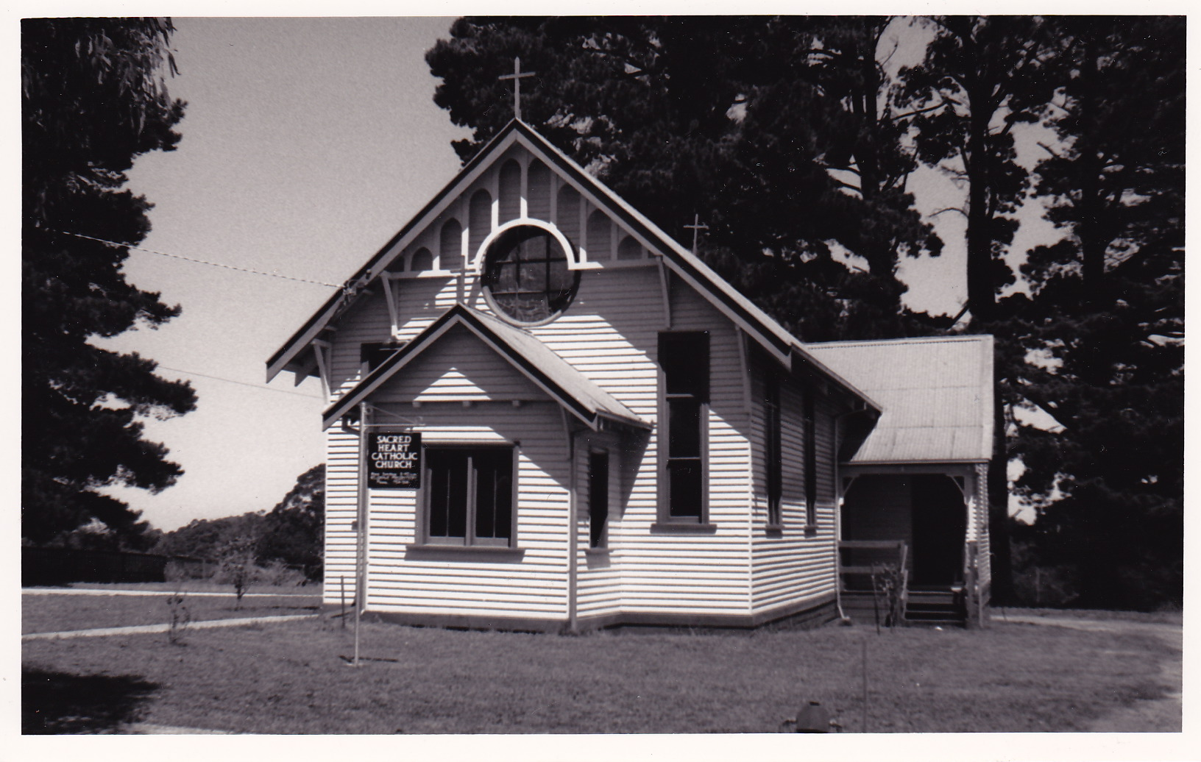
His successor, Fr. Little, was not given to horse riding, so he acquired a motor cycle and was a familiar figure in the district travelling to tend his flock. He was a zealous worker and during his time the Austral Hall was built at Belgrave (now the church of St. Thomas More). It was built in 1920 by voluntary labour and was financed largely by Harry Luscombe's dances and functions. In the Ferntree Gully Parish a Queen of Cards competition was organized — Mrs. V. Griffin was the winner, and Archbishop Mannix came from Melbourne to crown her as Queen in the Shire Hall. Fr. Little also organized the building of the Gembrook church, opened in 1922.
The site for the new church was again a gift from the Buckley family. I must pay tribute to the memory of Mary Buckley (daughter) who did so much to help the children of our Parish during its early years. She taught Sunday School for many years and always rode her horse (side-saddle) when she wasn't driving her aged parents. She would line us up — girls on one side of the aisle and boys on the other — and she sat down with her riding crop, which really kept order even though we were anything but attentive.
Just after the new church was opened, Fr. T. McCarthy was appointed parish priest and he was responsible for the building of the presbytery and the school. He invited the Presentation Nuns to the Parish and the convent was built to accommodate them. The school was well established by World War 2.
Rev. Fr. Flynn was appointed curate to assist Fr. McCarthy in about 1938 as the parish was growing rapidly, and indeed it was a mammoth task to organize Sunday Masses in all parts of the far-flung parish. Just after the war broke out, Fr. McCarthy was appointed to Southern Command as Padre-in-Charge, so it was left to his curate to carry on. He became our beloved Fr. Flynn — a zealous worker. There was always the problem of finance to keep the school going. There was a population explosion in the district and Nissan Huts were secured as temporary classrooms. About 1943 Mr. Munn offered land and Brenock Park was opened as a sports ground and a means of revenue raising. St. Joseph's Regional College now occupies most of this land.
With the coming of Fr. Harman, transport was organized for the children, and they were brought to school from the remotest corners of the parish. Mr. John Winters was a great helper with this work.
Belgrave Parish was established in the late 1950's and Rev. Fr. Kennelly was appointed first parish priest. So much is owed to the work of the pioneer priests and people, when one thinks of the obstacles and difficulties they had to contend with, such as transport problems, bad roads (or lack of them) and distance to be travelled in such a scattered area, that one hopes their work and sacrifices will never be forgotten.

PART TWO

The Last Fifty Years: 1959–2009

1959–1984 (From the Silver Jubilee Booklet, 1984)

"By 1959 it became apparent that the area was becoming too big to be administered from Ferntree Gully and moves were made to have a separate parish based in Belgrave. Father Flynn in jest remarked in his final speech that had he known that the reason the ladies wanted the church for a novena, was to pray for a separate parish, he might never have given his blessing. These fourteen ladies were only half way through the novena when Father Kennelly was appointed as Parish Priest. He requested that they continue and pray for nuns for the school. Very shortly afterwards the Good Samaritan Community laid their foundation in Belgrave. Such was the excitement of having a parish priest of their own, one basic fundamental requirement was overlooked — his sleeping accommodation for the first night! To this day there are those who believe Father Kennelly slept in his car — a fact that was never confirmed."
Father Kennelly acquired the old Preston home on the west side of the church and work began to make it the Presbytery of the new parish. Kind hearts and willing workers gathered to transform the building. Jack O'Dwyer was ill at the time, but his tip truck was borrowed to clear away the mess. By accident, Leo Walsh was trapped in a small pantry by plaster and debris and after quite some time of shouting and knocking was freed from the small room. In no time St. Thomas More's had a respectable presbytery for Father Kennelly and his curate.
Father Kennelly acquired a total of eight properties to form the old church, presbytery, school, new church and presbytery area. The school [St. Thomas More's] was built for £41,800 and opened on 5th June, 1962, staffed by Sisters Joan, Thecla, Finian and Isadora, of the Good Samaritan Community.
The contributions to the first Sacrificial Giving commenced on 2nd July, 1961. The total amount contributed for the entire parish was £142/11/6.
The Maytime Ball was revived with the church being used for the festivities and the marvellous supper was served across the road in the then R.S.L. Hall. Many may remember trying to return keys to the presbytery during Father Kennelly's days and being confronted by "Paddy", his crossbred Queensland Heeler. One parishioner noted that Father Kennelly's days as a South Melbourne footballer gave him considerable accuracy when "drop kicking" the cushions from the altar to the sacristy.
After eight years of hard work, Father Kennelly was replaced by Father Greg Handley whose task it became over the next few years to budget for and provide more substantial Mass Centres at Monbulk, Belgrave and Emerald. To his great credit, this was done without committing the Parish to a long term of debt. As the Church went through great change, Father Handley was able to move with the times. Evidence of his love of liturgy is reflected in many of his ideas in the churches and his eagerness to beautify the surrounds, so as to make St. Thomas More's a focal point of Belgrave.
1982 saw the arrival of Father Peter Carrucan. Coming from a suburban parish, to the wide spread areas of the Belgrave Parish, he was only just becoming familiar with people and places when the Ash Wednesday fires struck the Dandenongs. Within hours he was at the scene at Cockatoo and quickly assessed the needs of those affected. With monies provided from parishes all around Australia, the Belgrave Fire Relief Centre was set up and with a dedicated staff for twelve months catered for all victims in the fire affected areas. Soon after Father Peter arrived, the Church at Emerald was opened (September, 1982).

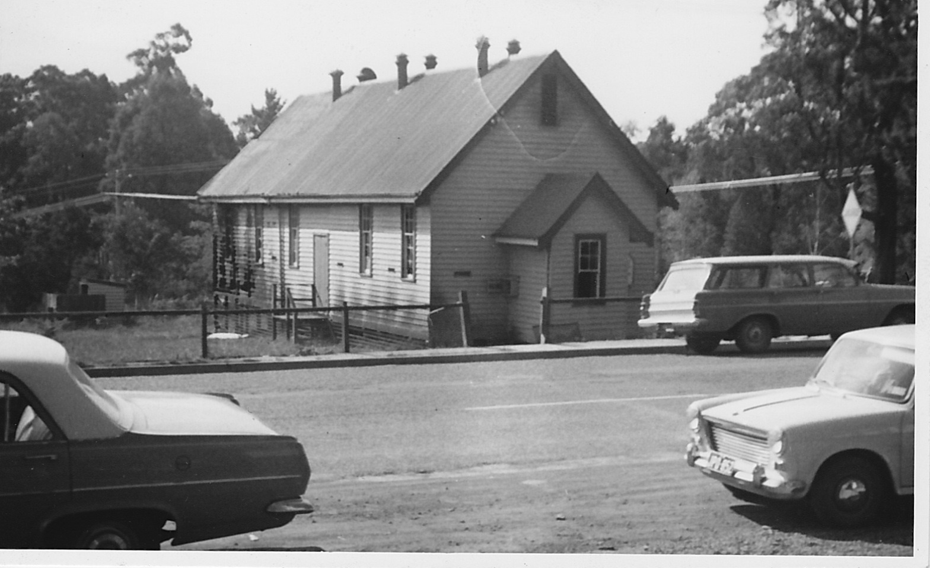
1983 saw the arrival of the first Parish Pastoral Associate — Sister Mary Scanlon from the Good Samaritan community. At the same time to cater for the growing needs of the parish, particularly in the Monbulk area, Sister Shirley of the Josephite Order arrived and was joined in 1984 by Sister Therese Stubbs who is the Principal of the new primary school at Monbulk [St. Paul's] which opened at the beginning of the 1984 school year.
We pay tribute to Fathers — Camilleri, Abela, Nippard, James, McCarthy, Dalton, Tricarico, McDonald, Scarlett, McKernan and Quinn and the Salesian Priests from Ferntree Gully. To the dedicated principals and teachers past and present, to those who work or have contributed in the past in any way to this Parish of St. Thomas More's, we thank you and pray that God will always bless those who reflect His love in their care and love for one another.

1984 to 2009: Parish Update (prepared by Elisabeth Drake)
Schools
Our two parish primary schools are flourishing. St. Paul's, Monbulk (opened in 1984) has grown to an enrolment of 120. St. Thomas More's, Belgrave (opened in 1962) has seen expansion and changes in the past 25 years. Enrolment is now 185. The two regional secondary colleges are also thriving. Mater Christi has some 1,000 students and St. Joseph's the same number.
Parish Programs
There have been a number of adult education, spiritual formation and retreats offered on a parish-wide basis. The 1988 "Renew" Program saw many people come together for discussion and study in smallish groups. The strong Small Christian Communities were part of the outcome. Neighbourhood Groups also participated. Each year there is the Lenten Program where these groups and others gather for themed discussion and reflection. In the early '80's Fr. Peter Carrucan called a Parish Synod which gathered a lot of people for a day of far-reaching examination of current and foreseeable future possibilities for our parish.
Hospitality and Outreach
Each of our five churches is a welcoming place. A cuppa after Mass, a welcome at the door, community meetings all contribute. Food and a listening, sympathetic ear are often provided by wonderful volunteers after a funeral. Pat McCarrick co-ordinates a big team of bakers for the Belgrave church and others do the same at the other Mass Centres. Other parishioners over the years have contributed to a "casserole bank" and more recently to a request system. The caring and visiting group includes those who take Communion to the sick and housebound parishioners.
Music
Music is an important ingredient of our liturgies. Each centre has a core of gifted and generous musicians. Many of us remember Sr. Elizabeth Murray who shared her considerable musical gifts with many over several years. At 'big' celebrations, especially in Holy Week, musicians from all centres come together to enhance our worship.
Sacramental Program
This area is a well structured and very inclusive program. Children in the two parish schools and also those attending other local schools are all catered for and parishioners welcome and support those preparing for Reconciliation, Eucharist and Confirmation. Families bringing children for Baptism are welcomed and prepared. RCIA is also active and links enquirers with Small Church Communities.
Mountain Doo / Mountain Summer Fete
This is also a great social occasion as well as our principal fund-raising effort. The huge organizational and publicity task always results in an excellent day. "The Doo" remains a parish-wide event and very well supported. Contributors to the Thanksgiving Program provide a regular, certain part of parish income. The big raffle held in conjunction with the Mountain Doo takes a lot of organization and work.
Parish Priests, Assistant Priests, Deacons
The twenty-five years have brought us a number of priests, each with his own distinct personality and giftedness. Parish Priests: Fathers Peter Carrucan, Phil O'Donnell, Vince Jewell, Brian McDermott and Nhan Le. Assistant Priests: Fathers Brian Quinn, Matt McDonald, Jim Scarlett, Gerry McKernan, Thien Vo, Philip Le Son, Norm Healey, Vince Jewell (not all in order). Recent Deacons: Phuong Vu — Hiagi Motofaga. Salesians: too numerous to mention — a very welcome factor in our lives.
Pastoral Associates
We began with Sr. Mary Scanlon, a much loved person fondly remembered by many. She had a broad view of her role and apart from spiritual and personal support she brought people together in a range of ways such as a Christian Yoga Group, a Men's Group, an Oaks Day lunch. She was joined by Sr. Shirley and Sr. Therese Stubbs (later Principal of St. Paul's). Sr. Yvonne Parker was a quiet but vital ingredient of parish life. She was followed by Sr. Joyce White, a real stayer and able to contribute to many aspects of our parish life. Sr. Marie Therese West followed Joyce. In May 2009 we welcomed Mrs. Deborah Kottek. Anne Collins is one of our Pastoral Associates (part-time), as is Mo Chirgwin, our Faith-development Coordinator. Other religious sisters from the Josephite Order who have helped us over the years are Sisters Mary McArdle, Henrica Jans and Helena O'Neill.
Parish Council and Parish-Wide Groups
In 2004 a well-organised and structured process led to the formation of the Parish Council which we have today. The first chairman was John Robat and he was succeeded by Marg Waldeck. The Liturgy Team is a smallish, enthusiastic group working to bring vitality and beauty to our liturgies. The Social Justice Group finds good support across the parish. The group supports three major programs — the school headed by Sr. Rita in Railco, East Timor; the boys' technical education program established in Pakistan by Fr. Hans Dopheide; Mission Impossible, in Belgrave, which supports homeless/disadvantaged people in our area. Some 35 people are rostered to provide a hot meal and friendly company one evening each month.

Parish Personnel
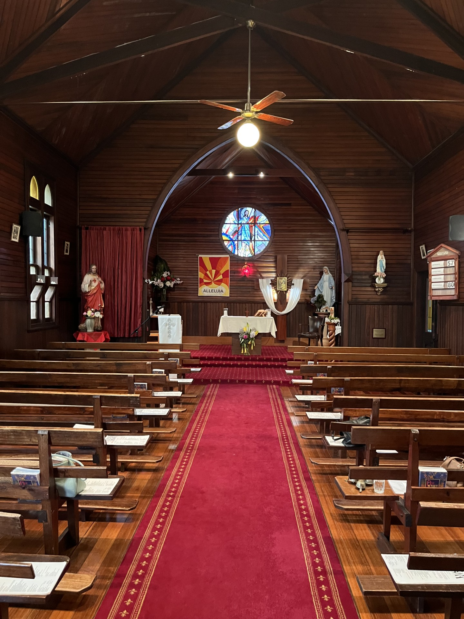
The Parish could not run at all without the hardworking, efficient and delightful Parish Secretary. Names include Pat Price, Val Wishart, Cathy Oliver, Pam Holmes, Ann Greene (who left after fifteen years of loyal service), and the present incumbent Helen Surman, who has been with us for six years. Also worthy of special mention: our fifth church, St. Clare's at Mount Dandenong, was blessed by Archbishop Frank Little on 26th March, 1995. Our oldest church, Sacred Heart in Gembrook, celebrated its 80th Anniversary in 2003. Parishioner Peter Hill coordinates building maintenance across all centres.

Sacred Heart in Gembrook, 2026

PART THREE

Golden Jubilee: 1959–2009

Parish Mass at Gillwell Park, Gembrook — February 2009
Written by Maree Lyons

We come together today from all corners of our Parish and begin our celebrations for the 50th Anniversary of the Parish of Belgrave.
We come together around the table of the Lord. We welcome Fr. Nhan Le, our Parish Priest, and Fr. William Matthews, who will celebrate the Eucharist with us today.
As our founding Parishioners 50 years ago welcomed all, let us be welcoming to each other. As they were compassionate to those in need, let us move forward with compassion to the wider Hills Community. As they came together to strengthen their faith, let us unite and foster strong ties within our Parish family. As they were active in serving the community, let us draw on their commitment and example, reaching out to our Hills Community in the Name of Jesus.
Today in our Eucharistic Celebration we come together to thank God for the gift of Our Parish Family, past and present, and the gift of each other. As our celebrations unfold in the coming months, we pray that God will guide and bless us all as we celebrate the Good News in the Parish of Belgrave.

PART FOUR

Contributions from Parishioners
Memories, interviews, and reflections gathered for the Golden Jubilee

St Paul's Community: A Walk Down Memory Lane
I was introduced to St. Paul's community by my new boyfriend, who brought me to the old church situated where Safeway now stands. The one visit was followed by the news that the church had been burnt down.
Then the earliest memory of St. Paul's new church was in 1974 when we moved into the township of Monbulk. Father Handley was the special priest who ran the whole of the Parish. St. Paul's community was predominately Dutch — immigrants, mostly flower growers, who gave much of their support financially and also with their precious time. These wonderful people kept the church in beautiful floral array, and supported all money-making programs.
I got to know the parishioners through our church choir. Corrie and Gerald Nyhuis held practice at their home each Thursday evening. Corrie played the organ. We would all sing at Sunday Mass and then after church all were welcomed for a cuppa at the Monbulk Community Centre.
The early choir members were Jo and Cees Tesselaar, Nell Kruyer, Nelly Van Raay, Lida Cabret, and her sister Bep Schuyt, Bas Nieuwesteeg, Albert Molenaar, Nick Koomen, Hermina Damen and Agaart Van der Hulst.
When Father Handley left, Father Peter Carrucan joined our Parish. Some of the choir joined into a musical called 'At Home in the Hills', about how Monbulk grew with our Dutch immigrants and the Monbulk Jams factory.
We were struggling with four young children and another on the way, when our car was stolen. Some wonderful people from the community put in enough money to buy us another car. We were never told who these people were. This was an act of true Christianity. It was very humbling and we were so grateful.
The community once again supported our family when my husband was dying. Each day people would visit, and parishioners would arrive with food, cakes and flowers. So much love surrounded us that even typing this memory brings tears. Sister Mary McArdle and Sister Helena O'Neil were looking after the Parish at this time. They would bring us messages of love from everyone who had enquired after us.
And, again, when one of my lovely sons passed away, the love of the parishioners once again surrounded us. The caring ladies of St. Paul's organized the wake at the RSL hall with food and drinks.
St. Paul's is a true Christian community, with all the ingredients needed: love and love and love. 'Love one another' is expressed without any fanfare in our Parish.
A parishioner spending thirty-plus years as a member of St. Paul's community.

1966–2009: Memories of the Parish
In 1966 St Thomas More school was functioning with grades 2 to 6. Father Kennelly was very conservative and had served as an Army Chaplain in the Korean war. He was very much aware of the needs of his parishioners and quietly went about helping them. On the other hand he was not averse to tapping the head of a forgetful lady who might present to receive Communion not wearing a hat, or chasing a man he thought was a burglar with a hand gun through the main street of Upwey at night.
The Parish church was the original Austral Hall which is now the school hall, built in 1920 by the local Catholic population and dedicated as St Thomas More's in 1938. Mass was celebrated each Sunday morning at 7 a.m. and 9 a.m. Mass was also said at Monbulk, Emerald and Gembrook, and in the Progress Hall in Upwey at 11 a.m.
In the hall the sanctuary was separated from the body of the hall by pews with sheets hung across them. On one occasion a dog made a successful invasion before being dealt with by the celebrant. On another Sunday Mass was very drawn out as Father had forgotten the Communion hosts and Jim McCart was dispatched to get them from Belgrave — only to find he'd been given the wrong key.
Father Kennelly acquired a total of eight properties to form the old church, presbytery, school, new church and presbytery area. He could see the bigger picture when others could only see the present.
Anonymous.

Fr Peter Carrucan's Vision for Small Christian Communities

The Small Christian Community (SCC) does not take anything away from the rich tradition of the Catholic Church. Its aim is to enhance the quality of our faith experience that is lived out in the society in which we live. It enables us "to be who we are better".

The SCC is for ordinary people whose lives are made up of joys, sufferings and struggles. In the SCC a small group of people can begin to make a difference in the lives of each other.
Pat O'Meara was part of a formation team which met at Chestnut Hill in Kallista for a four day workshop, led by Fr. Jose Marrins. Fr. Peter was a forward thinker and was preparing us for the time when we may have no priest or may only have Mass and the Sacraments occasionally.
Slowly and gently, he and Sister Mary Scanlon helped bring localities within the whole Parish together in these small groups. The first area to be identified was Belgrave Heights/South. We had our first meeting at the home of Jack and Anne Castricum. The O'Meara, Bowers, Magnus and Gamley families were at that first meeting and remain in the group to this date.
We have now been meeting every fortnight for 19 years. What binds us is without doubt our faith, but having known and supported one another for all those years, naturally great friendships have been forged also. We've cried together, prayed together, laughed together and we've stayed together.
Pat O'Meara and Loretta Gamley, for the Belgrave Heights/South Small Christian Community.

Part of the Belgrave Parish 'History': A Very Personal Experience — Patricia Barber
The first time I ever set foot in St. Thomas More's church was Christmas Day, 1989. I was particularly struck by the sense of social responsibility: the priest spoke about the homelessness of the Holy Family and related this to the situation of the refugees who had found their way to the Dandenong's. He asked parishioners to donate furniture, by requesting that they 'just leave it in the courtyard', from where the St. Vincent de Paul Society would distribute the items.
My husband and I moved to live in Australia in 2003 and bought a house in Upwey. I find there is a very strong sense of community, of people 'looking out for each other', and of people being prepared to reach out to the wider community: the very active St. Vincent de Paul's and Social Justice Group are examples. I am happy to be part of this community celebrating its 50th Anniversary!
Patricia Barber, 7th May, 2009.

Interview with Past Parishioners, Joe & Cis Beekman — Wantirna, 2009
Fr. Kennelly had his dog there, so I asked him once if the dog was a Catholic. And he said, 'Yes, he comes to Mass every day.' One day Father comes to Mass and his car has had an accident, his headlight gone. I said 'What happened here?' He said 'Not enough faith. If you've got enough faith you can move mountains. I couldn't!'
Cis: There was a very good side to Fr. Kennelly... I remember a family in the parish where the mother was very ill. The husband actually died first. Fr. Kennelly would go and visit them and look after them, and he would make arrangements for them to get help.
Joe: Then we got Father Greg Handley. He was the one that built the church at Belgrave. He was insistent in having that tower, which cost a lot of money — nobody liked it. He kept saying it was a symbol of Baptism. At his send-off, the compere told a joke about driving past wheat silos: 'Look, Dad, a Catholic church!' What was Fr. Greg's reaction? Not good!
We got on all right with Fr. Greg and the rest. Fr. Peter was lovely. Eighteen months ago was our 60th Wedding Anniversary, so Fr. Nhan wanted us to come to Belgrave for a special blessing. I said to Fr. Nhan 'We don't need this Blessing. I've been blessed for sixty years.' He said 'It's for the next 60 years.'
What year did you come out from Holland? 1955. We were there 46 years in the same Sassafras house, till we came here. (Cis) I do miss Belgrave though. People don't stay for coffee as they do at Belgrave. It's a fantastic part of going to Mass at Belgrave.
Thank you both for sharing your memories.

Easter Sunday 2009 — The Story of St Clare's, Mount Dandenong
Speech to the Parish Community, 12th April 2009 — Stephen Billington
This year the parish of Belgrave (St. Thomas More's) celebrates its 50th anniversary as a parish in its own right. Our parish includes: Gembrook — Sacred Heart; Emerald — St. Joseph's; Monbulk — St. Paul's; Belgrave — St. Thomas More's; Mount Dandenong — St. Clare's.
The Olinda community stretches from Tremont, Sherbrooke, Ferny Creek, Sassafras through to Olinda, Mount Dandenong and as far as Kalorama. In those early years Mass was celebrated in private homes, including the home of the late Jack Dunbar in Falls Road. There were occasional visits from priests on horseback, including Fr Little, uncle of Archbishop Frank Little.
From the early '70s the Olinda community celebrated Mass in the Olinda public hall near the football ground. This is where one could see true community in action — local nursery men would wheel in large pots of flowers and transform that hall into a place of welcome for the 150 or more people in attendance on Christmas Day and Easter Sunday.
The Olinda Hall was far from ideal, as it was often rented out on Saturday nights for parties. Parishioners would have to sweep rubbish out of the hall, and the priest told us on several occasions not to kneel on the floor as it was too dirty.
In 1986 Fr. Peter Carrucan asked the parishioners to form a building committee. It took until 1991 before building could commence — a house on the property earmarked for use was vandalized beyond repair on Australia Day weekend, 1991, and had to be demolished.
St. Clare's was built and we celebrated our first Mass in November 1992 — finally our faith community had a place we could call home. St. Clare's was blessed in March 1995 by Archbishop Frank Little. The design of the church is such that it is a true place of welcome — we can see the dawn break over the hills, though the priest, facing the congregation, cannot. There have been subtle threats to shift the altar so he could too!

Interview with Leny Broekhof — 27 September 2008
Where did you grow up? Holland. So was that during the war? Yes, I was a teenager during the war. I always said that I lost my teenage years; you couldn't go anywhere, there was a curfew. We lived on a big property; every night my father would light a fire under a big copper and put carrots, onions and potatoes in it, and a lot of people from the city used to come and have a meal.
When did you come out? In '59. We tried to get to Canada first, but my husband had a stomach ulcer so they wouldn't take us. Our house burnt down in '62. We never had to go into a camp because my husband had a job with Van Berkel's, and they had a little house for us — actually more like a shed, there was no power. We had to do with tilly-lamps.
With the church, that was really funny. The first time we went, I didn't have a hat on (we never wore hats in Holland) and Father Kennelly tapped me on the head and said I had to wear a hat. Then when he started his homily, Jeni, who was only a year old, started 'baby talk' and he stopped — she stopped — and as soon as he started, she started again, so he told me to leave the church with the baby! I thought 'Where am I going?' Mr Damen said 'Father wants you to leave the church... you can go and sit in my car.'
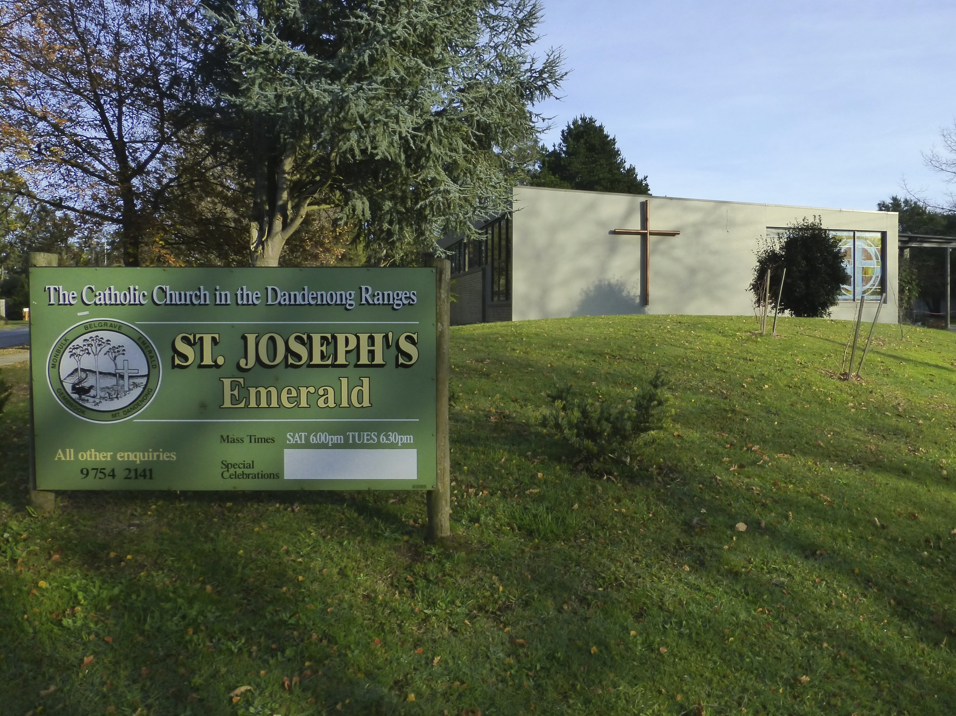
With Ash Wednesday — I said to Norienne 'We have to do something for these people', so we started with towels because the workers got so dirty. Somehow somebody got the Fire Brigade to come to Emerald to the big football oval and set up shower cubicles. We realised they also needed clothing and the hall was completely transformed into a second 'Myers'. From that grew the 'Casserole Service'.
What I really wanted to do was a memorial wall. That is my big thing before I die. In Dutch, it is called a 'kirkhoff' — a church garden. I put the first $500 in for the first memorial wall.
Thanks very much, Leny.

Snippets from Parishioners
"Being in the right place at the right time — We took Sr. Joyce out for lunch on her birthday. We decided to visit a very ill parishioner at Peter MacCallum Cancer Centre. Joyce offered Communion, he agreed. It was the most powerful experience I have had with the Eucharist. The man passed away peacefully a few days later."
Claire Lester
"Three children baptised at St. Thomas More's. Eight children did their sacraments there. Sr. Mary Scanlon was an enormous influence on me. Most of my children married there. Many of my grandchildren baptised in the parish."
Anon.
"The only time we ever sang the Collingwood theme song and in church! Fr. Phil O'Donnell's last Mass at Emerald."
Anon.
"We knew no-one when we married here on 9th November, 1985. Mary Cameron cleaned and flowered the church at Gembrook. We have been welcomed ever since."
Ian and Pam
"I will always remember Fr. Nhan's Installation. The church rocked as the community and Father's family came together to celebrate."
Paula Maidment
"My wife, Denise and I used to clean the old church at Emerald. It had a large hole in the floor. We often wondered what treasures may have been swept in there. We were never to find out as the church, and what was under it, burnt before an exploration could take place."
Kevin Burns
"My most precious memory is of Father Peter holding Ashleigh up before the congregation in 1991. I remember everyone clapping — it was a very welcoming community."
Sue Hilder
"My best memory is marrying my knight with charger (Valiant that is), Ian, at Sacred Heart Church, Gembrook on 9th November, 1985."
Pam Giulieri
"Mountain Doo fetes were always a time of great excitement — it meant sleepover in Dad's truck — dark and cold and in the school yard!"
Jo Schill
"St. Clare's is a beautiful space to experience the presence of God, the getting together of people, the caring for others, praying."
Anon.
"To be associated with this Parish is a feeling of belonging. I don't know where we would be without our Parish Community."
Anon.

From the Children of Gembrook
Connor Jans:
It is fun at children's liturgy because you get to do worksheets. The thing I like about church is that sometimes the priest is funny. What I love about God is he rose and died for us. Gembrook church is a great community because there are nice people.
Maddy Jans:
It is fun at children's liturgy because it is easy to understand the gospel. What I love about God is being able to pray to Him. Gembrook church is a friendly church where we all care about one another.
Amie Jans:
It is fun at children's liturgy because I get to do different activities. The thing I like about church is going to communion because you are taking in God. Gembrook church has a lot of nice people there.

A Golden Era and the Antioch Story — Kevin & Denise Burns
We moved to the parish part time in 1968, purchasing a small cottage in Emerald, and full time in 1971. Father Peter arrived in early 1983, and before he had time to settle in, we were confronted with the Ash Wednesday Bushfires. His great leadership qualities immediately sprang into action. He set up a relief centre at the parish house and proceeded to help dozens of needy people.
Peter was a great visionary and a man before his time. As a result of the bushfires he set up a sixth Mass centre at Cockatoo. He opened the old parish house, Friendship House, as a place of refuge for needy and homeless people. He also had a hand in starting Marriage Encounter, Baptism Awareness programs, Small Christian Communities, RCIA, Focus Program for Engaged Couples, and the preparation for the building of St Clare's.

Antioch — A Catholic Youth Group
Antioch was introduced to the Belgrave Parish in 1984. A group of 10 teenagers were recruited by Fr. Brian Quinn and Sr. Condon. They attended a camp at Wantirna Parish. Meetings took the form of 2 leaders, boy and girl, with the motto 'Lead — don't be led', a lighted candle in the centre symbolizing the 'Light of Christ'.
From a small group of 10, we blossomed to well over 60 to 80 at weekly meetings. The Rock and the Rose were our symbols at camps — the Rock symbolizing coldness and hardness when we arrived; by the end we'd moved to the opening up of a beautiful creation, a person of God — The Rose.
Antioch continued until April 1995. It was wonderful being part of this Golden Era. His work lives on today in our vibrant communities.
Kevin & Denise Burns.

Memories of St Thomas More's Parish — Lawrie Canning
I came to St Thomas More's in Belgrave in 1982. Kerry and I were married there in 1984 and our girls were baptised there. The terrific contribution made by the wonderful women of the parish always impressed me — Norienne Peterson and Pat McCarrick stood out. The men of our parish probably think they are the ones running things but the truth is without the wonderful 'Women of the Well' our parish would be a dry and desolate place.
Lawrie Canning

Jack & Anne Castricum
We bought a 20 acre hobby farm at The Patch. We had six children and our 7th was baptised at St. Thomas More's. The Parish Priest did not believe ladies should come to church hatless — at Communion he'd say instead of 'The Body of Christ', 'no hat, no host.'
The Ash Wednesday bush fires saw us getting involved in parish life. Fr. Peter Carrucan started the same time we came to Belgrave. Over 25 years we participated in many Parish projects, including the Party in the Barn to raise funds for Fr. Peter's 25th Anniversary — 350 people fed, raising $3,200. We are so lucky!!
Jack & Anne Castricum.

The Chirgwin Family
Our family emigrated from the UK to Belgrave in November 2002. After a long dry spell with rain, Fr Brian McDermott opened Mass with a dramatic gesture: 'Will the person who has prayed for rain please STOP.' Everyone laughed.
We were unable to attend Gerry's mother's funeral in the UK. Mass was said for her in Belgrave; her grandchildren brought her photo to the altar. Fr Peter-Damien spoke movingly about the difficulties migrants face. This community were now our family in Australia — through sickness, decisions, death, celebrations, teenagers — our community have walked with us, shared and supported us. We think ourselves most blessed.
The Chirgwin family.

Soon After Moving to the Dandenong's — Chris Clark
In the late eighties I was warmly welcomed to the Olinda Hall, with windows heavily barred and Saturday-night party rubbish to clean before Mass. People dressed in gumboots, drizabones, beanies.
I remember the liberating move to St. Clare's — clean lines, floor-to-ceiling windows over the valley. Our community Nativity set — families dressed individual figures; the Billingtons produced sheep from wooden pegs covered in fleece; one King wore authentic African material. Despite ups and downs in attendance, St. Clare's seems to regenerate itself, which is reason for wonder and joy.
Chris Clark

I'm As Lucky As Can Be... I Belong to St Paul's, Monbulk! — Anne Collins

"To be human is to belong... the Longing of our being and the Being of our longing."
— John O'Donoghue
In twenty-five years my late husband Jim and I raised six children here. I've experienced the high points of my faith at World Youth Day 2008 and walking 100km in Oxfam teams. One Sunday I backed my car into the water meter tap, water shooting thirty metres! It's all part of BELONGING to our Parish.

Like the tree that puts roots deep into the clay, each one of us needs the anchor of belonging in order to bend with the storms and continue towards the light.
Anne Collins, 20/5/2009.

Diary Entry: Palm Sunday, 24th March 1991 — Peter Cook
I was playing the piano at Mass in the Old Shire Hall, Olinda. As Father Carrucan read the Passion narrative and passed near the piano, I was seized with a desire to kiss the hem of his robe. Soon after he uttered 'lama, lama Sabacthani' and the piano moved slightly — a rise and rocking motion. I thought I must have imagined it. Clem Elliot got to his feet saying never had he felt so close to the Presence of God. The piano moved again during silent prayer. I was not touching it. Nobody was near it. The hairs on the back of my head began bristling.
Clem Elliot sent me a note afterward: 'When Father Carrucan moved past me I experienced a Presence as though Christ himself was alongside of me... the Olinda community does every now and again have an aura about it.' P.S. This is the same Clem Elliot who, during one Sunday Mass, was peed upon by a possum from the rafters. It was Clem who freely built St Clare's to the architect's drawings, charging only for materials.
Peter Cook

Palm Sunday at Olinda Shire Hall, 1991 — Paul Cleveland
Mount Dandenong had no Catholic church and our small congregation worshipped at Olinda Shire Hall. It was Palm Sunday, 24th March, 1991. We met outside in a tennis court for the procession, traffic roaring past. That day was not ordinary. Father Carrucan was explaining the invisible using the visible in the Gospel — I thought I heard and saw the upright piano move, though no one was near it. Peter Cook, at the piano, had a similar mysterious experience. In gratitude we walk our days with this precious memory.
Paul Cleveland, Mount Dandenong, 4th May, 2009.

Reminiscences of 40 Years in Gembrook — Lenore Crundall
In 1960 John bought seven acres in Gembrook. We decided to make our home there, joining the faithful community at Sacred Heart — a little Nazareth, made up of kind, selfless people. Father Kennelly provided transport for a bachelor parishioner who always tried to be last to Communion — one Sunday Father reversed direction so the man was first in line! He refused to travel with Father again.
Father Peter was parish priest when the Ash Wednesday bushfires struck. Father quickly rallied parishioners. The people of Gembrook have kept their church through cake stalls, raffles, and generous donations. Frank Blunden donated the new carpet and arranged flowers from his own garden. Sr Mary Scanlon, Sr Mary McArdle, and Sr Joyce White all served as pastoral carers over the years.
Lenore Crundall

33 Wonderful Years — Kath Dawson
We arrived in Belgrave from Tasmania in January 1973 and stayed for 33 wonderful years. The Parish was alive and vibrant. The Mountain Doo had lots of social/fundraising events. A few years after building the New Church, Father Handley left and Father Peter Carrucan arrived — then came Ash Wednesday and the fires. I was invited many times to join one of the Small Church groups, and eventually when I did join, I was sorry that I had been so slow to join. I still miss Belgrave.
God Bless, Kath Dawson.

Where Did I Come From? — Elisabeth Drake
After two years in a French student parish, I wondered what was in store when I came to the Dandenongs in 1970. The celebrant was Fr. Paul Dalton and he gave a heartfelt homily about the Sign of Peace. 'Ha!' thought I, 'They're on the ball here.'
Fr. Handley had us draw straws to decide the first Lay Ministers of Eucharist — his response to my drawing a good straw: 'You could wear your red caftan.' For the washing of feet on Holy Thursday he added the instruction 'and don't wear panty hose Elisabeth.'
No one who was here in February, 1983, will ever forget the Ash Wednesday fires. Our parish house became a communication and relief hub for the whole year. Joan Mitchell (later McCart) led the effort with extraordinary dedication and was given an award. I love the variety of our area and the five parish centres.
Elisabeth Drake

The Music Group — Tony Ellingworth, 26/4/2009
After listening to the talents of Maggie Williams, Jenny Simpson, Pat O'Meara for 8-9 years, I had an overwhelming desire to join the music group. With Pat's steady hand in the middle of my back, I was pushed closer to the microphone. I thank God for the opportunity given to us and hope future generations will find the PEACE, LOVE, and FORGIVENESS shown to us by the FATHER, SON, and HOLY SPIRIT.
Tony Ellingworth, 26/4/2009

Some History of St Joseph's, Emerald — Dianne Fletcher, 21 April 2009
I was married at Sacred Heart Gembrook by Father Handley in 1976. I felt very much at home in the old wooden church in Ann Street, watching birds nest in the falling-down gutters. I was very disappointed when the new Emerald St Joseph's was erected and didn't much look like a church at all. Nevertheless, the Church was a great learning tool and influence in my life — not only by its teachings but by the people I came in contact with.
Dianne Fletcher

Mass at the Upwey Progress Hall — Loretta Gamley
My family, the Petersons, went to Mass at the Upwey Progress Hall. Fr. Kennelly was the Parish Priest, and if the fire siren went off during the sermon, he would stop mid sentence — no more sermon. He gave me my first cigarette and let me steer his Holden Premier car when he would take us kids to the drive-in. At our most irreverent times we called him Ned, but no one ever said it to his face. The progress hall burnt down in 1968.

The Re-Emergence of Deb Balls in the Hills
Dot Webber and I were part of a Social Committee that decided to run a Debutante Ball around 1982/83. Father Peter Carrucan thought it was a great idea. As bad luck would have it, the Ash Wednesday bushfires occurred and Joan Mitchell, who was training the debs, became a leader in the fire relief instead, so we moved rehearsals and Eric and Kaylene Manks trained the debs. The sixteen debs danced The Pride of Erin and The Lucielle. The most amazing thing was the transformation of the boys — arriving for practice in work boots, loving getting dressed up on the night.
Loretta Gamley.

My Memories of Ash Wednesday in Belgrave 1983 — Sr. Janice Gleeson sgs
As I drove to Belgrave, I was amazed to hear the radio declare the fires under control when it was obvious they were moving rapidly across the area. Father Peter Carrucan asked me to help distribute the ashes — reminding the congregation 'Remember you are but dust and unto dust you shall return!' while wondering how everyone would get home safely. Our loving God was certainly protecting his people that night.
St. Thomas More's Parish became an Emergency Relief Centre for many months. To our amazement, eighteen people enrolled in the RCIA Program that Easter.
Sr. Janice Gleeson sgs

Parish Memories — Cheryl Graham
I came to St. Thomas More's in 1979, received into the Catholic Church in the old hall. One of the things I found most attractive about Catholicism was its symbolism — someone always remembered to light a candle or add a cross. I loved the build-up of tension from Lent until the final vigil, emerging at dawn.
My first Parish Priest, Fr. Greg Handley, was rather crusty on the outside, marshmallow on the inside. The next priest, Fr. Peter Carrucan, said he had young couples to prepare for marriage: 'What would a crusty old bachelor like me know about this? This is your job. How about some volunteers?' Fr. Vince Jewell's homilies were by far the most inspiring of all the priests, in my opinion.
One of the highlights of my RCIA involvement was a girl called Christine, baptised in black, who emerged radiant in white. Two days later, she was killed. We were heartbroken, but it also felt as though she had been sent to us. St. Thomas More's, in its best moments, has been a lively, creative, enthusiastic parish with a social conscience. I'm glad to have been a part of it for thirty years.
Cheryl Graham

A Life in the Parish — Annette Hanigan
In 1952 my parents moved to Monbulk. Our first parish priest, Fr Kennelly, had a huge task setting up the parish structure — he was straight to the point and did an enormous amount, purchasing land for the future. Fr Peter Carrucan re-invigorated the parish family with the Care Group, RCIA, Liturgy, Children's Liturgy. We had altar boys and girls until someone complained and the girls were banned — so very sad. I will never forget the love and support given to our family when John died in 1991 and our daughter, Katryna, in 2004.
With Love, Annette Hanigan

When We First Moved to the Parish — Helen Hermann
My husband Bill and I left Holland in 1954. From 1963 to 1968 we lived with our nine children in an old weatherboard house owned by the Parish, where the current presbytery now stands. Father Kennelly let us live there until building works commenced. We had two small water tanks that didn't fill, so we got permission to run a hose from the old presbytery.
My husband Bill died of a heart attack in 1989; Fr Thien Vo conducted the funeral. My granddaughter, Cari Dinkgreve, died aged 2½ in 1996, six weeks after diagnosis with a brain tumour. Fr. Peter Carrucan and Sr. Joyce conducted the celebration of her life — unique and beautiful, just like Cari.
Helen Hermann

Recollections of Fr. Maurice Kennelly — Keith Herten, Parishioner 1963–1966

"He was the Parish Priest of Belgrave and I was the Principal at Kallista State School. A whisper told me that he requested a parish in the hills where he could breathe in the cold air because of his asthma. Being a very good card player having probably learnt the tricks of the trade in the Air Force, he regularly played cards in a foursome on Saturday evenings at the Presbytery. His sermons were brief and to the point, thus reducing Mass to a minimum time. I once asked him why he translated the Gospel from Latin to English as he read it at Mass. His response, 'That's my weekly penance.'"
Keith Herten

Reminiscences — Joe Hilder, Sacred Heart Gembrook
My Grandfather Hilder was responsible for cutting the grass around the church with a scythe — a family tradition that continues. Mrs. Kermond used to make scones for Father Flynn — one Sunday he brushed her off: 'No thanks. I've got to get back. The bloody Bishop is coming.' Everyone was shocked a priest would say such a thing.
At one time Mass alternated between Gembrook and the old Cockatoo Hall. Once candles set the curtains alight — I rushed down the aisle interrupting Mass to put it out, only to find the fire had already burnt itself out, and had to walk quietly back to my seat.
Fr. Kennelly once did a head count at Benediction before a parish dance, found only five people had attended, and closed the dance down and sent everyone home.
Joe Hilder

Parish Memories — Les Hill (Two Essays)
My wife and I first came to Belgrave in 1953. My final acceptance into the faith was with Father Flynn, and I will always remember the friendliness and welcome by the late Jim McCart. We used to polish the old hall floor for dances with a box-like arrangement towed à la huskies, calling 'mush'!! I became Parish Treasurer with Frank Price, helping establish the new Parish, and had the honour of reading at the dedication, complimented by Archbishop Little.
My great discovery at a progressive dinner was the Pianola at Nat McDermott's house, which I could pedal while enjoying the music. Our baby daughter once cried 'I want a Bronnie' having seen Terry McDermott's old TV role as Sergeant Bronson in Homicide.
Les Hill

Christmas Carolling in Emerald — Rosemary Hogan
Each Christmas Eve, Mrs. Hilde Knorr organized the children of St. Joseph's community to carol the sick and elderly around Emerald. In thanks, we received small cash donations and were plied with lollies and lemonade. The star, made by Mr. Knorr, was used to poke and prod anyone taking themselves too seriously — when Mrs. Knorr wasn't looking. It is one of the warm, enduring memories of my childhood in St. Joseph's community.
Rosemary Hogan

St Thomas More 1959–2009: First Impressions — Marilyn Huber
Christmas, 1975 — early on Christmas morning I found Mass was almost over at Belgrave, and we flew back to Emerald just in time for the start of Mass in the little wooden chapel. Yet there was a heartening homeliness here. When the 1983 fires ravaged the Dandenongs, the new St Joseph's congregation had increased — we sat bathed in golden light through the stained glass. I attended a 'Renewal of Faith' course and soon began to feel accepted. Thirty three years since that first Christmas, I still feel nourished by the faith community at St Joseph's.
Marilyn Huber

Memories of Belgrave and the Dandenong's — Evert and Mia Jansen
We became residents in January, 1960. The Church then was what is now the Parish Hall, with Mass often at the Upwey Progress Hall. All this building and hard work, by many people, has made the Parish of St Thomas More — a Parish of which we can all be very proud.
Evert and Mia Jansen

Gembrook: Where We Belong — John and Martine Killeen
In 2006 we migrated from Ireland to Gembrook, feeling apprehensive with no relatives in a very large country. By our third week we had no place to live. Not only were we offered places in several homes for Easter Sunday, we were offered emergency accommodation. The Goodie family took our children in as Special Friends when my wife was in a car accident. As parishioners today, we belong! We are thankful that we were 'chosen' to live in Gembrook.
John and Martine Killeen

Lia Kelleners on her Memories of the Parish — November 2008
We came to the Parish around 1967. I taught Indonesian language and culture at St Thomas More School until 2001. I ran a 'Twelve Star Group' and the 'Sherbrooke Group' for young people. We also had 'Antioch' for young adults, with a rock and a rose on the altar — the rock for hardship offered to God, the rose for soft and gentle things.
With Ash Wednesday, I said to Norienne 'We have to do something for these people' — we got the Fire Brigade to set up showers, then realised people needed clothing, transforming the hall into a second 'Myers'. From that grew the Casserole Service. What I really wanted to do was a memorial wall — that is my big thing before I die.
Years later a young woman came up to me with two little children: 'Oh Mrs Kelleners' — one of my first Star Girls, remembering my face after all these years.
Lia Kelleners

St Paul's, Monbulk — Marijke Klep
My first memory of St Paul's was the old Timber Church on the site now Safeway's, with lots of Dutch people in Church. Gerry and I bought a property in Monbulk and our daughter Deidré was one of the first pupils to start at St Paul's new school. I enjoyed locking horns with Fr. Phil O'Donnell; he made religion relevant. We are grateful for all the love and support given to us in the tough times we had in the past.
God Bless St Paul's! Marijke Klep, Monbulk.

First Impressions... From a Newcomer — Deborah Kottek, Pastoral Associate
It has been three weeks and already I feel quite welcome at St Thomas More parish. I have shaken hands, been hugged, kissed, anointed, blessed, had multiple morning and afternoon teas, driven through incredibly beautiful tree filled mountains, and celebrated Mass with many lovely parishioners. Thank you, dear Lord, for bringing me to the faith community of St Thomas More.

"One has to be alone, under the sky, before everything falls into place and one finds his own place in the midst of it all."
— Thomas Merton
Deborah Kottek, Pastoral Associate

A Story from St Thomas More's — Erica Kurec, March 2009
It was early 1989. One morning Frankie was late waking, and I found him stiff and cold in his cot — SIDS. Father Peter Carrucan rode with us in the ambulance, holding Kiera, his presence such a blessing during that bleak, heartbreaking journey. Casey insisted on going to school, telling another child his brother had died in the night.
In the aftermath, Father sought me out to decorate the Paschal Candle, possibly the first by a parishioner. I joined the 'Women and Spirituality Group' started by Sister Mary Scanlon, facilitated by counselor Helen Chapman. Gradually the fog of grief lifted. The Parish Community had made itself known to me, providing a kind of cradle from which to emerge into the world again.
Erica Kurec

My St Clare's Story — Claire Lester, Parish Councillor
1995 — I first went to St. Clare's though I was Church of England. Fr. Phil O'Donnell led the Mass — warm, humorous, it touched a chord. I was soon accepted onto the Pastoral Team; that's when I 'fessed up' I wasn't Catholic — it didn't matter to them. That same year I was accepted into the Catholic faith at St. Clare's.
2000 — My beautiful mother passed away. I arrived home to scones, jam and cream on the front door step, flowers at the back door — love, support and prayer just happened, no asking, just the amazing St. Clare's community.

One of the most precious things about St. Clare's is how things just happen — no fuss — mostly without asking. A TRULY FAITH LIVING COMMUNITY.
Claire Lester, Parish Councillor

The Belgrave Parish — My New Home — Maree Lyons
We arrived in 2001. Irene Wilson welcomed me and suggested I join a Small Church Community — this was the beginning of a new and exciting spiritual journey for me. Pat O'Meara introduced me to the music group, and before I knew it, had asked me to organise the music once a month! The faces are now familiar, I am no longer the stranger, I feel at home.
Maree Lyons.

I.O.G.D. — Double Vision by a Two-Timer — Sr. Maureen Keating sgs
Have you ever looked at a well-loved place twice with twenty-five years between viewings? My first glimpse of the parish was 1965, working with Mater Christi's founding Good Samaritan Sisters. Sr. Gertrude Kelly once sent Father Kennelly's dog Paddy to the Pound; Father got his own back by leading her whole Grade 6 class on an impromptu walk in Sherbrooke Forest while she stood with chalk dangling in hand. We kept a goat as head of landscape gardening; coloured chalk was our most advanced technological aid.
My second glimpse came in 1991, this time as Home/College Liaison driving the blue 'bubble car' christened ELROY. On a few occasions in Selby, Elroy and I ended up in ditches, rescued by innovative fathers with planks and four-wheel-drives. In 2004 I transitioned to Volunteer visiting, having coffee and conversation with the families who shaped the parish in its pioneering stages.

"I thank my God, each time I think of you, and when I pray for you, I pray with joy."
Sr. Maureen Keating sgs

The McCart Family — Neil McCart
My grandfather Charlie McCart first camped in the Tecoma Basin as a boy hitching rides on bullock trains hauling timber out of Emerald — he liked the spot so much he later bought it. My parents, Jim and Verna, married in 1945 and lived in a 400 sq ft fibro shack with four boys. Times were tough but we never went hungry; growing up in Sophia Grove was a golden time for all of us. Mum coordinated emergency aid for Ash Wednesday bushfire victims in 1983. Mum died suddenly in 1992, aged 68; Dad later married fellow parishioner Johanna Mitchell in 1999.

The McCart family will always have a special connection with the hills. The treasured gift my parents and their community gave me is faith.
Neil McCart

The Mountain Doo — Remembered by Nathalie and Terry McDermott
When we arrived in 1967, the School Fete was a glorified Sausage Sizzle on a rainy day. A meeting elected Ev Kiker Secretary and Terry McDermott President. We ran a 'Wig' night, a Progressive Dinner, an Art Show, and a Wine Bottling to raise funds. Father Greg Handley made a special appeal for the men of the Parish to get involved — to great effect.
The committee adopted the name Mountain Doo (Mountain Dew was suggested first). Over the years it became bigger and bigger with Maurie Bilston's connections. Heaps of money has been made to run the Parish and the social value is incalculable. God seems to approve, for we nearly always get great weather on the day.

Long Live the Mountain Doo!
Remembered by Nathalie and Terry McDermott

Neighbourhood Groups — Maureen Miller
In the days of Sr Mary Scanlon, neighbourhood groups sprang up around the parish. Upwey Neighbourhood Group still meets monthly, 25 years on, now called Upwey Friendship Group. We continue to support Project Brazil, initiated by Sr Mary Scanlon in 1991.
Maureen Miller

We Arrived in Belgrave Heights as Newlyweds in 1962 — Joan and Len Nash
Norienne and Jack Peterson, Evie and Ray Kiker, Leo and Josie Walsh welcomed us. Our kids thought Fr Greg Handley was God, as the sun shone through the window and lit up his white hair like a halo. We had lethal progressive dinners, musical nights, wine bottling nights, and car rallies where we inevitably got lost. Fr Peter Carrucan shanghaied our kids and us into the new Antioch Group — busy, happy years, 1985–95.
Joan and Len Nash.

Twenty Years in the St Thomas More's Choir — Pat O'Meara
1988 was RESTRUCTURE in the Parish. Fr Peter Carrucan and Sr. Mary Scanlon encouraged more participation. We restructured the choir so a core team of three were responsible for one Sunday a month, a structure still used today.
During Advent, unable to find lyrics about Mary's preparation for Jesus's birth, Maggie wrote 'Wait with Mary' — sung every Advent since. John Piggott has played at most midnight Masses for twenty years. Jenny Simpson wrote our school song 'We Are One'. Fr. Vince joined the choir at his last midnight Mass to sing 'War Is Over'.

The vision statement of RESTRUCTURE was 'to be a Church where we are drawn to share Life and Faith.' I think this could be described as the overall goal of the Choir.
Pat O'Meara

Memories of St John's, Ferntree Gully, and St Thomas More's — Rosemary Pickthall
Fr. Flynn was so generous he gave everything away — when parishioners bought him a ticket to Ireland, they had to see him onto the plane! Fr. Kennelly had a blue heeler called 'Paddy' who once stole a string of sausages from the butcher's — it made front page of 'The Free Press'! He'd say if you coughed, 'You'd think this was a sanitarium!'
My daughter Melissa recalls taking our panting dog Gertie to Mass with us — embarrassing, but we giggled.
Rosemary Pickthall

Memories of Monbulk — Lida and Robert Ploeg
We arrived in Australia in 1963. The old church was like out of a cowboy movie. Robert and I were the first ones married in the new St. Paul's Church, 2nd September 1972 — no car park, no school, no foyer, no carpet.
Lida and Robert Ploeg

Recollections of the St Paul's Community, Monbulk — Ann Rogers
We moved from the U.K. in 1989. My first day at Mass, Barry Duivenvoorden introduced me to Delma Calcagno, who made us feel so welcome I still appreciate it. In 1993, while overseas I became unwell and required surgery — the community organised a roster to take me daily, for six weeks, for treatment. Meals arrived on the doorstep often.

The symbol for St Paul's for the 50th Anniversary is Hope. What I hope is that all young families coming to the parish will have the wonderful experiences, love and support that we have had in the last twenty years.
Ann Rogers

The Memories and Mirth of Carolyn Ryan
We moved to South Belgrave in 1977. Father Peter Carrucan's words 'Not when we get a curate, but if we get a curate' opened doors for the laity. Sr. Mary's words, 'You'd be good at', helped many discover new talents.
The plight of a zealous altar server:
Fr. Handley sent our son Gerard to remove the bells. A tug of war resulted — two adults versus an 11-year-old. A dishevelled Altar Server returned with the bells.
For Confirmation, Fr. Gerry McKernan told Gerard to watch the Bishop's lip curl as his cue to present the Mitre — the whole family experienced this tense and demanding role.
Spontaneous Prayer:
'Lord, I pray for those who think that Father and I are having an affair.' Lord, hear us. The 'Lord, hear our prayer' was not readily forthcoming.
Take care, Carolyn E. Ryan

My Return to Faith — Peter Saunders, May 2009
By 1992 I considered myself an atheist following depression after a career setback. My therapist suggested I return to my faith. I entered St Thomas More's with great anxiety, met by Irene Wilson's warm welcome. Sr Yvonne Parker introduced me to deeper prayer. At the end of an 8-day silent retreat, Frank Wallace introduced me to Cheryl Graham, who invited me to join the RCIA team — her and Irene's leadership taught me what faith and community could be like.
In 1997, with my wife Lorraine, I joined the Upwey small church community, meeting at Terry and Nath McDermott's place ever since. Over 12 years we have shared illnesses, operations, death, and new life together.

I am continually grateful to Christ for drawing me back into my faith and into this wonderful community of St. Thomas More's.
Peter Saunders, May 2009

Our Lady of Fatima — Elizabeth Scott
Some 35 years ago Maureen and Pat Coyne obtained a Statue of Our Lady of Fatima from a convent in Maryborough, to travel from home to home in the parish for weekly Rosary. After several restorations, it still travels from family to family today.
Elizabeth Scott

Parish Secretary — Helen Surman
I grew up in Sassafras, attending Mass at the old Sassafras Mechanics Hall. As a seven-year-old with meningitis I used Lourdes water given by our neighbour — the simple faith of a child rewarded by Our Lady. I married John in the old church building, Austral Hall, in 1971 — he forgot to pay Fr. Dalton for the wedding!
Six years ago I saw an ad for Administration Assistant and thought 'If it's meant to be I'll get the job.' The most rewarding aspect of working for our Parish is interacting with other parishioners, both in good times and not-so-good times.
With love and gratitude, Helen Surman.

Memories of the Parish of St Thomas More — John Taylor (interviewed by Tina Nabb, 28 July 2007)
I was born in Belgrave; we travelled to Ferntree Gully on dad's truck for Mass. Fourteen ladies asked the parish priest for the church keys to pray a novena — for a separate parish, though he didn't know it. Father Kennelly came to the parish in 1959, acquiring eight properties, buying land at Gembrook, Emerald and Monbulk that he later sold to build churches there. He could see the bigger picture when others could only see the present.
He tried to join the RSL after his RAAF chaplaincy but was refused on a technicality. It was cruel and it hurt him. But he built the school and there were lots of stories about him, most of them true, because he was a man's man.
John Taylor

St Vincent de Paul Society — Bill Hitchcock
The Belgrave conference came into existence in the 1940's. I came into the Belgrave Church in 1960, instructed by Father Kennelly — both ex-RAAF, I was his golden-haired boy. I was abducted very early into St Vincent de Paul. Morry Wallace told a struggling woman 'I am sorry, we can't help you, we haven't got any money' — I realised this was St. Vincent's De 'Poor'.
In 1967 Father Kennelly asked me to rejuvenate the conference. My wife Jean became Manageress of the first clothing store in Ferntree Gully, unpaid — all 'voluntary'. Today, St Vincent de Paul has over 100 stores helping the poor and needy.
Bill Hitchcock

Snippets from the Past — Gembrook. Personal Memories of Joy Goodie (nee Hilder)
Father Harmon:
"Every day Father Harmon would drive the bus to and from Fern Tree Gully, sleeping overnight in the sacristy and saying Mass four days a week at 7.00 a.m."
Flowers:
"Mrs Tom Williams Snr always did the flowers, using red tipped, silver top gum leaves. Jim, her youngest son, would bring tips in his billy-cart drawn by a husky-type dog called Ted."

St Thomas More's Belgrave — 1964-65 — Sr Moya Weissenfeld sgs
In 1964 the Sisters lived in 'Sunny Siesta', a small cottage at Mater Christi. We hosed down the walls of the weatherboard classroom for end-of-year exams. My main impressions were of a supportive, generous, happy and united group of parishioners which continues to this day.
Sr Moya Weissenfeld sgs

Reflection — Belgrave Parish — Sr. Marie Therese West LCM
Twelve months was the span of my ministry in Belgrave. I set myself the task of visiting each community monthly. There were several people I journeyed with, and by the last week of my ministry, they had all died. I wonder if this was the reason I was in the parish for such a short time — to walk with these men and women into eternal life.
Sr. Marie Therese West LCM

My Belgrave Childhood — Val Wishart, 2006
Our family home, Myradale, was near the Trestle Bridge where we roasted potatoes borrowed from the pantry — 'Where have all the potatoes gone?' The Austral Hall hosted birthday parties, card parties, dances, and once a month Mass before becoming Belgrave's own parish church.
Val Wishart, 2006

A Welcome That Changed Everything — Fay Ryan
My first association with St. Thomas More Parish was through children at Tecoma Primary School. When my husband Kevin passed away, I was invited to join the Christian Community and made very welcome — a supportive, caring group giving me love and spiritual strength.
Fay Ryan

CLOSING REFLECTION

For Our Parish Community
Written for the Golden Jubilee, 2009

Lord, look upon this Parish of ours
See the love we share
Across our varied mountain land
With people everywhere.

From Belgrave's busy, bustling streets
To Gembrook, green and serene,
From Emerald's golden-stained glass light
To Monbulk's hillside scene.

And on the top of Dandenong,
Where misty mornings glow
St. Clare's looks out across the vale
On hills we love and know.

In these five places we have prayed
And gathered at your call;
We've shared our joys and sorrows too —
You've been our Lord through all.

Beauty in our people, now and in the past.
Beauty on the inside, which is where it lasts.

Amen.

Acknowledgements
This volume was compiled for the Golden Jubilee of the Parish of St Thomas More, Belgrave, celebrated in 2009. It preserves in full all materials gathered for that occasion — every contributor's voice, every memory, every story.
The early history was told by pioneer parishioner Ellen Stevens (née Winters). The Silver Jubilee account (1959–1984) was produced for the parish's 25th anniversary in 1984. The 1984–2009 update was prepared by Elisabeth Drake. The Easter Sunday 2009 reflection was written by Maree Lyons. The St Clare's community address was given by Stephen Billington.
Individual contributions were made by: Patricia Barber, Joe and Cis Beekman, Kevin and Denise Burns, Lawrie Canning, Jack and Anne Castricum, The Chirgwin family, Chris Clark, Anne Collins, Peter Cook, Lenore Crundall, Kath Dawson, Elisabeth Drake, Tony Ellingworth, Dianne Fletcher, Loretta Gamley, Sr. Janice Gleeson sgs, Joy Goodie, Cheryl Graham, Annette Hanigan, Helen Hermann, Keith Herten, Joe Hilder, Les Hill, Rosemary Hogan, Marilyn Huber, Evert and Mia Jansen, John and Martine Killeen, Lia Kelleners, Marijke Klep, Deborah Kottek, Erica Kurec, Claire Lester, Maree Lyons, Neil McCart, Nathalie and Terry McDermott, Maureen Miller, Joan and Len Nash, Pat O'Meara and Loretta Gamley, Rosemary Pickthall, Lida and Robert Ploeg, Ann Rogers, Carolyn Ryan, Fay Ryan, Peter Saunders, Elizabeth Scott, Helen Surman, John Taylor, Sr. Moya Weissenfeld sgs, Sr. Marie Therese West LCM, Val Wishart, Leny Broekhof, Sr. Maureen Keating sgs, Bill Hitchcock.
Particular thanks to all the children of Gembrook who contributed their own reflections, and to every parishioner, past and present, whose name appears in these pages. We also honour those whose names do not appear — the many who served quietly, without record, for the love of their community and their God.
The Parish of St Thomas More, Belgrave — 1959 to 2009.

