
4
2nd Aug 2026
The Chimes
Dallas & Meadow Heights

18th Sunday in Ordinary Time, Year A
SUNDAY 2nd AUGUST, 2026

1st Reading: is 55:1-3 | 2nd Reading: Rom 8:35, 37-39 | Gospel: Mt 14: 13-21

Parish Priest: Fr Joseph D.Truong
0415 455 845
Email: Joseph.DanhTruong@cam.org.au

Priest in Residence - Fr Fadhel Yakob
(Syriac Rites) 0433 833 647

Parish Secretary: Joecy Taiafi and Cong Pham
Parish Office: 115 Corinella Crescent, Dallas
Office Hours - Tuesday 12pm – 4pm & Friday
9am—1pm (other times: By appointment with
Fr Joe 0415 455 845)

CHURCH: 227 Blair St, Dallas 3047

Parish Office:

115 Corinella Cres, Dallas, Vic 3047

Phone: 9412 8409
Email: dallas@cam.org.au
Website: https://www.melbcatholic.org/s/dallas

Parish House: 115 Corinella Cres. Dallas.

School Principal: Mr. Aaron Kuras

School Office: 9309 1620

WEEKDAY MASSES:
Dallas: Tues - Fri. 9.15 am
1st Fri. Anointing Mass: Dallas 10 am

WEEKEND MASSES:
Sat. Dallas Vigil Mass 6.00 pm
Sun. Meadow Heights 9.00 am (English)
Dallas 11.00 am
*Note: Vietnamese Mass
2nd Sunday of the Month: 8.00 am HFC
4th Sunday of the Month: 11.00 am @ Dallas

RECONCILIATION
Dallas Saturday 5.15 - 5.45 pm
Thursday 8.45 - 9.00 am
During Friday’s Holy Hour at Meadow Heights

LEGION OF MARY
Eng. Tues after 9.15am mass – Dallas
Viet. Sat. at 9 am at Holy Family Centre

ADORATION & BENEDICTION
Of the Blessed Sacrament
Fridays 8:45am (English) Dallas
1st.Friday 9.30 am before Mass
Friday’s Holy Hour: 5.30 – 6.30pm @ Meadow Heights
Fridays 6.30 pm (Vietnamese prayer) Holy Family Centre

BAPTISMS
Contact Parish Office during office hours

WEDDINGS
Please contact Parish Office
Preferably 6 months before the wedding .


The death of the Baptist has left Jesus saddened, and he withdraws to be alone with the disciples. But even his personal sorrow is overwhelmed by compassion for the people who had followed him, and he cures their sick. The crowd stays with him, even into the evening.
When the disciples ask Jesus to send them away to eat, Jesus’ response is a challenge to the disciples: feed them yourselves. He is training them to take the initiative, to be confident leaders of the community after he has gone. Jesus employs the ritual of the daily Jewish meal in blessing, breaking and giving, but this ritual now points to the actions of the Last Supper. All are fed; all are satisfied. There are overtones of the messianic banquet, a common image in the Hebrew Scriptures describing the reign of God; there is an abundance. The crowd represents all of Israel gathered by Jesus, and the twelve baskets of remainders represent the twelve tribes of Israel gathered by the twelve disciples. (Summit Online)

4
19th Sunday in Ordinary times, Year a

1st Reading | 1 Kgs 19:9, 11-13
Responsorial Psalm | Ps 84:9-14
2nd Reading | Rom 9:1-5
Gospel | Mt 14:22-33

1st Reading: Isaiah:22:19-23; 2nd Reading: Romans 11:33-36; Gospel: Mathew 16:13-20

1

BAPTISM PREPARATION AND BAPTISM DATES

Next Baptism Preparation Day | Baptism Date:
Wednesday, 2nd September 2026 | Sunday, 4th October 2026

Responsorial Psalm: | The hand of the Lord feeds us: he answers all our needs.
Gospel Acclamation: | Alleluia, alleluia!  No one lives on bread alone, but on every word that comes from the mouth of God.  Alleluia!

Holy Child Parish….

Is committed to a safe nurturing culture for all our children.
BOOKING THE HOLY
FAMILY CENTRE
The Holy Family Centre is Available for any group or parishioners to book.
Please call the Parish Office
on 9412 8409 to make a booking.
SCHEDULING APPTS WITH FR JOE
Please note that Parishioners are encouraged to schedule an appointment with Fr Joe as walk-in meetings are not always ideal.

(Names of the sick will only be printed for a month, unless the Office has been notified otherwise)
SICK: Joan Lobs, Shirley Martin, Adrian Zuccato, Nguyen Thi Thin, Le Thi Quy, Dina, Lien, Connie, Miriam Smith, Florentino Casimiro, Farif Ashlaq, Beaderez Lamoc, Margaret Braddock, Revelita Blanco

REMEMBRANCES: Prudengio Espiritu, Teodoro Espiritu, Laura Camilerri, Sylvia Buhaja, Tomas Mc Loughlin, Elizabeth Maguire, Elsie Athorne, Thi Lieu, Burke Family; Mother, Father, Brother and 2 Sisters, Jose Antonio, Luzia Calvalho, Maria, Connie Losciavo, Maddie, Bridget
RECENT DEATHS:

all departed souls, the Souls in Purgatory and all those mentioned in the Book of Remembrance.

RECENT DEATH:

Please keep them in your Prayers


Mini Fiesta – Friday, 7 August 2026
Celebrating the Women of Faith: The Blessed Virgin Mary & Saint Mary of the Cross
“We invite everyone to join the parish and school for the Fiesta on Friday, 7 August, to honour the Women of Faith, the Blessed Virgin Mary, and St. Mary MacKillop.”
Schedule of Events:
- 2:45 PM: Registration Desk Opens
- 3:30 PM: Welcome – Mary MacKillop Hall
- 3:40 PM – 4:40 PM: Activities for Children and Adults – Mary MacKillop Hall and Area 4 (Tennis Court)
- 5:00 PM: Presentation on the Life of St. Mary MacKillop by Sr. Patricia Williams RSJ
- 5:30 PM: Mass in Honour of St. Mary MacKillop – Solemnity
- 6:30 PM: Celebration with a sausage sizzle and more. Parishioners are asked to bring a plate to share.
Lễ hội nhỏ: Thứ Sáu, ngày 7 tháng 8 năm 2026
Chúng tôi mời tất cả mọi người cùng tham gia Lễ hội do giáo xứ và nhà trường tổ chức vào Thứ Sáu, ngày 7 tháng 8, để tôn vinh các Phụ nữ có đức tin, Đức Trinh Nữ Maria và Thánh Mary MacKillop.
Chương trình
- 14:45: Bàn đăng ký mở cửa
- 15:30: Chào mừng – Hội trường Mary MacKillop
- 15:40 - 16:40: Các hoạt động dành cho trẻ em và người lớn – Hội trường Mary MacKillop và Khu vực 4 (Sân tennis)
- 17:00: Bài thuyết trình về cuộc đời Thánh Mary MacKillop của Souer Patricia Williams RSJ
- 17:30: Thánh lễ kính Thánh Mary MacKillop – Lễ trọng
- 18:30: Tiệc mừng . Giáo dân được yêu cầu mang theo một món ăn để chia sẻ.

For more information, please contact the parish office at Dallas@cam.org.au.

all departed souls, the Souls in Purgatory and all those mentioned in the Book of Remembrance.

RECENT DEATH:

Melbourne Synod 2026 – Invitation to Engage in Reflection and Discussion
Fr Joe invites parishioners to participate in the Archdiocesan Melbourne Synodal Theme Papers sharing and reflection at Meadow Heights on the following Fridays:
24 July 4-5pm @ Meadow Heights.
31 July 4-5 Pm @ Meadow Heights.
14 August 2- 3 Pm @ Meadow Heights.
21 August 4-5 Pm @ Meadow Heights
Melbourne synod 2026 – Theme Paper Release
The Synod theme papers are an important step in our journey of listening and discernment as we prepare for the Melbourne Synod. The papers aim to foster a spirit of hope and imagination—trusting that, as we walk together, God is calling us into a future marked by faithfulness, renewal, and deeper communion. The suggested reflection process is a ‘Conversation in the Spirit’ or a Spiritual Conversation. This method It is based in prayer and allows people to come together to both speak and to listen. Different from a discussion, it is an attentive listening process that aims to discern where the Holy Spirit is leading us. At the conclusion of each theme paper, there are prompt questions for reflection. Responses to these prompt questions can be provided via the QR code which is at the end of each paper.

all departed souls, the Souls in Purgatory and all those mentioned in the Book of Remembrance.

RECENT DEATH:

PARISH PASTORAL CALENDAR August 2026

2 | Confirmation Commitment Mass, 11am Sunday @ Dallas | 14 | Mass of St Maximillian 9:15 AM @Dallas  Assumption - TBA
 |  | 15 | Assumption - TBA
5 | Confirmation Family Workshop 5:30pm | 19 | Pastoral Council Meeting 6-7:30 PM @ Meadow Heights
7 | Mini Fiesta – Women of Faith 3:30 PM to 7:30 PM @ Dallas | 20 | Holy Hour 5:30 pm – 6:30 pm @ Meadow Heights
9 | Sacrament of Confirmation, 2PM Sunday @ Dallas | 28 | Holy Hour 5:30 pm – 6:30 pm @ Meadow Heights
12 | Finance Meeting 6-7:30 PM @ Meadow Heights | 30 | Formation for Special Ministers of Communion 3-5 PM @ Dallas


Feast Day During the Week

3rd August – St Dominic
4th August – St John Vianney
6th August – The Transfiguration of the Lord
8th August – St Mary of the Cross

Special Collection

Hai, Loan, An, | 4/8/26
Judy, Juanita, Mele & Sr V | 11/8/26
Hai, Loan, An | 18/8/26
Judy, Juanita, Mele & Sr V | 25/8/26

Sunday 8am Viet Roster
 | 9th Aug. | 13th Sept.
Readers | TBC | Kim Van
Comment. | Lan Melissa | Hai Vu
Special Minister

Thanksgiving Collection

Loose: $287.45
Church (Actual): $846
Church (Pledge): $1324.46
Presbytery (Actual): $600
Presbytery (Pledge): $950.55

Flowers Donated By



 | 4/8/26
Judy, Juanita, Mele & Sr V | 11/8/26
Hai, Loan, An | 18/8/26
Judy, Juanita, Mele & Sr V | 25/8/26

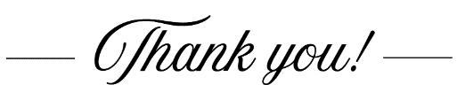
Group | Names | Date
A | Mele, Sarah Kempen,  Magina Musingarabul | 22-23 August
B | Viet Legion of Mary | 1-2 August
C | Sam & Vicky Buhagiar, Cynthia | 8-9 August
D | Van My Nguyen Famil | 15-16 August
 | (SAT) 6.00 pm | (SUN) 9.00 am | (SUN) 11.00 am
Readers | Joseph | Elijah | Elenora
Commentators | Vicky | Judy | Cynthia
Special Ministers | Sr Veronica | Henry | Mele
Money Collectors | As Per | Volunteers  mass | At Each
THIS Weekend ROSTERS: (1st – 2nd August 2026)
 | (SAT) 6.00 pm | (SUN) 9.00 am | (SUN) 11.00 am
Readers | Damian | Veronica S | Louise
Commentators | Vicky | Judy | Lahra
Special Ministers | Sr Veronica | Taafaonga | Adorabelle
Money Collectors | As Per | Volunteers  mass | At Each
NEXT Weekend ROSTERS: (8th – 9th August 2026)
COUNTING ROSTER FOR July 2026

DALLAS CHURCH CLEANING ROSTER FOR July 2026

Big thank you to CDF who donated $500

Big thank you to the Veggie Group who contributed $1000

Big thank you to an anonymous donor who contributed $1000

Big thank you to an anonymous donor who contributed $1000

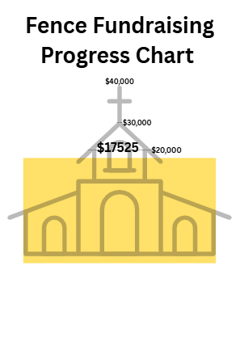



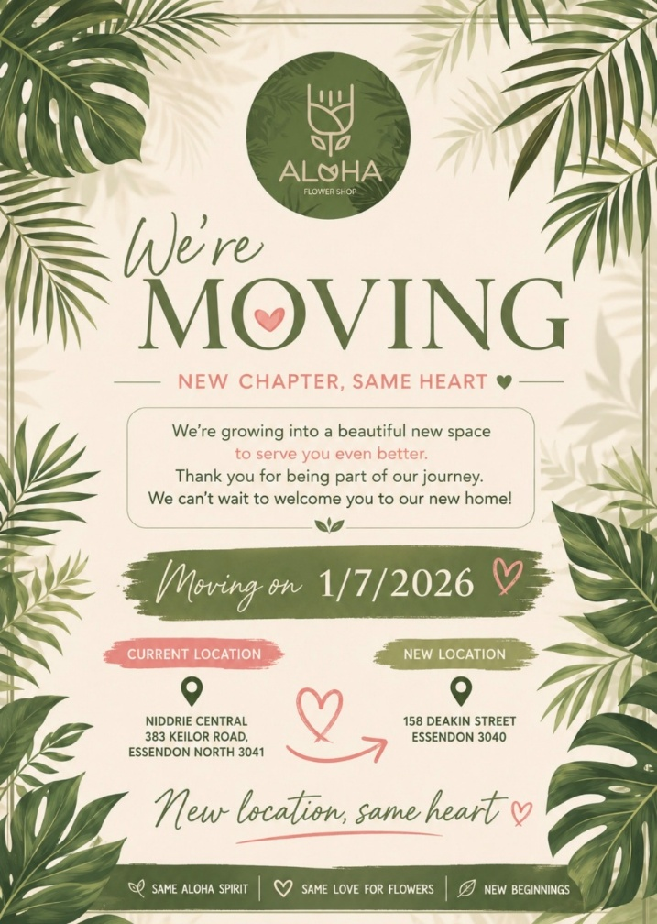

ADVERTISE YOUR BUSINESS HERE FOR $50 FOR 3 MONTHS

