
4
9th Aug 2026
The Chimes
Dallas & Meadow Heights

19th Sunday in Ordinary Time, Year A
SUNDAY 9th AUGUST, 2026

1st Reading: 1 Kgs 19:9, 11-13 | 2nd Reading: Rom 9:1-5 | Gospel: Mt 14: 22-33

Parish Priest: Fr Joseph D.Truong
0415 455 845
Email: Joseph.DanhTruong@cam.org.au

Priest in Residence - Fr Fadhel Yakob
(Syriac Rites) 0433 833 647

Parish Secretary: Joecy Taiafi and Cong Pham
Parish Office: 115 Corinella Crescent, Dallas
Office Hours - Tuesday 12pm – 4pm & Friday
9am—1pm (other times: By appointment with
Fr Joe 0415 455 845)

CHURCH: 227 Blair St, Dallas 3047

Parish Office:

115 Corinella Cres, Dallas, Vic 3047

Phone: 9412 8409
Email: dallas@cam.org.au
Website: https://www.melbcatholic.org/s/dallas

Parish House: 115 Corinella Cres. Dallas.

School Principal: Mr. Aaron Kuras

School Office: 9309 1620

WEEKDAY MASSES:
Dallas: Tues - Fri. 9.15 am
1st Fri. Anointing Mass: Dallas 10 am

WEEKEND MASSES:
Sat. Dallas Vigil Mass 6.00 pm
Sun. Meadow Heights 9.00 am (English)
Dallas 11.00 am
*Note: Vietnamese Mass
2nd Sunday of the Month: 8.00 am HFC
4th Sunday of the Month: 11.00 am @ Dallas

RECONCILIATION
Dallas Saturday 5.15 - 5.45 pm
Thursday 8.45 - 9.00 am
During Friday’s Holy Hour at Meadow Heights

LEGION OF MARY
Eng. Tues after 9.15am mass – Dallas
Viet. Sat. at 9 am at Holy Family Centre

ADORATION & BENEDICTION
Of the Blessed Sacrament
Fridays 8:45am (English) Dallas
1st.Friday 9.30 am before Mass
Friday’s Holy Hour: 5.30 – 6.30pm @ Meadow Heights
Fridays 6.30 pm (Vietnamese prayer) Holy Family Centre

BAPTISMS
Contact Parish Office during office hours

WEDDINGS
Please contact Parish Office
Preferably 6 months before the wedding .
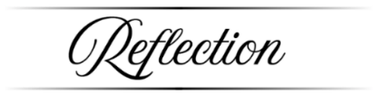

A little-noticed phrase in this text adds significantly to the way we understand this story. Jesus told the disciples to cross to the other side of the lake. In doing this, they were heading away from the Jewish region and into Gentile territory. The boat is a symbol of the Church, and as such, we can detect in this text a reflection of the situation of Matthew’s community, who have been forced out of the synagogue and away from traditional Judaism. More and more, it is Gentiles who are coming to belief in Jesus. This is causing fear and concern for some in the community. Matthew gives a prominent place to Peter, whose actions do not make sense, except as a combination of impulsive love and faith weakened by doubt. While his full attention is on Jesus, Peter is fine, but as soon as he allows what is going on around him to distract him from Jesus, he begins to sink.
This text offers a parable of the Church besieged and being tossed about. Peter’s response is to be bold and to step out into the unknown, yet he is vulnerable. The great comfort is in the risen Lord stretching out his hand to restore morale. This manifestation of the power of Christ is greeted by that great acclamation of faith: ‘Truly you are the Son of God.’ (Summit Online)

4

20th Sunday in Ordinary times, Year a

1st Reading | Is 56:1, 6-7
Responsorial Psalm | Ps 66:2-3, 5-6, 8
2nd Reading | Rom 11:13-15, 29-32
Gospel | Mt 15:21-28

1st Reading: Isaiah:22:19-23; 2nd Reading: Romans 11:33-36; Gospel: Mathew 16:13-20

1

BAPTISM PREPARATION AND BAPTISM DATES

Next Baptism Preparation Day | Baptism Date:
Wednesday, 2nd September 2026 | Sunday, 4th October 2026

Responsorial Psalm: | Lord, show us your mercy and love, and grant us your salvation.
Gospel Acclamation: | Alleluia, alleluia!  I hope in the Lord, I trust in his word.  Alleluia!

Holy Child Parish….

Is committed to a safe nurturing culture for all our children.
BOOKING THE HOLY
FAMILY CENTRE
The Holy Family Centre is Available for any group or parishioners to book.
Please call the Parish Office
on 9412 8409 to make a booking.
SCHEDULING APPTS WITH FR JOE
Please note that Parishioners are encouraged to schedule an appointment with Fr Joe as walk-in meetings are not always ideal.

(Names of the sick will only be printed for a month, unless the Office has been notified otherwise)
SICK: Joan Lobs, Shirley Martin, Adrian Zuccato, Nguyen Thi Thin, Le Thi Quy, Dina, Lien, Connie, Miriam Smith, Florentino Casimiro, Farif Ashlaq, Beaderez Lamoc, Margaret Braddock, Revelita Blanco

REMEMBRANCES: Prudengio Espiritu, Teodoro Espiritu, Beatrice Bastian, Mary Jackson, Maria Nguyen Thi Luong, Jerry Cavetano, Graciana Cardoso, Genevive Bruce, Elizabeth Barnabas, Olga Knight, Angelo Rambaldo, Abrao Martins, Peter Perera, Lina Priano
RECENT DEATHS:

all departed souls, the Souls in Purgatory and all those mentioned in the Book of Remembrance.

RECENT DEATH:

Please keep them in your Prayers



Mass Schedule for the Week ahead.

Tuesday 11 August – 9:15 Mass @ Dallas
Wednesday 12 August – No morning Mass in the parish. Fr Joe is away at the annual clergy conference.
Thursday 13 August – 9:15 Mass @ Dallas.
Friday 14 August – 9:15 AM Mass @ Dallas – Memorial of St Maximilian Kolbe.

Lịch Thánh lễ trong tuần tới.
Thứ Ba, ngày 11 tháng 8 – Thánh lễ lúc 9:15 tại Dallas
Thứ Tư, ngày 12 tháng 8 – Không có Thánh lễ sáng tại giáo xứ. Cha Joe đi dự hội nghị linh mục thường niên.
Thứ Năm, ngày 13 tháng 8 – Thánh lễ lúc 9:15 tại Dallas.
Thứ Sáu, ngày 14 tháng 8 – Thánh lễ lúc 9:15 sáng tại Dallas – Lễ tưởng niệm Thánh Maximilian Kolbe.

Mass Schedule for the Assumption of the Blessed Virgin Mary – A Holy Day of Obligation.

Friday 14 August, 7:00 PM Vigil Mass of the Assumption of Mary @ Dallas – Bilingual Mass.

Saturday 15 August, 10:30 AM Mass of the Assumption of Mary @ Dallas – Bilingual Mass.

Lịch Thánh Lễ Đức Mẹ Lên Trời – Thánh Lễ Buộc

Thứ Sáu, ngày 14 tháng 8, 19:00 Thánh Lễ Vọng Đức Mẹ Lên Trời tại Dallas – Thánh Lễ Song ngữ.

Thứ Bảy, ngày 15 tháng 8, 10:30 AM Thánh Lễ Đức Mẹ Lên Trời tại Dallas – Thánh Lễ Song ngữ.

all departed souls, the Souls in Purgatory and all those mentioned in the Book of Remembrance.

RECENT DEATH:

PARISH PASTORAL CALENDAR August 2026

2 | Confirmation Commitment Mass, 11am Sunday @ Dallas | 14 | Mass of St Maximillian 9:15 AM @Dallas  Mass for the Assumption – 7:00 PM @ Dallas (Bilingual Mass)
 |  | 15 | Mass for the Assumption – 10:30 AM @ Dallas (Bilingual Mass)
5 | Confirmation Family Workshop 5:30pm | 19 | Pastoral Council Meeting 6-7:30 PM @ Meadow Heights
7 | Mini Fiesta – Women of Faith 3:30 PM to 7:30 PM @ Dallas | 20 | Holy Hour 5:30 pm – 6:30 pm @ Meadow Heights
9 | Sacrament of Confirmation, 2PM Sunday @ Dallas | 28 | Holy Hour 5:30 pm – 6:30 pm @ Meadow Heights
12 | Finance Meeting 6-7:30 PM @ Meadow Heights | 30 | Formation for Special Ministers of Communion 3-5 PM @ Dallas


Feast Day During the Week

10th August – St Lawrence
11th August – St Clare
14th August – St Maximilian Mary Kolbe
15th August – The Assumption

Special Collection

Hai, Loan, An, | 4/8/26
Judy, Juanita, Mele & Sr V | 11/8/26
Hai, Loan, An | 18/8/26
Judy, Juanita, Mele & Sr V | 25/8/26

Sunday 8am Viet Roster
 | 9th Aug. | 13th Sept.
Readers | TBC | Kim Van
Comment. | Lan Melissa | Hai Vu
Special Minister

Thanksgiving Collection

Loose: $415.25
Church (Actual): $1019
Church (Pledge): $1324.46
Presbytery (Actual): $643
Presbytery (Pledge): $950.55

Flowers Donated By



 | 4/8/26
Judy, Juanita, Mele & Sr V | 11/8/26
Hai, Loan, An | 18/8/26
Judy, Juanita, Mele & Sr V | 25/8/26

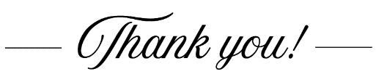
Group | Names | Date
A | Mele, Sarah Kempen,  Magina Musingarabul | 22-23 August
B | Viet Legion of Mary | 1-2 August
C | Sam & Vicky Buhagiar, Cynthia | 8-9 August
D | Van My Nguyen Famil | 15-16 August
 | (SAT) 6.00 pm | (SUN) 9.00 am | (SUN) 11.00 am
Readers | Thien | Juanita | Bernard
Commentators | Damian | Henry | Adorabelle
Special Ministers | Sr Veronica | Judy | Lahra
Money Collectors | As Per | Volunteers  mass | At Each
THIS Weekend ROSTERS: (8th – 9th August 2026)
 | (SAT) 6.00 pm | (SUN) 9.00 am | (SUN) 11.00 am
Readers | Joseph | Elijah | Elenora
Commentators | Vicky | Judy | Cynthia
Special Ministers | Sr Veronica | Henry | Mele
Money Collectors | As Per | Volunteers  mass | At Each
NEXT Weekend ROSTERS: (15th – 16th August 2026)
COUNTING ROSTER FOR July 2026

DALLAS CHURCH CLEANING ROSTER FOR July 2026

Big thank you to the Veggie Group who contributed $500

Big thank you to an anonymous donor who contributed $200

Big thank you to an anonymous donor who contributed $50

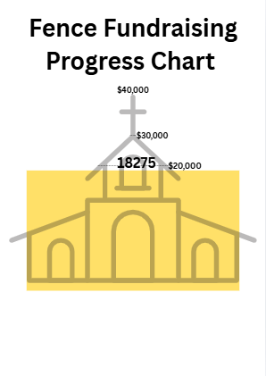

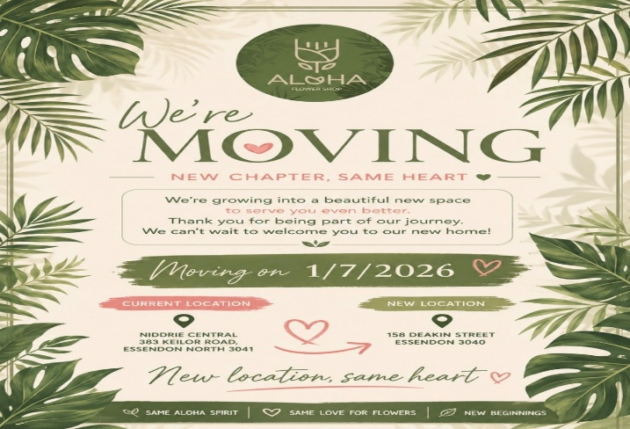



ADVERTISE YOUR BUSINESS HERE FOR $50 FOR 3 MONTHS

