
 14th December,2025

The Chimes

Dallas & Meadow Heights

THIRD SUNDAY OF ADVENT - YEAR A
SUNDAY 14TH DECEMBER, 2025

1st Reading: Is 35: 1-6, 10 2nd Reading: James 5: 7-10
Gospel: Mt 11: 2-11

Parish Priest: Fr Joseph D.Truong
0415 455 845
Email: Joseph.DanhTruong@cam.org.au

Priest in Residence - Fr Fadhel Yakob
(Syriac Rites) 0433 833 647

Parish Secretary: Carol McPherson
Office hours: Tuesday & Friday
9am—5pm (other times: By appointment with
Fr Joe 0415 455 845)

CHURCH: 227 Blair St, Dallas 3047

Parish Office & Holy Family Centre:

133 Malmsbury Dr, Meadow Heights, Vic 3048

Phone: 9412 8409
Email: dallas@cam.org.au
Website: https://www.melbcatholic.org/s/dallas

Parish House: 115 Corinella Cres. Dallas.

School Principal: Mr. Alan Smith

School Office: 9309 1620

WEEKDAY MASSES:
Dallas: Tues - Fri. 9.15 am
1st Fri. Anointing Mass: Dallas 10 am

WEEKEND MASSES:
Sat. Dallas Vigil Mass 6.00 pm
Sun. Meadow Heights 9.00 am
Dallas 11.00 am
*Note: Vietnamese Mass
2nd Sunday of the Month: 9.00 am HFC
4th Sunday of the Month: 11.00 am HFC

RECONCILIATION
Dallas Saturday 5.15 - 5.45 pm
Thursday 8.45 - 9.00 am

LEGION OF MARY
Eng. Tues after 9.15am mass – Dallas
Viet. Sat. at 9 am at Holy Family Centre

ADORATION & BENEDICTION
Of the Blessed Sacrament
Fridays 8:45am (English) Dallas
1st.Friday 9.30 am before Mass
Fridays 6.30 pm (Viet) Holy Family Centre

BAPTISMS
Contact Parish Office during office hours

WEDDINGS
Please contact Parish Office
Preferably 6 months before the wedding .


As we have already noted, one of the main purposes of Matthew’s Gospel is to reveal Jesus as the long-awaited Messiah of the Jews to Matthew’s largely Jewish community. In this text, Matthew cites the evidence that is before their eyes. Why is it necessary for John to question the identity of Jesus when his own eyes and ears will give him the answer he seeks? The blind see, the lame walk, the lepers are cleansed, the deaf hear, the dead are raised to life, and good news is proclaimed to the poor! Such were the signs of the coming of the Lord that Isaiah had prophesied. Such are the actions that Jesus undertakes! His identity is clear for all who have the eyes to see it. source: the summit on-line)

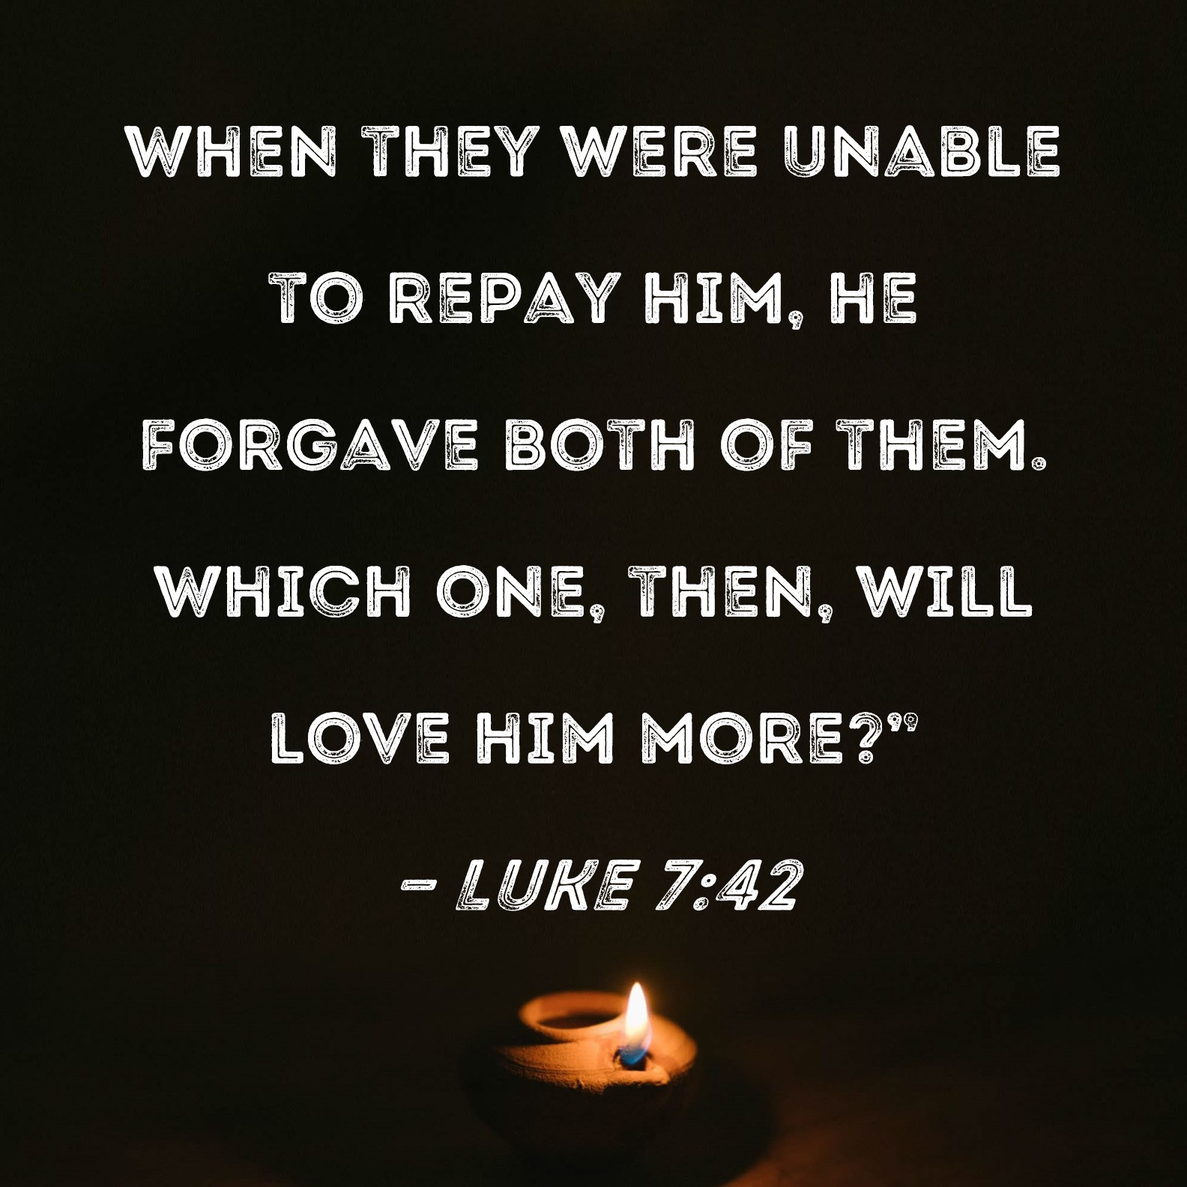

.

FOURTH SUNDAY IN ADVENT - YEAR A
Sunday 21ST DECEMBER, 2025

1st Reading: Is 7: 10-14

Responsorial Psalm: Ps 23: 1-6

2nd Reading: Rom 1: 1-7

Gospel: Mt 1:18-24

Our cities are becoming more crowded yet more than ever before people are lonely. Sadly many travel on crowded trains and work in buildings full of people, yet feel left out. Jesus is telling us our role is to “reach out” even to people we don’t know and tell them they are part of our family. We are after all brothers and sisters with one Father.
If we do this then the “Kingdom is here” and Jesus is our king. If we don’t create the “kingdom “ here who can?

1st Reading: Isaiah:22:19-23; 2nd Reading: Romans 11:33-36; Gospel: Mathew 16:13-20

Responsorial Psalm: Lord, come and save us.

Gospel Acclamation: Alleluia, Alleluia! The Spirit of the Lord is upon me; he sent me to bring Good News to the poor. Alleluia!

Holy Child Parish….

Is committed to a safe nurturing culture for all our children.
HOLY CHILD PRIMARY SCHOOL – is in the process of establishing an Alumni platform and would love to reconnect with past students. If you have attended Holy Child Primary School, please reach out to the office on 9309 1620, and we will connect you with the appropriate staff member.

.

(Names of the sick will only be printed for a month, unless the Office has been notified otherwise)

SICK: Joan Lobs, Shirley Martin, Adrian Zuccato, Nguyen Thi Thin, Le Thi Quy, Dina, Jack Ward,
Lien, Connie, Miriam Smith, Florentino Casimiro, Farif Ashlaq.

REMEMBRANCES: Mariano Barroso, Tony Calleja, Maria L Maraggay, Guzepra Busuttil, Sajani Kadados, Phao Lo Nguyen Duc Trac, Kaitlyn Renee Thomas, Phanixico Xavic Nguyen Duc Tam, Ita Stiklius, Maria Nguyen Thi Tiu, Maria Nguyen, James Ward, Antonio Caruso, Eugenia Andrades, Diana Baker, Giuse Nguyen Van Binh, Tome Andrade, Anthony Cachia, Fr JB Phan Ke Su, Francis Savier Nguyen Duc Tam.

RECENT DEATHS:

all departed souls, the Souls in Purgatory and all those mentioned in the Book of Remembrance.

RECENT DEATH:

PLEASE KEEP THEM IN YOUR PRAYERS
Multi-Cultural Dinner Dance - 18 June
This major fundraiser is fast approaching. Tickets on sale after Mass. Organise a table with family/friends. A great family fun evening. Donations of cash/gift items for raffle/door prizes are most welcome. Help to set up on the day/before would be greatly appreciated. Ring the Office and leave your name. Help and support your Parish. Tickets also available at the Parish Office or above Committee Members.

Mass for Expectant Mothers-The Life, Marriage & Family Office warmly invite all expectant mothers and their families to the Mass for Expectant Mothers. The Mass will be celebrated by Archbishop Denis Hart at St Patrick's Cathedral on Sunday 5 June at 11.00am. Registrations can be made online at: www.cam.org.au/lifemarriagefamily or alternatively by contacting: 9287 5587 or Lmf@cam.org.au. Please note that registration closes on Friday 27 May. Expectant mothers who register will receive a small token of recognition.

SCHEDULING APPTS WITH FR JOE
Please note that Parishioners are encouraged to schedule an appointment with Fr Joe as walk-in meetings are not always ideal.
BOOKING THE HOLY
FAMILY CENTRE
The Holy Family Centre is Available for any group or parishioners to book.
Please call the Parish Office
on 9412 8409 to make a booking.

BAPTISM PREPARATION AND
BAPTISM DATES
Baptism Preparation Day
(No baptism preparation day in Jan 2026)
Holy Family Centre.
Baptism Date:
(No baptisms in Jan 2026)

** CHRISTMAS MASS TIMES **
CHRISTMAS EVE MASSES – WEDNESDAY 24TH DECEMBER - DALLAS
- Family Mass – 6.00pm (all children are invited to come dressed as angels, shepherds Mary or Joseph).
- Parish Mass – 8.00pm

CHRISTMAS DAY – THURSDAY 25TH DECEMBER, 2025
- 9.00am Mass at Meadow Heights Family Centre – English
- 11.00am Mass at Dallas – Vietnamese.

Booking of Holy Family Centre for 2026.
Any parish group or hirers wishing to book the Holy Family Centre for their 2026 event must submit their booking to the parish office by 20 December 2025.

Holy Child Parish Lunar New Year Celebration 2026
Lunar New Year Eve Mass will be held on Monday, 16 February. Anyone with ideas for celebrations or fundraising should contact Fr Joe or Paul Manh by 23 December 2025. We will continue with the Lunar New Year raffle with exciting prizes.

RCIA
We have welcomed Nathan into the Order of the Catechumen. Let us keep Nathan in our prayers as he embarks on this meaningful journey in search of faith and truth. We are looking forward to celebrating his Baptism and full reception into the Catholic Church during the Easter Vigil in 2026.

CHRISTMAS TOYS - ST VINCENT DE PAUL
Please place your UNWRAPPED gift in the Big Box. All gifts will be taken to Good Shepherd Parish at
12 noon on Sunday 15th December so St Vincent De Paul can sort and distribute them.
A GIFT FOR A 10–12 YEAR OLD BOY OR GIRL WOULD BE MOST APPRECIATED. THANK YOU! - Brenda Nyssen

WEDDING ANNIVERSARY
Congratulations to Cecilia and Tony on celebrating their 60th Wedding Anniversary on Thursday 11th December, 2025. May God continue to walk with them on their marriage journey.

Feast Day During the Week


Thanksgiving Collection
Loose: $470.25
Church (Actual): $967
Church (Pledge): $1324.46
Presbytery (Actual): $652
Presbytery (Pledge): $950.55


Special Collection

Flowers Donated By

Mrs Phu & family



-----------------------------------------------------------------------------------------------------------------------------------------------------------------------------------------------------------------------------------------------------------------------------------------------------------------------------------

COUNTING ROSTER FOR DEC 2025
Hai, Loan, An, Mai | ------
Judy, Juanita, Mele & Sr V | ------
Hai, Loan, An, Mai | ------
Judy, Juanita, Mele & Sr V | 16 Dec

DALLAS CHURCH CLEANING ROSTER FOR NOV/DEC 2025/JAN 2026
Group | Names | Date
A | Mele & friends, Fr Joseph | -------
B | Damian & Sarah Kempen, Anita Barnabas, Magina Musingarabul | --------
C | Viet Legion of Mary | 20/21 Dec
D | Sam & Vicky Buhagiar, Cynthia Juico | 27/28 Dec
E | Van My Nguyen Family | 3/4 Jan 2026

THIS Weekend ROSTERS: (13-14 Dec 2025)

 | (SAT) 6.00 pm | (SUN) 9.00 am | (SUN) 11.00 am
Readers | Sr Veronica | Kim Van | Anita
Commentators | Thien | Thuy Pell | Adorabella
Special Ministers | Vicky B | Volunteer | Lahra
Money Collectors | As Per | Volunteers | At Each Mass

NEXT Weekend ROSTERS: (20-21 Dec 2025)
 | (SAT) 6.00 pm | (SUN) 9.00 am | (SUN) 11.00 am
Readers | Damian | Judy | Elenora
Commentators | Vicky B | Juanita | Lahra
Special Ministers | Tuyet Nguyen | Henry | Jacinto Juico
Money Collectors | As Per | Volunteers | At Each Mass

---------------------------------------------------------------------------------
ADVERTISEMENTS


HAI CARPORT
Specialised In:
Fencing, Carport, Verandah, All Doors, Automatic Gates, Roller Doors,
Remote Control Doors & Gates
Contact: Hai (03) 9367 5520
Mob: 0423 971 568

THE ROAST HOUSE
162 Gladstone Park Shopping Centre PH: 0468 946 704
SPECIAL
Vietnamese Roll
Chicken Schnitzel Roll
Chicken Skewer
Fried Rice
Noodles + more

ADVERTISE YOUR BUSINESS HERE FOR $50 FOR 3 MONTHS

