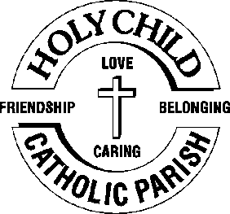
 5th April 2026

The Chimes

Dallas & Meadow Heights

EASTER SUNDAY
Sunday 5TH April, 2026

1st Reading: Acts 10:34, 37-43 2nd Reading: Colossians 3:1-4 Gospel: John 20:1-9

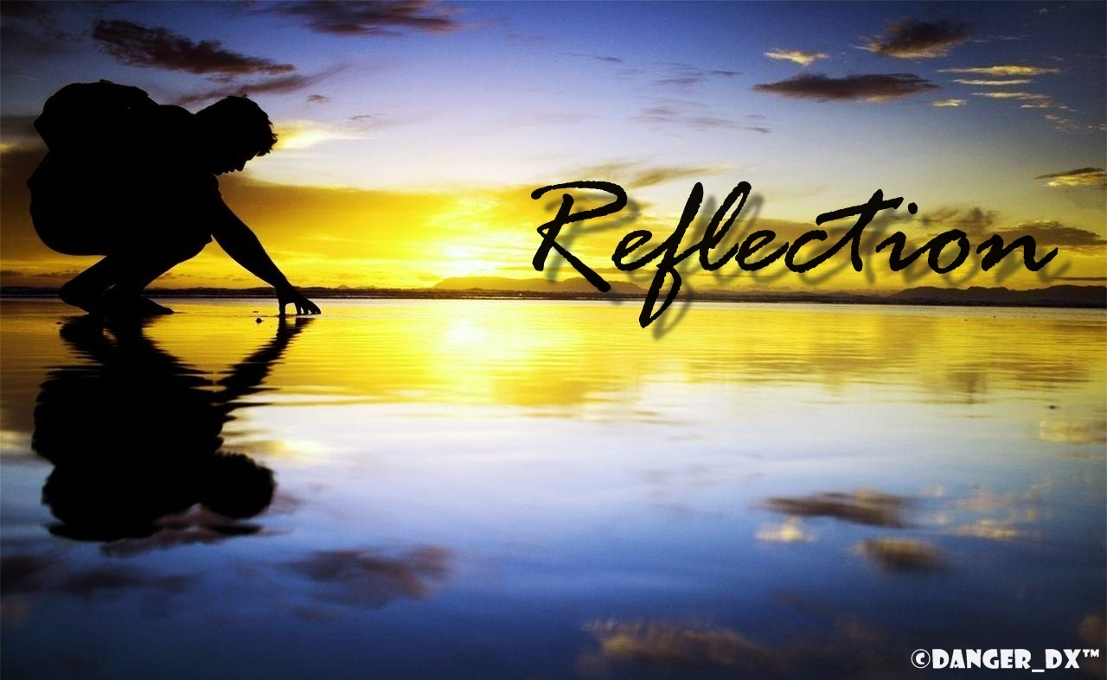
Parish Priest: Fr Joseph D.Truong
0415 455 845
Email: Joseph.DanhTruong@cam.org.au

Priest in Residence - Fr Fadhel Yakob
(Syriac Rites) 0433 833 647

Acting Parish Secretary: Joecy Taiafi
Parish Office: 115 Corinella Crescent, Dallas
Office Hours - Tuesday & Friday
9am—5pm (other times: By appointment with
Fr Joe 0415 455 845)

CHURCH: 227 Blair St, Dallas 3047

Parish Office:

115 Corinella Cres, Dallas, Vic 3047

Phone: 9412 8409
Email: dallas@cam.org.au
Website: https://www.melbcatholic.org/s/dallas

Parish House: 115 Corinella Cres. Dallas.

Acting School Principal: Mr. Aaron Kuras

School Office: 9309 1620

WEEKDAY MASSES:
Dallas: Tues - Fri. 9.15 am
1st Fri. Anointing Mass: Dallas 10 am

WEEKEND MASSES:
Sat. Dallas Vigil Mass 6.00 pm
Sun. Meadow Heights 9.00 am
Dallas 11.00 am
*Note: Vietnamese Mass
2nd Sunday of the Month: 9.00 am HFC
4th Sunday of the Month: 11.00 am HFC

RECONCILIATION
Dallas Saturday 5.15 - 5.45 pm
Thursday 8.45 - 9.00 am

LEGION OF MARY
Eng. Tues after 9.15am mass – Dallas
Viet. Sat. at 9 am at Holy Family Centre

ADORATION & BENEDICTION
Of the Blessed Sacrament
Fridays 8:45am (English) Dallas
1st.Friday 9.30 am before Mass
Fridays 6.30 pm (Viet) Holy Family Centre
Holy Hour: 5.30 – 6.30pm @ Meadow Heights

BAPTISMS
Contact Parish Office during office hours

WEDDINGS
Please contact Parish Office
Preferably 6 months before the wedding .

You could perhaps allow time to read over some of the many Scripture texts used over these three days. You could point out the unity of the three days and how the readings fit together. It is essentially one liturgy with various moments. It is not simply a re-enactment of the past but a way of drawing people into the present reality of the mystery of God. (Source: summit on-line)
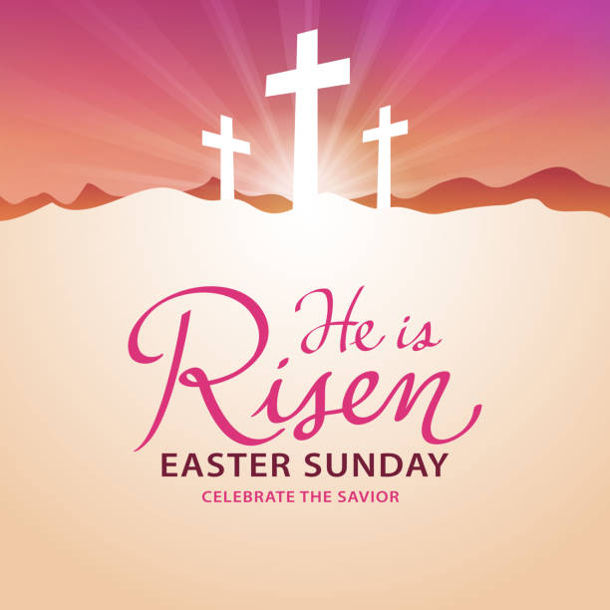

SECOND SUNDAY OF EASTER, Year A
Sunday 12TH APRIL, 2026

1st Reading: Acts 2:42-47
Responsorial Psalm: Ps 117
2nd Reading: 1 Peter 1:3-9
Gospel: John 20:19-31

Our cities are becoming more crowded yet more than ever before people are lonely. Sadly many travel on crowded trains and work in buildings full of people, yet feel left out. Jesus is telling us our role is to “reach out” even to people we don’t know and tell them they are part of our family. We are after all brothers and sisters with one Father.
If we do this then the “Kingdom is here” and Jesus is our king. If we don’t create the “kingdom “ here who can?

1st Reading: Isaiah:22:19-23; 2nd Reading: Romans 11:33-36; Gospel: Mathew 16:13-20

Responsorial Psalm: This is the day the Lord has made; let us rejoice and be glad.

Gospel Acclamation: Alleluia, alleluia!
Christ has become our paschal sacrifice; let us feast with joy in the Lord.
Alleluia!

BAPTISM PREPARATION AND BAPTISM DATES

Next Baptism Preparation Day Baptism Date:
Wednesday 6th May 2026 Sunday 7rd June, 2026

SCHEDULING APPTS WITH FR JOE
Please note that Parishioners are encouraged to schedule an appointment with Fr Joe as walk-in meetings are not always ideal.
Holy Child Parish….
Is committed to a safe nurturing culture for all our children.
BOOKING THE HOLY
FAMILY CENTRE
The Holy Family Centre is Available for any group or parishioners to book.
Please call the Parish Office
on 9412 8409 to make a booking.

(Names of the sick will only be printed for a month, unless the Office has been notified otherwise)
SICK: Joan Lobs, Shirley Martin, Adrian Zuccato, Nguyen Thi Thin, Le Thi Quy, Dina, Jack Ward,
Lien, Connie, Miriam Smith, Florentino Casimiro, Farif Ashlaq, Beaderez Lamoc.

REMEMBRANCES: Amelia Espiritu, Alfonso Espiritu, Teodoro Espiritu, Prudencio Espiritu, Vittorio Zuccato, Dawn Zuccato, Michael Muldowney, Arch Franklin, Joseph Peiris, Domingas Seixas Da Costa, Eithue Mary Daly, Carmelo Ciantar, Albina Da Costa, Jane Dulna, Jason Trubridge, Carmena Grech, Aurora Babo Cavalheira, Vicente Paloma, Brenda Fernandes, Anna Nguyen Thi Huy Loan

RECENT DEATHS: JOHN (JACK) WARD

all departed souls, the Souls in Purgatory and all those mentioned in the Book of Remembrance.

RECENT DEATH:

PLEASE KEEP THEM IN YOUR PRAYERS
Multi-Cultural Dinner Dance - 18 June
This major fundraiser is fast approaching. Tickets on sale after Mass. Organise a table with family/friends. A great family fun evening. Donations of cash/gift items for raffle/door prizes are most welcome. Help to set up on the day/before would be greatly appreciated. Ring the Office and leave your name. Help and support your Parish. Tickets also available at the Parish Office or above Committee Members.

Mass for Expectant Mothers-The Life, Marriage & Family Office warmly invite all expectant mothers and their families to the Mass for Expectant Mothers. The Mass will be celebrated by Archbishop Denis Hart at St Patrick's Cathedral on Sunday 5 June at 11.00am. Registrations can be made online at: www.cam.org.au/lifemarriagefamily or alternatively by contacting: 9287 5587 or Lmf@cam.org.au. Please note that registration closes on Friday 27 May. Expectant mothers who register will receive a small token of recognition.

DIVINE MERCY SUNDAY
The Liturgy Team has decided not to hold the Divine Mercy Sunday this year due to the lack of interest.

PARISH PASTORAL CALENDAR APRIL 2026

2 Holy Thursday 7 PM Mass @ Dallas.
3 Good Friday 10 AM Stations of the Cross @ Dallas; 3 PM Passion of the Lord @ Dallas.
4 Holy Saturday, 8:30 PM Mass @ Dallas
5 Easter Sunday 8:30 A M Mass (Croatian) @ Dallas; 9 AM Mass @ Meadow Heights; 11 AM Mass @ Dallas
8 Finance Meeting 6-7:30 PM @ Meadow Heights
15 Pastoral Council Meeting 6-7:30 PM @ Meadow Heights
17 Holy Hour, 5:30 PM – 6:30 PM @ Meadow Heights.
24 Holy Hour, 5:30 PM – 6:30 PM @ Meadow Heights.
29 School First Communion Information Evening 5:30 PM @ Dallas


Feast Day During the Week

Thanksgiving Collection
Loose: $545.15
Church (Actual): $1255
Church (Pledge): $1324.46
Presbytery (Actual): $817.35
Presbytery (Pledge): $950.55

Flowers Donated By

Nguyen Ke Phuc

Special Collection



-----------------------------------------------------------------------------------------------------------------------------------------------------------------------------------------------------------------------------------------------------------------------------------------------------------------------------------

COUNTING ROSTER FOR MARCH/APRIL 2026
Hai, Loan, An, | 28/3/26
Judy, Juanita, Mele & Sr V | 7/4/26
Hai, Loan, An | 14/4/26
Judy, Juanita, Mele & Sr V | 21/4/26

DALLAS CHURCH CLEANING ROSTER FOR APRIL 2026
Group | Names | Date
A | Mele, Sarah Kempen, Magina Musingarabul | 4-5 April
B | Viet Legion of Mary | 11-12 April
C | Sam & Vicky Buhagiar, Cynthia | 18-19 April
D | Van My Nguyen Family | 25-26 April

THIS Weekend ROSTERS: (4 - 5 April 2026)

 | (SAT) 6.00 pm | (SUN) 9.00 am | (SUN) 11.00 am
Readers | Follow the Holy Week Roster | Follow the Holy Week Roster | Follow the Holy Week Roster
Commentators
Special Ministers
Money Collectors | As Per | Volunteers | At Each Mass

NEXT Weekend ROSTERS: (11-12 April 2026)
 | (SAT) 6.00 pm | (SUN) 9.00 am | (SUN) 11.00 am
Readers | Damian | Chi Nhu | Adorabelle
Commentators | Sr Veronica | Martin | Cecilia
Special Ministers | Vicky |  | Mele
Money Collectors | As Per | Volunteers | At Each Mass

---------------------------------------------------------------------------------
ADVERTISEMENTS

THE ROAST HOUSE
162 Gladstone Park Shopping Centre PH: 0468 946 704
SPECIAL
Vietnamese Roll
Chicken Schnitzel Roll
Chicken Skewer
Fried Rice
Noodles + more

ADVERTISE YOUR BUSINESS HERE FOR $50 FOR 3 MONTHS

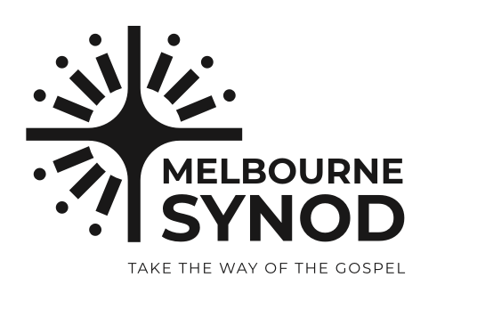
Convocation of the Melbourne Synod 2026
Parishes wishing to mark the convocation of the Melbourne Synod on the weekend of the third Sunday of Lent (7 and 8 March) may find the following resources useful:
· sample parish bulletin announcement
· prayer of the faithful
· prayer for the synod: Adsumus, Sancte Spiritus. This prayer may be helpful as a prayer after Communion at Mass, to commence meetings and for personal prayer
· homily notes compiled by Bishop Rene Ramirez
· link to frequently asked questions.
Sample bulletin announcement: weekend of 7 and 8 March
On the third Sunday of Lent, Archbishop Peter A Comensoli will formally convoke a Synod for the Archdiocese of Melbourne. The synod calls the Melbourne Church to journey together in communion, participation and mission, echoing Pope Francis’ vision of a ‘listening Church’ (Evangelii Gaudium, §31). Informed by Vatican II’s teaching, the Church is ‘a people made one with the unity of the Father, the Son, and the Holy Spirit’ (Lumen Gentium, §4).
There are three themes about which the church of Melbourne is being invited to discern:
· young discipleship
· missionary leadership
· formation and participation.
The synod assembly will be held across the weekend of 4–6 December 2026. Over these next months, a range of opportunities will be available for Melbourne Catholics to be part of the consultation process toward the synod. In the meantime, further information can be accessed at melbournecatholic.org/synod2026.
In the synodal Church ‘the whole community, in the free and rich diversity of its members, is called together to pray, listen, analyse, dialogue, discern and offer advice on taking pastoral decisions (ITC 68) for mission’ (Final Document, §87).

1. What is a Synod?
A Synod is a moment when the Church deliberately pauses to listen, pray, and discern together. It is not simply a meeting or a conference, but a spiritual process rooted in faith that the Holy Spirit continues to guide the Church today. In a Synod, we ask not only “What do we think?” but more importantly, “What is God asking of us at this moment in our mission?”

2. Where does the word “Synod” come from?
The word Synod comes from the Greek syn-hodos, meaning “walking together on the road.” This reminds us that the Christian life is never meant to be lived alone. Faith is a shared journey, where we support one another, listen to one another, and discern together how best to follow Christ.

3. Synodality is not new
Synodality is not a modern invention. From the earliest days of the Church, Christians gathered to pray, listen, and discern together. In the Acts of the Apostles, the Church faced difficult questions and resolved them not through power struggles, but through prayer, dialogue, and trust in the Holy Spirit.

