
 2nd November,2025

The Chimes

Dallas & Meadow Heights

SUNDAY 2ND NOVEMBER, 2025
The COMMEMORATION of ALL the FAITHFUL DEPARTED

1st Reading: Wisdom 3:1–9 2nd Reading: Romans 5: 5-11
Gospel: John 14: 1-6

Parish Priest: Fr Joseph D.Truong
0415 455 845
Email: Joseph.DanhTruong@cam.org.au

Priest in Residence - Fr Fadhel Yakob
(Syriac Rites) 0433 833 647

Parish Secretary: Carol McPherson
Office hours: Tuesday & Friday
9am—5pm (other times: By appointment with
Fr Joe 0415 455 845)

CHURCH: 227 Blair St, Dallas 3047

Parish Office & Holy Family Centre:

133 Malmsbury Dr, Meadow Heights

Phone: 9412 8409
Email: dallas@cam.org.au
Website: https://www.melbcatholic.org/s/dallas

Parish House: 115 Corinella Cres. Dallas.

School Principal: Mr. Alan Smith

School Office: 9309 1620

WEEKDAY MASSES:
Dallas: Tues - Fri. 9.15 am
1st Fri. Anointing Mass: Dallas 10 am

WEEKEND MASSES:
Sat. Dallas Vigil Mass 6.00 pm
Sun. Meadow Heights 9.00 am
Dallas 11.00 am
*Note: Vietnamese Mass
2nd Sunday of the Month: 9.00 am HFC
4th Sunday of the Month: 11.00 am HFC

RECONCILIATION
Dallas Saturday 5.15 - 5.45 pm
Thursday 8.45 - 9.00 am

LEGION OF MARY
Eng. Tues after 9.15am mass – Dallas
Viet. Sat. at 9 am at Holy Family Centre

ADORATION & BENEDICTION
Of the Blessed Sacrament
Fridays 8:45am (English) Dallas
1st.Friday 9.30 am before Mass
Fridays 6.30 pm (Viet) Holy Family Centre

BAPTISMS
Contact Parish Office during office hours

WEDDINGS
Please contact Parish Office
Preferably 6 months before the wedding .
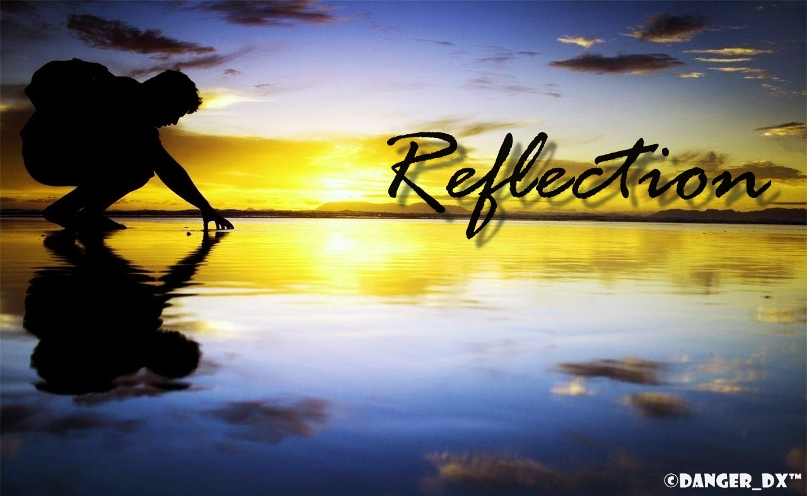

The practice of not only burying but praying for the dead has been a universal mainstay of human culture and religion throughout history. Many tombs of the early Christians bear inscriptions explicitly asking for prayers for their passage to eternal life. For this reason, it is an old practice that whenever passing a cemetery we pray these simple words: ‘May the Divine Assistance remain always with us and may the souls of the faithful departed through the mercy of God rest in peace.’ We do not approach death with despair or dread, however; a healthy reverence, perhaps, but never despair. We approach trusting in the extravagant hope Jesus himself held out to us: ‘whoever comes to me, I shall not turn him away’ (Jn 6:37).

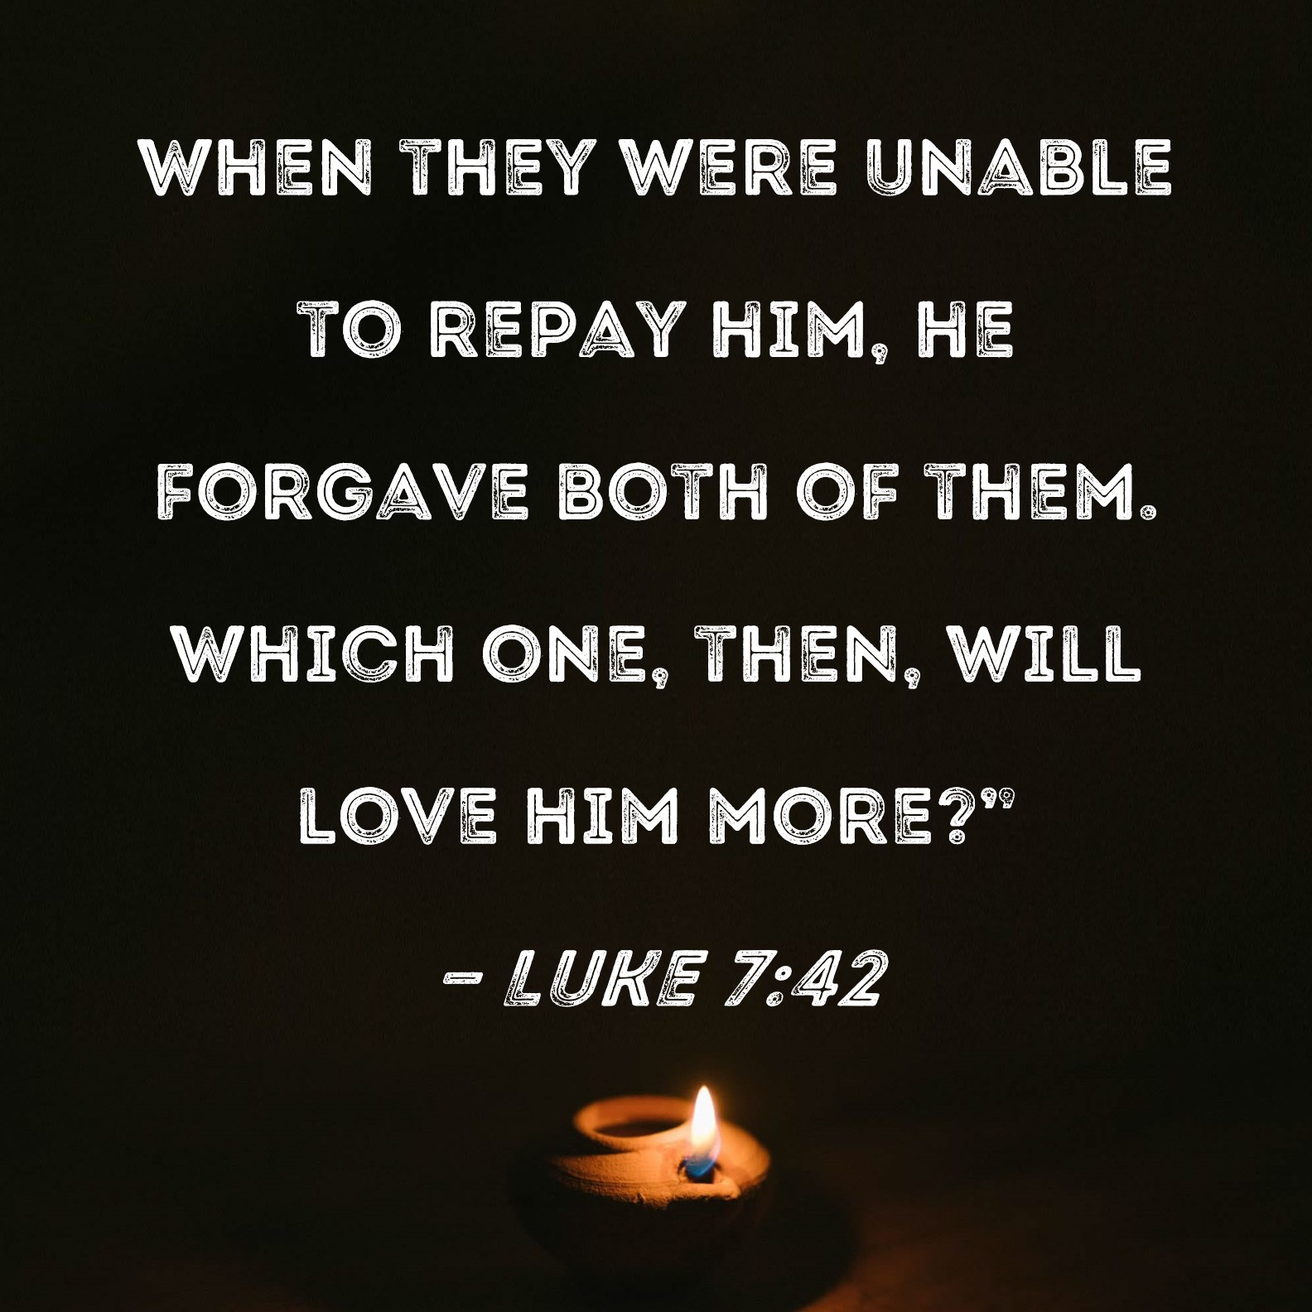

.

THE DEDICATION of the LATERAN BASILICA - year C
Sunday 9TH November, 2025

1st Reading: Ezek 47:1-2, 8-9, 12

Responsorial Psalm: Ps 45: 2-3, 5-6, 8-9

2nd Reading: 1 Cor 3: 9-11, 16-17

Gospel: Jn 2: 13-22

Our cities are becoming more crowded yet more than ever before people are lonely. Sadly many travel on crowded trains and work in buildings full of people, yet feel left out. Jesus is telling us our role is to “reach out” even to people we don’t know and tell them they are part of our family. We are after all brothers and sisters with one Father.
If we do this then the “Kingdom is here” and Jesus is our king. If we don’t create the “kingdom “ here who can?

1st Reading: Isaiah:22:19-23; 2nd Reading: Romans 11:33-36; Gospel: Mathew 16:13-20

Responsorial Psalm:
I will walk in the presence of the Lord in the land of the living.

Gospel Acclamation: Alleluia, Alleluia! Alleluia!
This is the will of my Father, says the Lord, all who believe in the Son will have eternal life, and I will raise them to life again on the last day. Allelulia!

Holy Child Parish….

Is committed to a safe nurturing culture for all our children.
HOLY CHILD PRIMARY SCHOOL – is in the process of establishing an Alumni platform and would love to reconnect with past students. If you have attended Holy Child Primary School, please reach out to the office on 9309 1620, and we will connect you with the appropriate staff member.

.

(Names of the sick will only be printed for a month, unless the Office has been notified otherwise)

SICK: Molly Knox, Joan Lobs, Shirley Martin, Adrian Zuccato, Nguyen Thi Thin, Le Thi Quy, Dina, Jack Ward,
Lien, Connie, Miriam Smith, Florentino Casimiro, Farif Ashlaq, M. Knox.

REMEMBRANCES: Paul & Carmen Busuttil and Family, Rita & John Teuma, Sally Iotanzio, Mary Teuma (and all the names written in the remembrance book)

The Souls in Purgatory, departed souls, and all deceased persons mentioned in the Book of Remembrance.

RECENT DEATHS: Molly Knox (Sr Veronica’s older sister)

all departed souls, the Souls in Purgatory and all those mentioned in the Book of Remembrance.

RECENT DEATH:

PLEASE KEEP THEM IN YOUR PRAYERS
Multi-Cultural Dinner Dance - 18 June
This major fundraiser is fast approaching. Tickets on sale after Mass. Organise a table with family/friends. A great family fun evening. Donations of cash/gift items for raffle/door prizes are most welcome. Help to set up on the day/before would be greatly appreciated. Ring the Office and leave your name. Help and support your Parish. Tickets also available at the Parish Office or above Committee Members.

Mass for Expectant Mothers-The Life, Marriage & Family Office warmly invite all expectant mothers and their families to the Mass for Expectant Mothers. The Mass will be celebrated by Archbishop Denis Hart at St Patrick's Cathedral on Sunday 5 June at 11.00am. Registrations can be made online at: www.cam.org.au/lifemarriagefamily or alternatively by contacting: 9287 5587 or Lmf@cam.org.au. Please note that registration closes on Friday 27 May. Expectant mothers who register will receive a small token of recognition.

BAPTISM PREPARATION AND
BAPTISM DATES
Baptism Preparation Day
Wednesday, 5th November
Holy Family Centre.
Baptism Date:
SUNDAY, 7th December

BOOKING THE HOLY
FAMILY CENTRE
The Holy Family Centre is Available for any group or parishioners to book.
Please call the Parish Office
on 9412 8409 to make a booking.
SCHEDULING APPTS WITH FR JOE
Please note that Parishioners are encouraged to schedule an appointment with Fr Joe as walk-in meetings are not always ideal.

VOLUNTARY ASSISTED DYING AND EUTHANASIA BILLS
Parishioners are encouraged to write to their local Member of Parliament and request that they vote against the proposed revised Voluntary Assisted Dying and Euthanasia Bill.

FR JOE’S ANNUAL LEAVE
During Fr Joe’s annual leave from 5th to 26th November, Mass will be held in the Parish only on Thursdays and Fridays on weekdays. There will be no Adoration or Benediction on Fridays.
Please note: Weekend Masses remain the same.

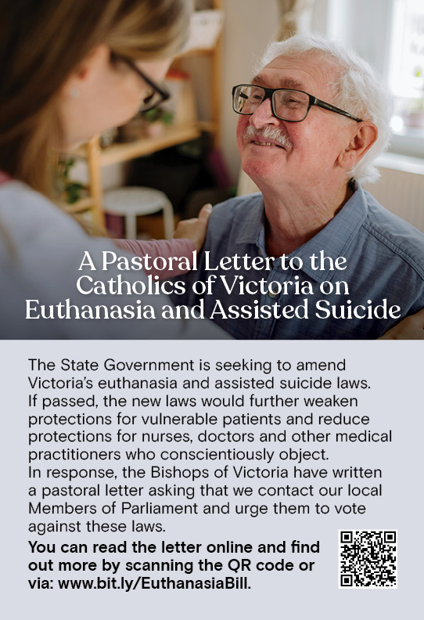


Feast Day During the Week
3 Nov – St Martin de Porres
4 Nov– St Charles Borromeo

Thanksgiving Collection
Loose: $525
Church (Actual): $1054.10
Church (Pledge): $1324.46
Presbytery (Actual): $655.40
Presbytery (Pledge): $950.55


Special Collection

For Australian Catholic Youth Festival $1598.65 (collection/fundraising/donations
Thank you!

Flowers Donated By

Profit – Raffle Tickets - $1009.60
Profit – Mugs & Pins - $1,090.73


-----------------------------------------------------------------------------------------------------------------------------------------------------------------------------------------------------------------------------------------------------------------------------------------------------------------------------------

COUNTING ROSTER FOR OCT/NOV/DEC 2025
Hai, Loan, An, Mai | ----- | 25 Nov
Judy, Juanita, Mele & Sr V | 4 Nov | 2 Dec
Hai, Loan, An, Mai | 11 Nov | 9 Dec
Judy, Juanita, Mele & Sr V | 18 Nov | 16 Dec

DALLAS CHURCH CLEANING ROSTER FOR NOV/DEC 2025
Group | Names | Date | Date
A | Mele &friends, Dong | ----- | 6/7 Dec
B | Damian & Sarah Kempen, Anita Barnabas, Magina Musingarabul | 8/9 Nov | 13/14 Dec
C | Viet Legion of Mary | 15/16 Nov | 20/21 Dec
D | Sam & Vicky Buhagiar, Cynthia Juico | 22/23 Nov | 27/28 Dec
E | Van My Nguyen Family | 29/30 Nov | 3/4 Jan 2026

THIS Weekend ROSTERS: (1-2 Nov 2025)

 | (SAT) 6.00 pm | (SUN) 9.00 am | (SUN) 11.00 am
Readers | Sr Veronica | Judy | Anita B
Commentators | Vicky B | Henry | Lahra
Special Ministers | Tuyet Nguyen | Juanita | Mele
Money Collectors | As Per | Volunteers | At Each Mass

NEXT Weekend ROSTERS: (8-9 Nov, 2025)
 | (SAT) 6.00 pm | (SUN) 9.00 am | (SUN) 11.00 am
Readers | Damian | Kim Oanh | Cynthia
Commentators | Hanh Nguyen | Phuong Loan | Lahra
Special Ministers | Vicky B | Volunteer | Adorabella
Money Collectors | As Per | Volunteers | At Each Mass

---------------------------------------------------------------------------------
ADVERTISEMENTS
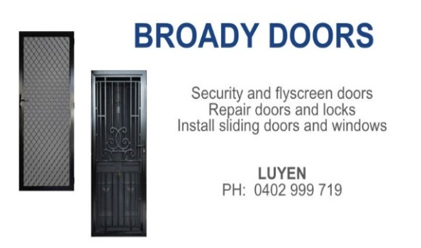

HAI CARPORT
Specialised In:
Fencing, Carport, Verandah, All Doors, Automatic Gates, Roller Doors,
Remote Control Doors & Gates
Contact: Hai (03) 9367 5520
Mob: 0423 971 568

THE ROAST HOUSE
162 Gladstone Park Shopping Centre PH: 0468 946 704
SPECIAL
Vietnamese Roll
Chicken Schnitzel Roll
Chicken Skewer
Fried Rice
Noodles + more

ADVERTISE YOUR BUSINESS HERE FOR $50 FOR 3 MONTHS

