
 12th October,2025

The Chimes

Dallas & Meadow Heights

28th SUNDAY IN ORDINARY TIME - YEAR C
SUNDAY 12th October, 2025

1st Reading: 2 Kg 5:14-17 2nd Reading: 2 Tim 2: 8-13
Gospel: Lk 17:11-19

Parish Priest: Fr Joseph D.Truong
0415 455 845
Email: Joseph.DanhTruong@cam.org.au

Priest in Residence - Fr Fadhel Yakob
(Syriac Rites) 0433 833 647

Parish Secretary: Carol McPherson
Office hours: Tuesday & Friday
9am—5pm (other times: By appointment with
Fr Joe 0415 455 845)

CHURCH: 227 Blair St, Dallas 3047

Parish Office & Holy Family Centre:

133 Malmsbury Dr, Meadow Heights

Phone: 9412 8409
Email: dallas@cam.org.au
Website: https://www.melbcatholic.org/s/dallas

Parish House: 115 Corinella Cres. Dallas.

School Principal: Mr. Alan Smith

School Office: 9309 1620

WEEKDAY MASSES:
Dallas: Tues - Fri. 9.15 am
1st Fri. Anointing Mass: Dallas 10 am

WEEKEND MASSES:
Sat. Dallas Vigil Mass 6.00 pm
Sun. Meadow Heights 9.00 am
Dallas 11.00 am
*Note: Vietnamese Mass
2nd Sunday of the Month: 9.00 am HFC
4th Sunday of the Month: 11.00 am HFC

RECONCILIATION
Dallas Saturday 5.15 - 5.45 pm
Thursday 8.45 - 9.00 am

LEGION OF MARY
Eng. Tues after 9.15am mass – Dallas
Viet. Sat. at 9 am at Holy Family Centre

ADORATION & BENEDICTION
Of the Blessed Sacrament
Fridays 8:45am (English) Dallas
1st.Friday 9.30 am before Mass
Fridays 6.30 pm (Viet) Holy Family Centre

BAPTISMS
Contact Parish Office during office hours

WEDDINGS
Please contact Parish Office
Preferably 6 months before the wedding .


This text conveys another teaching from Jesus about what real faith entails. It is not simply another miracle story. First, the lepers recognise their own need for healing—and it is this recognition that prompts them to cry out to Jesus and implore him for mercy. In their need, they turn to Jesus as their hope. He responds with compassion and sends them to the priests to fulfil Jewish law. Nine assumedly complete that journey and re-enter the religious and social world of the Jews. However, one does not continue with the priests and cultural practices of Israel. Instead, he turns back towards Jesus after realising the true source of his wholeness. The recognition that his salvation came through Jesus and not through the fulfilment of Jewish law is what assures him that he is saved. His response is appropriate: he falls to his knees, praising God loudly and thanking Jesus for all that he has done for him. The fact that he is a Samaritan, a foreigner, may have resonated with Luke’s community, which primarily comprised non-Jewish believers in Christ. (source: summit on line)

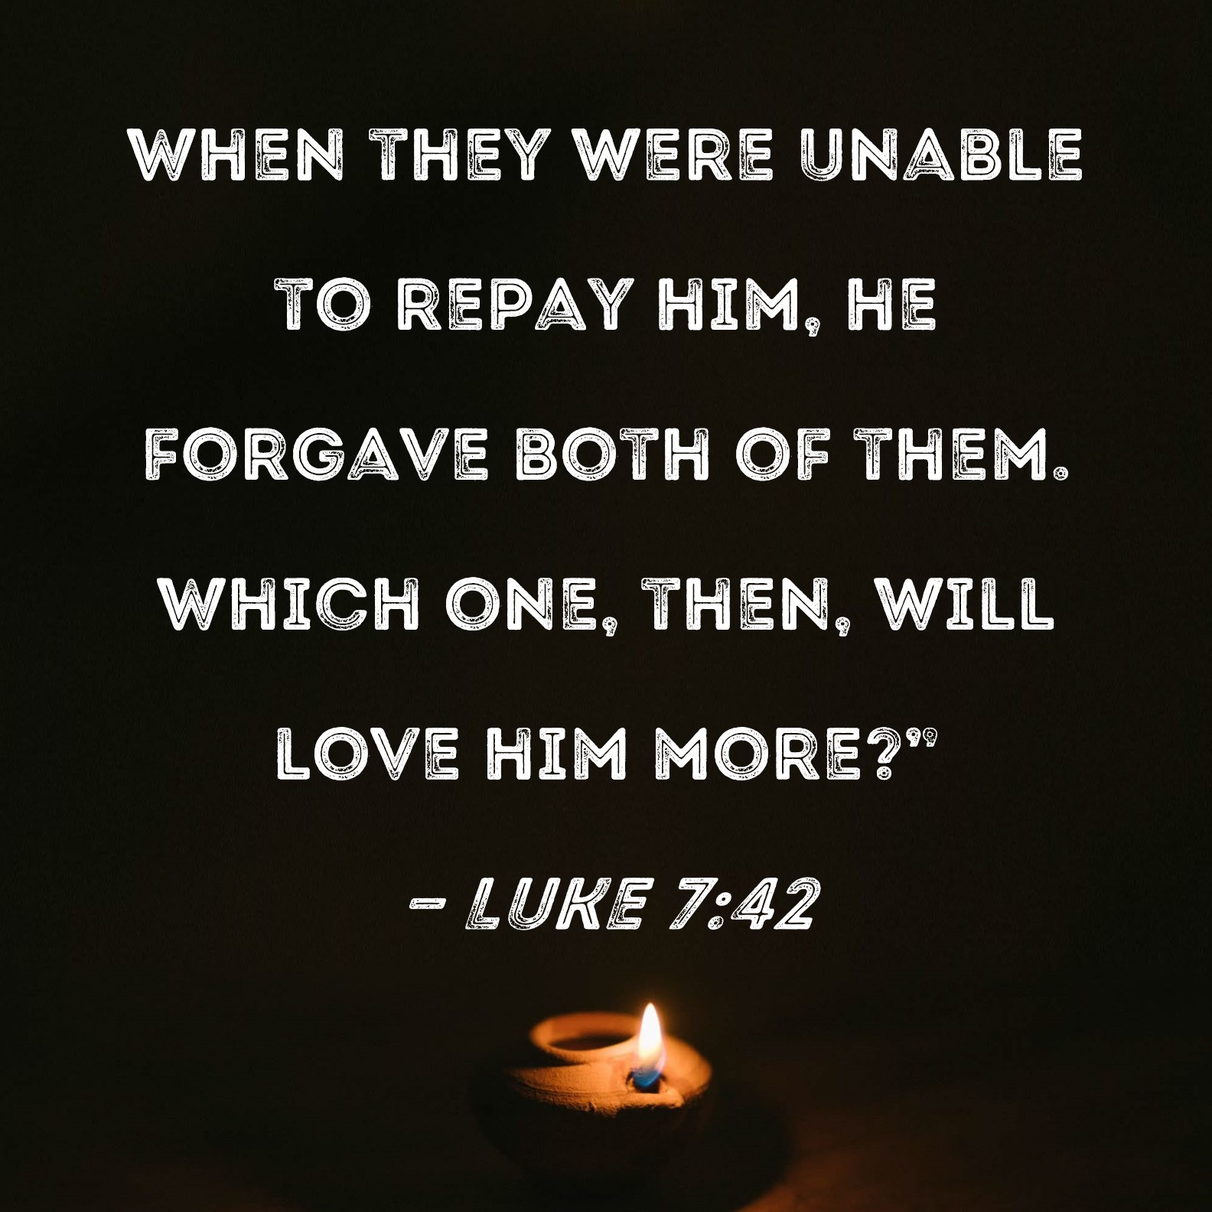

.

29th SUNDAY IN ORDINARY TIME - year C
Sunday 19th October, 2025

1st Reading: Ex 17: 8-13

Responsorial Psalm: Ps 120

2nd Reading: 2 Tim 3: 14 – 4:2

Gospel: Lk 18: 1 - 8

Our cities are becoming more crowded yet more than ever before people are lonely. Sadly many travel on crowded trains and work in buildings full of people, yet feel left out. Jesus is telling us our role is to “reach out” even to people we don’t know and tell them they are part of our family. We are after all brothers and sisters with one Father.
If we do this then the “Kingdom is here” and Jesus is our king. If we don’t create the “kingdom “ here who can?

1st Reading: Isaiah:22:19-23; 2nd Reading: Romans 11:33-36; Gospel: Mathew 16:13-20

Responsorial Psalm: The Lord has revealed to the nations his saving power.

Gospel Acclamation: . Alleluia, Alleluia! For all things give thanks to God, because this is what he expects of you in Christ Jesus. Alleluia!

Holy Child Parish….

Is committed to a safe nurturing culture for all our children.
HOLY CHILD PRIMARY SCHOOL – is in the process of establishing an Alumni platform and would love to reconnect with past students. If you have attended Holy Child Primary School, please reach out to the office on 9309 1620, and we will connect you with the appropriate staff member.

.

(Names of the sick will only be printed for a month, unless the Office has been notified otherwise)

SICK: Molly Knox, Joan Lobs, Shirley Martin, Adrian Zuccato, Nguyen Thi Thin, Le Thi Quy, Dina, Jack Ward,
Lien, Connie, Miriam Smith, Florentino Casimiro, Farif Ashlaq.

REMEMBRANCES: Rita Exposto, Carmelo Ruffino, Antonio Serra, Yne Bay, Setefano Tapu, Amelia Espiritu, Gerard McKenna, Doris Staface, Sridharan (A), Maria Vella (B), Anna Nguyen Thi Hiep, Dawn Zuccato.

The Souls in Purgatory, departed souls, and all deceased persons mentioned in the Book of Remembrance.

RECENT DEATHS:

all departed souls, the Souls in Purgatory and all those mentioned in the Book of Remembrance.

RECENT DEATH:

PLEASE KEEP THEM IN YOUR PRAYERS
Multi-Cultural Dinner Dance - 18 June
This major fundraiser is fast approaching. Tickets on sale after Mass. Organise a table with family/friends. A great family fun evening. Donations of cash/gift items for raffle/door prizes are most welcome. Help to set up on the day/before would be greatly appreciated. Ring the Office and leave your name. Help and support your Parish. Tickets also available at the Parish Office or above Committee Members.

Mass for Expectant Mothers-The Life, Marriage & Family Office warmly invite all expectant mothers and their families to the Mass for Expectant Mothers. The Mass will be celebrated by Archbishop Denis Hart at St Patrick's Cathedral on Sunday 5 June at 11.00am. Registrations can be made online at: www.cam.org.au/lifemarriagefamily or alternatively by contacting: 9287 5587 or Lmf@cam.org.au. Please note that registration closes on Friday 27 May. Expectant mothers who register will receive a small token of recognition.

BAPTISM PREPARATION AND
BAPTISM DATES
Baptism Preparation Day
Wednesday, 5th November
Holy Family Centre.
Baptism Date:
SUNDAY, 7th December

BOOKING THE HOLY
FAMILY CENTRE
The Holy Family Centre is Available for any group or parishioners to book.
Please call the Parish Office
on 9412 8409 to make a booking.

DIRECT DEBIT & CREDIT CARD CONTRIBUTORS
If you notice anything unusual on your bank statement related to your pledge to our parish, please contact the parish office promptly. We will investigate the matter for you. Thank you!

SCHEDULING APPTS WITH FR JOE
Please note that Parishioners are encouraged to schedule an appointment with Fr Joe as walk-in meetings are not always ideal.

MASS OFFERING ENVELOPES
A very gentle reminder – Please do not put mass offering envelopes in the collection bags. Please give them directly to Fr Joe.
Thank you!


Feast Day During the Week
14 Oct – St Callistus I, Pope
15 Oct – St Teresa of Jesus, Virgin
16 Oct – St Margaret Mary Alacoque, St Hedwig
17 Oct – St Ignatius of Antioch
18 Oct – St Luke, Evangelist

Thanksgiving Collection
Loose: $410.2
Church (Actual): $870
Church (Pledge): $1324.46
Presbytery (Actual): $1042
Presbytery (Pledge): $950.55


Flowers Donated By

--------

Special Collection

---------
--------




-----------------------------------------------------------------------------------------------------------------------------------------------------------------------------------------------------------------------------------------------------------------------------------------------------------------------------------

COUNTING ROSTER FOR SEPT/NOV 2025
Hai, Loan, An, Mai | ------- | 28 Oct
Judy, Juanita, Mele & Sr V | ----- | 4 Nov
Hai, Loan, An, Mai | 14 Oct | 11 Nov
Judy, Juanita, Mele & Sr V | 21 Oct | 18 Not

DALLAS CHURCH CLEANING ROSTER FOR SEPT/NOV 2025
Group | Names | Date | Date
A | Mele &friends, Dong | ------ | 1/2 Nov
B | Damian & Sarah Kempen, Anita Barnabas, Magina Musingarabul | ----- | 8/9 Nov
C | Viet Legion of Mary | ------ | 15/16 Nov
D | Sam & Vicky Buhagiar, Cynthia Juico | 18/19 Oct | 22/23 Nov
E | Van My Nguyen Family | 25/26 Oct | 29/30 Nov

THIS Weekend ROSTERS: (11-12 Oct, 2025)

 | (SAT) 6.00 pm | (SUN) 9.00 am | (SUN) 11.00 am
Readers | Special Roster | Hai Vu | Lahra
Commentators | Special Roster | Thuy Pell | Adorabella
Special Ministers | Special Roster | Volunteer | Jacinto Juico
Money Collectors | As Per | Volunteers | At Each Mass

NEXT Weekend ROSTERS: (18-19 Oct, 2025)
 | (SAT) 6.00 pm | (SUN) 9.00 am | (SUN) 11.00 am
Readers | Damian | Dhan Tri Pham | Cynthia
Commentators | Vicky B | Judy | Lahra
Special Ministers | Tuyet Nguyen | Taafoanga | Adorabella
Money Collectors | As Per | Volunteers | At Each Mass

---------------------------------------------------------------------------------
ADVERTISEMENTS
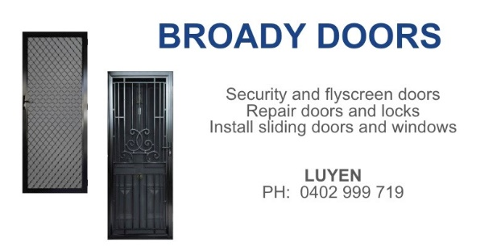

HAI CARPORT
Specialised In:
Fencing, Carport, Verandah, All Doors, Automatic Gates, Roller Doors,
Remote Control Doors & Gates
Contact: Hai (03) 9367 5520
Mob: 0423 971 568

THE ROAST HOUSE
162 Gladstone Park Shopping Centre PH: 0468 946 704
SPECIAL
Vietnamese Roll
Chicken Schnitzel Roll
Chicken Skewer
Fried Rice
Noodles + more

ADVERTISE YOUR BUSINESS HERE FOR $50 FOR 3 MONTHS

