
 19th October,2025

The Chimes

Dallas & Meadow Heights

29th SUNDAY IN ORDINARY TIME - YEAR C
SUNDAY 19th October, 2025

1st Reading: Ex 17: 8-13 2nd Reading: 2 Tim 3: 14 – 4:2
Gospel: Lk 18: 1 - 8

Parish Priest: Fr Joseph D.Truong
0415 455 845
Email: Joseph.DanhTruong@cam.org.au

Priest in Residence - Fr Fadhel Yakob
(Syriac Rites) 0433 833 647

Parish Secretary: Carol McPherson
Office hours: Tuesday & Friday
9am—5pm (other times: By appointment with
Fr Joe 0415 455 845)

CHURCH: 227 Blair St, Dallas 3047

Parish Office & Holy Family Centre:

133 Malmsbury Dr, Meadow Heights

Phone: 9412 8409
Email: dallas@cam.org.au
Website: https://www.melbcatholic.org/s/dallas

Parish House: 115 Corinella Cres. Dallas.

School Principal: Mr. Alan Smith

School Office: 9309 1620

WEEKDAY MASSES:
Dallas: Tues - Fri. 9.15 am
1st Fri. Anointing Mass: Dallas 10 am

WEEKEND MASSES:
Sat. Dallas Vigil Mass 6.00 pm
Sun. Meadow Heights 9.00 am
Dallas 11.00 am
*Note: Vietnamese Mass
2nd Sunday of the Month: 9.00 am HFC
4th Sunday of the Month: 11.00 am HFC

RECONCILIATION
Dallas Saturday 5.15 - 5.45 pm
Thursday 8.45 - 9.00 am

LEGION OF MARY
Eng. Tues after 9.15am mass – Dallas
Viet. Sat. at 9 am at Holy Family Centre

ADORATION & BENEDICTION
Of the Blessed Sacrament
Fridays 8:45am (English) Dallas
1st.Friday 9.30 am before Mass
Fridays 6.30 pm (Viet) Holy Family Centre

BAPTISMS
Contact Parish Office during office hours

WEDDINGS
Please contact Parish Office
Preferably 6 months before the wedding .


It is unusual for an evangelist to be so explicit about the meaning of a parable; however, in this text, Luke states that this parable is ‘about the need to pray continually and never lose heart’. Those who listened to Jesus recount the story in this text were likely familiar with judges, who were a law unto themselves and who did not dispense justice according to the demands of God and the Jewish law. Yet even these people will be persuaded to act in the face of persistence. As is typical in the Gospel of Luke, it is not the rich and powerful who prevail, but rather the poor and the weak—in this case, a widow. How much more, then, will God act? He is not like the wicked judge; he will hear the persistent cries of people, especially those of the poor, and not delay in answering. The real test of our faith is to accept that God may answer our prayers in ways we do not expect or even desire. Prayer does not equate to making demands of God. Instead, it involves an openness to God’s presence in our lives and a willingness to accept whatever he demands of us. (source: summit on line)

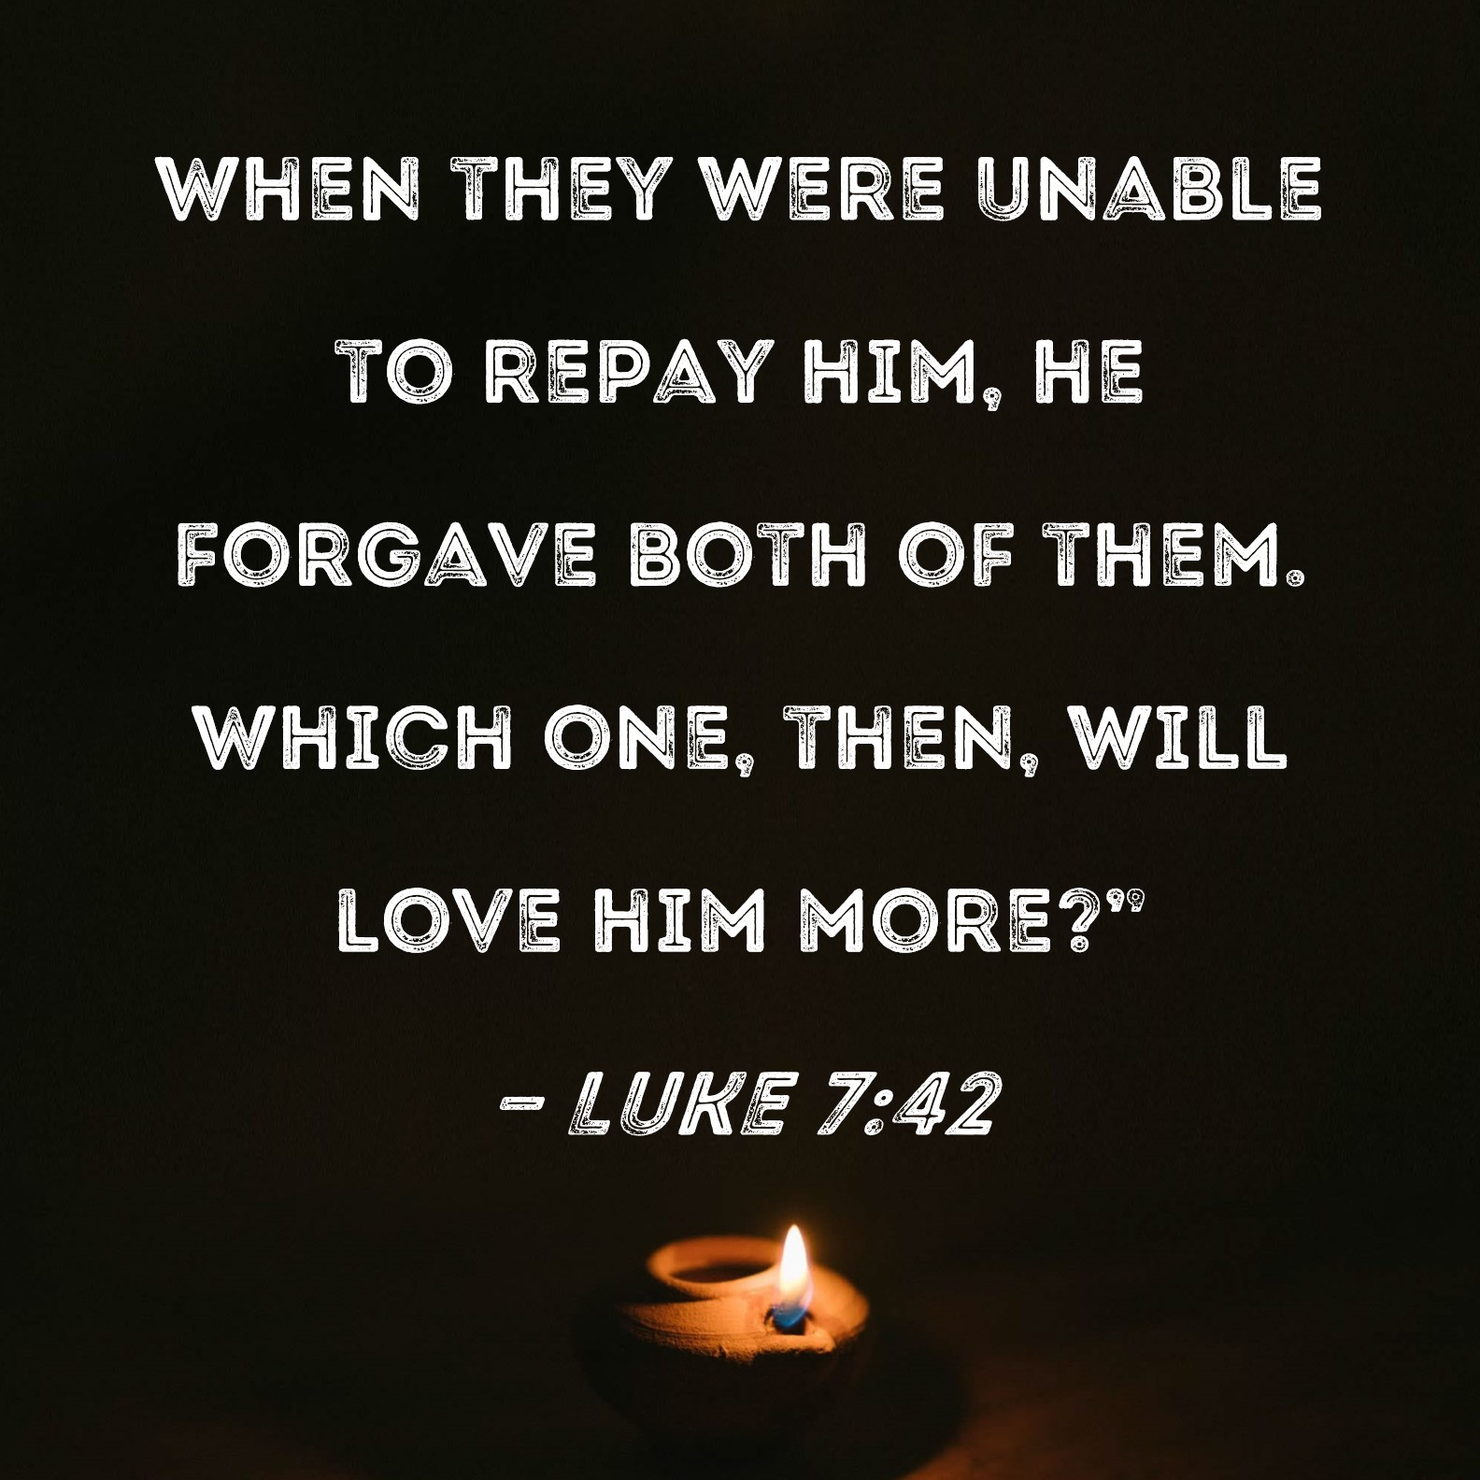

.

30th SUNDAY IN ORDINARY TIME - year C
Sunday 26th October, 2025

1st Reading: Sirach 35: 12-14, 16-19

Responsorial Psalm: Ps. 33: 2-3, 17-19, 23

2nd Reading: 2 Tim 4: 6-8, 16-18

Gospel: Lk 18: 9-14

Our cities are becoming more crowded yet more than ever before people are lonely. Sadly many travel on crowded trains and work in buildings full of people, yet feel left out. Jesus is telling us our role is to “reach out” even to people we don’t know and tell them they are part of our family. We are after all brothers and sisters with one Father.
If we do this then the “Kingdom is here” and Jesus is our king. If we don’t create the “kingdom “ here who can?

1st Reading: Isaiah:22:19-23; 2nd Reading: Romans 11:33-36; Gospel: Mathew 16:13-20

Responsorial Psalm: Our help is from the Lord, who made heaven and earth.

Gospel Acclamation: Alleluia, Alleluia! The word of God is living and active; it probes the thoughts and motives of our heart. Alleluia!

Holy Child Parish….

Is committed to a safe nurturing culture for all our children.
HOLY CHILD PRIMARY SCHOOL – is in the process of establishing an Alumni platform and would love to reconnect with past students. If you have attended Holy Child Primary School, please reach out to the office on 9309 1620, and we will connect you with the appropriate staff member.

.

(Names of the sick will only be printed for a month, unless the Office has been notified otherwise)

SICK: Molly Knox, Joan Lobs, Shirley Martin, Adrian Zuccato, Nguyen Thi Thin, Le Thi Quy, Dina, Jack Ward,
Lien, Connie, Miriam Smith, Florentino Casimiro, Farif Ashlaq.

REMEMBRANCES: Maria Madalena Nguyen Thi Phong, Josephine Busuttil, Thomas Chinh Nguyen, Maria Reim Nguyen, Annunziata Vassallo, Albert Leaney, Mariano, Mariana, Tome Andrade, Shirley Roberts,
Bert Gribble, Joan Glover,John Douglas Francke (A), Bruno, Luis Xavier Caldoho, Mark Robertson,
Efren Blanco, Roy Jayawardena, Lucia Dinh Thi Piuh.

The Souls in Purgatory, departed souls, and all deceased persons mentioned in the Book of Remembrance.

RECENT DEATHS: Joe Sciberras

all departed souls, the Souls in Purgatory and all those mentioned in the Book of Remembrance.

RECENT DEATH:

PLEASE KEEP THEM IN YOUR PRAYERS
Multi-Cultural Dinner Dance - 18 June
This major fundraiser is fast approaching. Tickets on sale after Mass. Organise a table with family/friends. A great family fun evening. Donations of cash/gift items for raffle/door prizes are most welcome. Help to set up on the day/before would be greatly appreciated. Ring the Office and leave your name. Help and support your Parish. Tickets also available at the Parish Office or above Committee Members.

Mass for Expectant Mothers-The Life, Marriage & Family Office warmly invite all expectant mothers and their families to the Mass for Expectant Mothers. The Mass will be celebrated by Archbishop Denis Hart at St Patrick's Cathedral on Sunday 5 June at 11.00am. Registrations can be made online at: www.cam.org.au/lifemarriagefamily or alternatively by contacting: 9287 5587 or Lmf@cam.org.au. Please note that registration closes on Friday 27 May. Expectant mothers who register will receive a small token of recognition.

BAPTISM PREPARATION AND
BAPTISM DATES
Baptism Preparation Day
Wednesday, 5th November
Holy Family Centre.
Baptism Date:
SUNDAY, 7th December

SCHEDULING APPTS WITH FR JOE
Please note that Parishioners are encouraged to schedule an appointment with Fr Joe as walk-in meetings are not always ideal.
BOOKING THE HOLY
FAMILY CENTRE
The Holy Family Centre is Available for any group or parishioners to book.
Please call the Parish Office
on 9412 8409 to make a booking.

VOLUNTARY ASSISTED DYING AND EUTHANASIA BILLS
Parishioners are encouraged to write to their local Member of Parliament and request that they vote against the proposed revised Voluntary Assisted Dying and Euthanasia Bill.

PARISH FEAST DAY MASS & DINNER
Thank you to everyone for your support and participation in the Parish Feast Day
mass and dinner. It was a successful event enjoyed by all. The proceeds from the
Parish Feast Day will be announced next weekend.

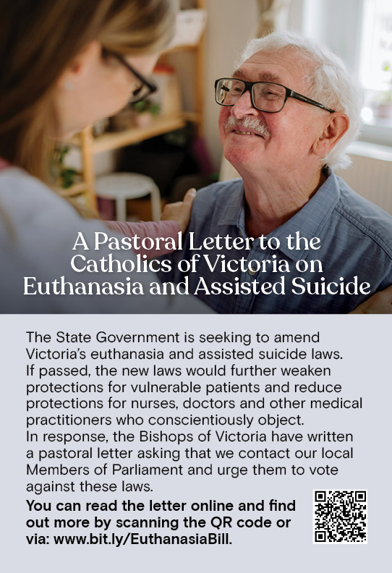

All SAINTS DAY
This year, All Saints Day falls on
Saturday, 1 November. All Saints Day Mass will be at 10 AM, Dallas, Saturday, 1 November.

All SOULS DAY
All Souls Day occurs on Sunday, 2 November. Parishioners are encouraged to bring photos of their deceased loved ones when attending the Vigil 6PM Mass on Saturday, 1 November, and at all other Sunday Masses.


Feast Day During the Week
22 Oct – St John Paul II, Pope
23 Oct – St John of Capistrano
24 Oct – St Anthony Mary Claret
25 Oct – Blessed Virgin Mary

Thanksgiving Collection
Loose: $592
Church (Actual): $927
Church (Pledge): $1324.46
Presbytery (Actual): $558.80
Presbytery (Pledge): $950.55


Flowers Donated By

Mrs Hoi & Oanh Nguyen

Special Collection

---------
--------

Thank you! Veggie group for your

generous donation of $500


-----------------------------------------------------------------------------------------------------------------------------------------------------------------------------------------------------------------------------------------------------------------------------------------------------------------------------------

COUNTING ROSTER FOR SEPT/NOV 2025
Hai, Loan, An, Mai | ------- | 28 Oct
Judy, Juanita, Mele & Sr V | ----- | 4 Nov
Hai, Loan, An, Mai | ------- | 11 Nov
Judy, Juanita, Mele & Sr V | 21 Oct | 18 Not

DALLAS CHURCH CLEANING ROSTER FOR SEPT/NOV 2025
Group | Names | Date | Date
A | Mele &friends, Dong | ------ | 1/2 Nov
B | Damian & Sarah Kempen, Anita Barnabas, Magina Musingarabul | ----- | 8/9 Nov
C | Viet Legion of Mary | ------ | 15/16 Nov
D | Sam & Vicky Buhagiar, Cynthia Juico | ------- | 22/23 Nov
E | Van My Nguyen Family | 25/26 Oct | 29/30 Nov

THIS Weekend ROSTERS: (18-19 Oct, 2025)

 | (SAT) 6.00 pm | (SUN) 9.00 am | (SUN) 11.00 am
Readers | Damian | Dhan Tri Pham | Cynthia
Commentators | Vicky B | Judy | Lahra
Special Ministers | Tuyet Nguyen | Taafoanga | Adorabella
Money Collectors | As Per | Volunteers | At Each Mass

NEXT Weekend ROSTERS: (25-16 Oct, 2025)
 | (SAT) 6.00 pm | (SUN) 9.00 am | (SUN) 11.00 am
Readers | Thien | Juanita | Tuyen Quang & Thom Nguyen
Commentators | Damian | Henry | Khanh Nguyen
Special Ministers | Vicky B | Judy | Volunteer
Money Collectors | As Per | Volunteers | At Each Mass

---------------------------------------------------------------------------------
ADVERTISEMENTS


HAI CARPORT
Specialised In:
Fencing, Carport, Verandah, All Doors, Automatic Gates, Roller Doors,
Remote Control Doors & Gates
Contact: Hai (03) 9367 5520
Mob: 0423 971 568

THE ROAST HOUSE
162 Gladstone Park Shopping Centre PH: 0468 946 704
SPECIAL
Vietnamese Roll
Chicken Schnitzel Roll
Chicken Skewer
Fried Rice
Noodles + more

ADVERTISE YOUR BUSINESS HERE FOR $50 FOR 3 MONTHS

