
 23rd March 2025

The Chimes

Dallas & Meadow Heights

THIRD SUNDAY IN LENT, YEAR C

1st Reading: Ex 3:1-8, 13-15 2nd Reading: 1 Cor 10: 1-6, 10-12

Gospel: Luke 13: 1-9

Parish Priest: Fr Joseph D.Truong
0415 455 845
Email: Joseph.DanhTruong@cam.org.au

Priest in Residence - Fr Fadhel Yakob
(Syriac Rites) 0433 833 647

Parish Secretary: Carol McPherson
Office hours: Tuesday & Friday
9am—5pm (other times: By appointment with
Fr Joe 0415 455 845)

CHURCH: 227 Blair St, Dallas 3047

Parish Office & Holy Family Centre:

133 Malmsbury Dr, Meadow Heights

Phone: 9412 8409
Email: dallas@cam.org.au
Website: https://www.melbcatholic.org/s/dallas

Parish House: 115 Corinella Cres. Dallas.

School Principal: Mr. Alan Smith

School Office: 9309 1620

WEEKDAY MASSES:
Dallas: Tues - Fri. 9.15 am
1st Fri. Anointing Mass: Dallas 10 am

WEEKEND MASSES:
Sat. Dallas Vigil Mass 6.00 pm
Sun. Meadow Heights 9.00 am
Dallas 11.00 am
*Note: Vietnamese Mass
2nd Sunday of the Month: 9.00 am HFC
4th Sunday of the Month: 11.00 am HFC

RECONCILIATION
Dallas Saturday 5.15 - 5.45 pm
Thursday 8.45 - 9.00 am

LEGION OF MARY
Eng. Tues after 9.15am mass – Dallas
Viet. Sat. at 9 am at Holy Family Centre

ADORATION & BENEDICTION
Of the Blessed Sacrament
Fridays 8:45am (English) Dallas
1st.Friday 9.30 am before Mass
Fridays 6.30 pm (Viet) Holy Family Centre

BAPTISMS
Contact Parish Office during office hours

WEDDINGS
Please contact Parish Office
Preferably 6 months before the wedding .


The role of Moses prefigures the role of Jesus. Through Moses God saved his people, Israel, from slavery in Egypt. We are the new people of God, saved through the waters of baptism from the slavery of sin, and new en route under the leadership of Jesus to the promised land of eternal life. We too are fed with food ‘from heaven’, namely the Eucharist.

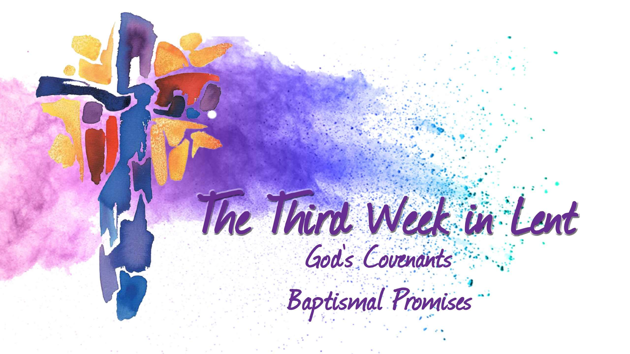

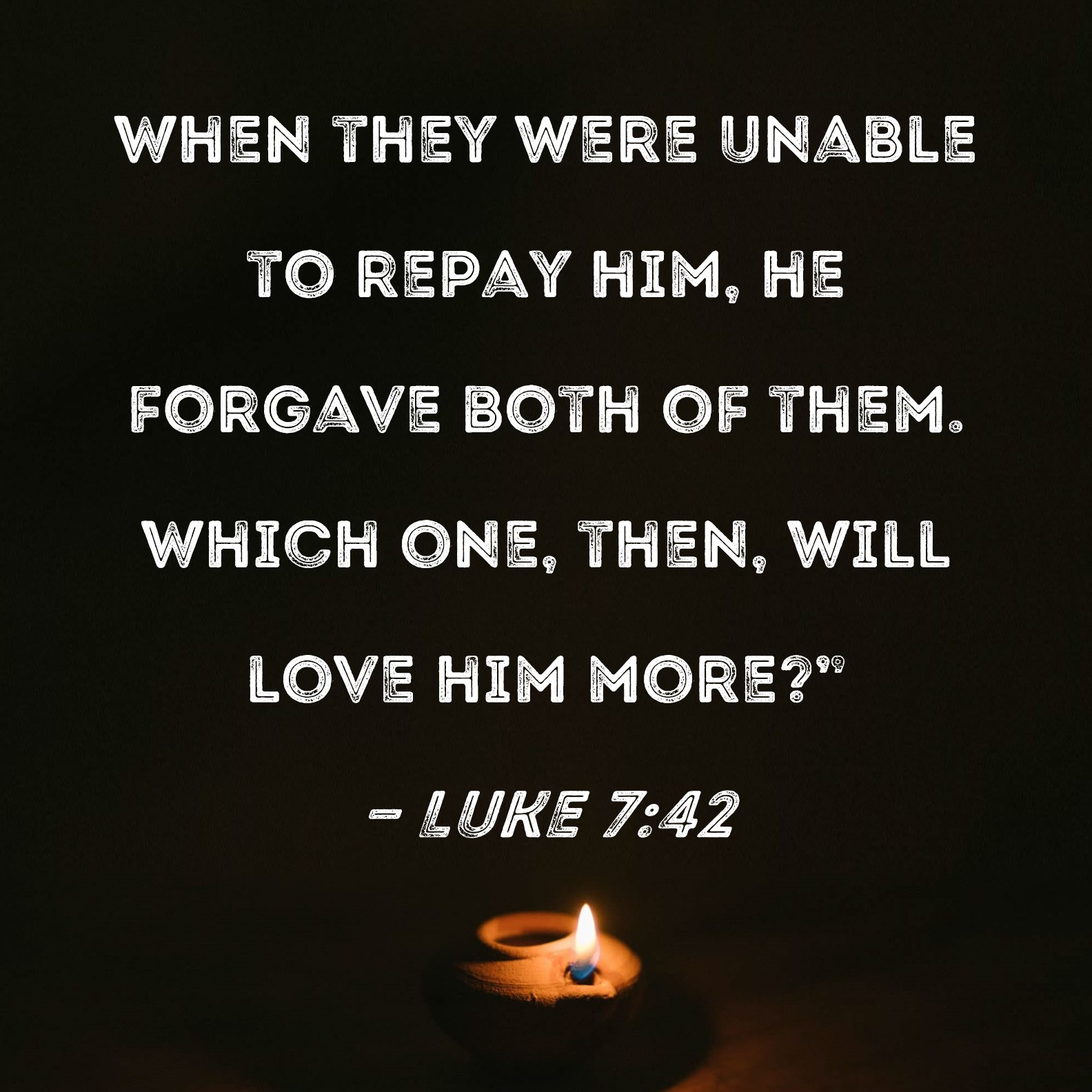

.

FOURTH SUNDAY IN LENT
YEAR C – Sunday 30th March, 2025

1st Reading: Joshua 5: 9-12
Responsorial Psalm:
Ps 33:2-7
2nd Reading: 2 Cor 5: 17-21
Gospel: Luke 15: 1-3, 11-32

Our cities are becoming more crowded yet more than ever before people are lonely. Sadly many travel on crowded trains and work in buildings full of people, yet feel left out. Jesus is telling us our role is to “reach out” even to people we don’t know and tell them they are part of our family. We are after all brothers and sisters with one Father.
If we do this then the “Kingdom is here” and Jesus is our king. If we don’t create the “kingdom “ here who can?

1st Reading: Isaiah:22:19-23; 2nd Reading: Romans 11:33-36; Gospel: Mathew 16:13-20

Entrance Antiphon: O Lord, hear my voice, for I have called to you; be my help. Do not abandon or forsake me, O God, my Saviour!
Responsorial Psalm: The Lord is kind and merciful.

Gospel Acclamation: Glory to you, Word of God, Lord Jesus Christ. Repent, says the Lord; the kingdom of heaven is at hand.
Glory to you, Word of God, Lord Jesus Christ.

BEING PILGRIMS OF HOPE IN THE WORLD
This hope is not optimism. It is not a forces positivity in the face of hardship and evil. It is a grace from God, a trust in the Lord’s promises: that he is good, that he is merciful, and that we are journeying towards the one who says, ‘Look, I am making everything new’ (Rev 21:5).

Pope’s intentions for March 2025- for families in crisis

For families in crisis. Let us pray that broken families might discover the cure for their wounds through forgiveness, rediscovering each other’s gifts even in their differences.

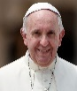
Holy Child Parish….

Is committed to a safe nurturing culture for all our children.

(Names of the sick will only be printed for a month, unless the Office has been notified otherwise)

SICK: Molly Knox, Joan Lobs, Shirley Martin, Adrian Zuccato, Nguyen Thi Thin, Le Thi Quy, Dina, Jack Ward, Lien, Connie
REMEMBRANCES: Tony Pace, Salvu Grech, Cesare Di Gregorio, Alice Custodid, Alex Hoang Nguyen, Rev P Alessio Galea, Brian Ward, Max Crossin, Ben Hollioake, Pasquale Villella, Giuse Nguyen Van Huam, Mario Teuma, the Teuma family & the Busuttil family.

The Souls in Purgatory, departed souls, and all deceased persons mentioned in the Book of Remembrance.

RECENT DEATHS:

all departed souls, the Souls in Purgatory and all those mentioned in the Book of Remembrance.

RECENT DEATH:

PLEASE KEEP THEM IN YOUR PRAYERS
Multi-Cultural Dinner Dance - 18 June
This major fundraiser is fast approaching. Tickets on sale after Mass. Organise a table with family/friends. A great family fun evening. Donations of cash/gift items for raffle/door prizes are most welcome. Help to set up on the day/before would be greatly appreciated. Ring the Office and leave your name. Help and support your Parish. Tickets also available at the Parish Office or above Committee Members.

Mass for Expectant Mothers-The Life, Marriage & Family Office warmly invite all expectant mothers and their families to the Mass for Expectant Mothers. The Mass will be celebrated by Archbishop Denis Hart at St Patrick's Cathedral on Sunday 5 June at 11.00am. Registrations can be made online at: www.cam.org.au/lifemarriagefamily or alternatively by contacting: 9287 5587 or Lmf@cam.org.au. Please note that registration closes on Friday 27 May. Expectant mothers who register will receive a small token of recognition.

LENTEN REFLECTION – Every Wednesday starting Wednesday, 12th March at 9.45am in Holy Child Catholic Church, Dallas
Stations of the Cross – Every Friday during Lent
9.45am – Holy Child Catholic Church, Dallas (English)
5.30pm – Holy Family Centre, Meadow Heights (English)
6.30pm – Holy Family Centre, Meadow Heights (Vietnamese)

OFFERTORY GIVING PROGRAM.
Dear Parishioners,
As we continue our parish offertory renewal, we invite those who have not yet returned their Pledge Cards to do so. You may place your completed card in the offertory collection, or drop it off at the parish office. If you were unable to collect a Pledge Pack, generic Pledge Cards are available on the pews this weekend. These can be filled out and returned immediately during Mass.
Thank you for your generosity and commitment to our parish community. Every offering, no matter the amount, is an expression of love and gratitude to God. Your support ensures that our parish can continue to serve and grow in faith together.
2nd RITE OF RECONCILIATION
Tuesday 1st April, 2025 at 7.00pm

-----------------------------------------------------------------------------------------------------------------------------------------------
RAFFLE TICKETS – WILL BE DRAWN ON PALM SUNDAY 13TH APRIL, 2025 AT 9.00AM PARISH MASS, MEADOW HEIGHTS

Thanksgiving
Collection
Church Offering: $1115.95
Presbytery: $578.35
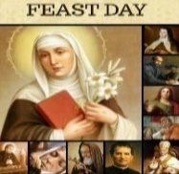
Feast Day’s During the Week
25 Mar – The Annunciation of the Lord


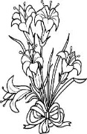
Flowers Donated By

Anonymous donor

BAPTISM PREPARATION AND
BAPTISM DATES
Baptism Preparation Day
Wednesday, 2ND April, 2025 at 4.00pm
Holy Family Centre.
Baptism Ceremony
Sunday, 6th April at 12:15pm, Holy Child, Dallas
Please contact the Parish office.
BOOKING THE HOLY
FAMILY CENTRE
The Holy Family Centre is Available for any group or parishioners to book.
Please call the Parish Office to make a booking.

COUNTING ROSTER FOR MARCH/APRIL 2025
EASTER RAFFLE 2025 (BOOKLETS)
Easter Raffle tickets are now available to purchase singly
or booklets of 5 at $5 per ticket. GREAT PRIZES! Please pick up your booklets after each weekend mass…..and Happy Selling!!

Sr V and Fr Joe | ---- | 1 Apr
Loan & Hai Vu | ----- | 8 Apr
Juanita & Judy | ----- | 15 Apr
Sr V and Fr Joe | ----- | 22 Apr
Loan & Hai Vu | 25 Mar | 29 Apr

DALLAS CHURCH CLEANING ROSTER MARCH/APRIL 2025
Group | Names | Date | Date
A | Fr Joe, Mele &friends, Thu, Dong | ------- | 5/6 Apr
B | Damian & Sarah Kempen, Anita Barnabas, Magina Musingarabul | ------- | 12/13 Apr
C | Viet Legion of Mary | ------ | 19/20 Apr
D | Sam & Vicky Buhagier, Cynthia Juice | -------- | 26/27 Apr
E | Van My Nguyen Family | 28/29 Mar

THIS Weekend ROSTERS: (22-23 Mar 2025)

 | (SAT) 6.00 pm | (SUN) 9.00 am | (SUN) 11.00 am
Readers | Sr Veronica | Veronica Smith | Bach Van
Commentators | Thien Nguyen | Henry Chong-Gum | Hai Nguyen
Special Ministers | Vicky Buhagiar | Juanita Jordan | Thuy Nguyen
Money Collectors | As Per | Volunteers | At Each Mass

NEXT Weekend ROSTERS: (29/30 Mar 2025)
 | (SAT) 6.00 pm | (SUN) 9.00 am | (SUN) 11.00 am
Readers | Damian Kempen | Veronica Smith | Adorebella
Commentators | Vicky Buhagiar | Juanita Jordan | Cecilia Yong
Special Ministers | Tuyet Nguyen | Henry | Lahra Stewart
Money Collectors | As Per | Volunteers | At Each Mass

------------------------------------------------------------------------------------
ADVERTISEMENTS

Ph: 1800 134 135 Exporter of Australian Grapes 218B Main Rd,
PH: 0428 126 982 East St Albans
PH: 9356 0555

Dr Tammy Nguyen

Ian Webb
Melmarsh Plumbing
Fully Licenced Plumber
PH: 0407 599 599

Braybrook Dental Group
Ph: 9078 1019



THE ROAST HOUSE
162 Gladstone Park Shopping Centre PH: 0468 946 704
SPECIAL
Vietnamese Roll
Chicken Schnitzel Roll
Chicken Skewer
Fried Rice
Noodles + more



