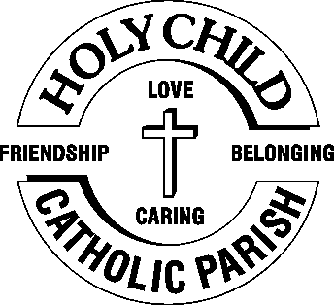
 23rd November,2025

The Chimes

Dallas & Meadow Heights

34th SUNDAY IN ORDINARY TIME - YEAR C
Our Lord JESUS CHRIST, KING of the UNIVERSE
SUNDAY 23rd NOVEMBER, 2025

1st Reading: 2 Sam 5: 1-3 2nd Reading: Col 1: 12-20
Gospel: Lk 23: 35-43

Parish Priest: Fr Joseph D.Truong
0415 455 845
Email: Joseph.DanhTruong@cam.org.au

Priest in Residence - Fr Fadhel Yakob
(Syriac Rites) 0433 833 647

Parish Secretary: Carol McPherson
Office hours: Tuesday & Friday
9am—5pm (other times: By appointment with
Fr Joe 0415 455 845)

CHURCH: 227 Blair St, Dallas 3047

Parish Office & Holy Family Centre:

133 Malmsbury Dr, Meadow Heights

Phone: 9412 8409
Email: dallas@cam.org.au
Website: https://www.melbcatholic.org/s/dallas

Parish House: 115 Corinella Cres. Dallas.

School Principal: Mr. Alan Smith

School Office: 9309 1620

WEEKDAY MASSES:
Dallas: Tues - Fri. 9.15 am
1st Fri. Anointing Mass: Dallas 10 am

WEEKEND MASSES:
Sat. Dallas Vigil Mass 6.00 pm
Sun. Meadow Heights 9.00 am
Dallas 11.00 am
*Note: Vietnamese Mass
2nd Sunday of the Month: 9.00 am HFC
4th Sunday of the Month: 11.00 am HFC

RECONCILIATION
Dallas Saturday 5.15 - 5.45 pm
Thursday 8.45 - 9.00 am

LEGION OF MARY
Eng. Tues after 9.15am mass – Dallas
Viet. Sat. at 9 am at Holy Family Centre

ADORATION & BENEDICTION
Of the Blessed Sacrament
Fridays 8:45am (English) Dallas
1st.Friday 9.30 am before Mass
Fridays 6.30 pm (Viet) Holy Family Centre

BAPTISMS
Contact Parish Office during office hours

WEDDINGS
Please contact Parish Office
Preferably 6 months before the wedding .


The Solemnity of Christ the King Year C teaches us that Jesus is our true King. His kingdom is not about wealth or force, but about love, mercy, and peace. He leads by serving and giving His life for us. His rule shows us that real power is found in kindness, forgiveness, and sacrifice. This feast also reminds us that His kingdom will never end. Earthly rulers come and go, but Christ’s reign is forever. He calls us to live in His love and to trust in His mercy. When we follow His way, we share in the joy of His kingdom, both in this life and in the life to come.
(source: young-catholics on-line)

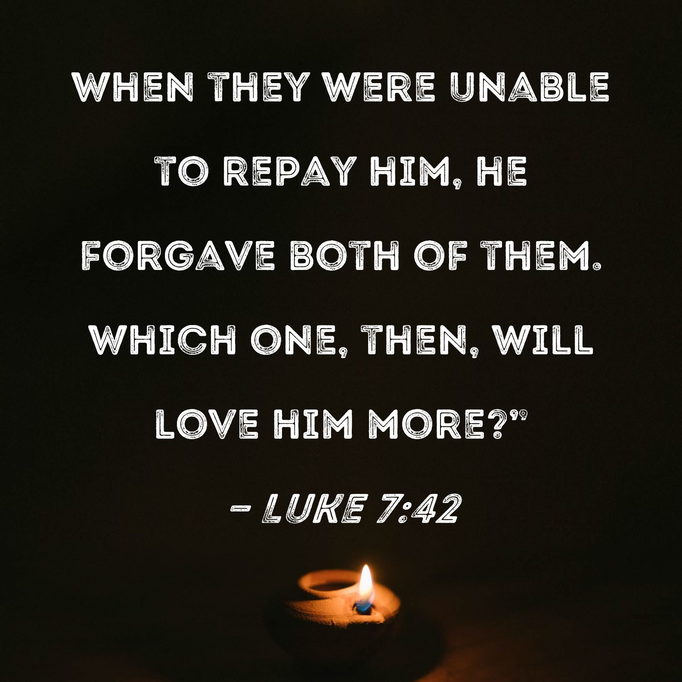

.

35th SUNDAY IN ORDINARY TIME- year C
Sunday 30TH November, 2025 – ADVENT

1st Reading: Is 2:1-5

Responsorial Psalm: Ps 121:1-2, 4-5, 6-9

2nd Reading: Rom 13: 11-14

Gospel: Mt 24: 37-44

Our cities are becoming more crowded yet more than ever before people are lonely. Sadly many travel on crowded trains and work in buildings full of people, yet feel left out. Jesus is telling us our role is to “reach out” even to people we don’t know and tell them they are part of our family. We are after all brothers and sisters with one Father.
If we do this then the “Kingdom is here” and Jesus is our king. If we don’t create the “kingdom “ here who can?

1st Reading: Isaiah:22:19-23; 2nd Reading: Romans 11:33-36; Gospel: Mathew 16:13-20

Responsorial Psalm: Let us go rejoicing to the house of the Lord.

Gospel Acclamation: Alleluia, Alleluia! Blessed is he who inherits the kingdom of David our Father; blessed is he who comes in the name of the Lord. Alleluia!

Holy Child Parish….

Is committed to a safe nurturing culture for all our children.
HOLY CHILD PRIMARY SCHOOL – is in the process of establishing an Alumni platform and would love to reconnect with past students. If you have attended Holy Child Primary School, please reach out to the office on 9309 1620, and we will connect you with the appropriate staff member.

.

(Names of the sick will only be printed for a month, unless the Office has been notified otherwise)

SICK: Joan Lobs, Shirley Martin, Adrian Zuccato, Nguyen Thi Thin, Le Thi Quy, Dina, Jack Ward,
Lien, Connie, Miriam Smith, Florentino Casimiro, Farif Ashlaq.

REMEMBRANCES: Anthony Sultana, Anthony Pham Van Quan, Aloysius Abraham, Helene Nguyen Thi Tot, Peter Cosgriff (A), Guise Nguyen Son, Paul, Ane, Maria, Gisan Kim, Maria, Maria Nguyen T Ngoc Hue, Tomy Cafarella, Aubrey Leon Francke (B), Thi Thanh Nguyen (A) (Danh Tran’s mum)

RECENT DEATHS:

all departed souls, the Souls in Purgatory and all those mentioned in the Book of Remembrance.

RECENT DEATH:

PLEASE KEEP THEM IN YOUR PRAYERS
Multi-Cultural Dinner Dance - 18 June
This major fundraiser is fast approaching. Tickets on sale after Mass. Organise a table with family/friends. A great family fun evening. Donations of cash/gift items for raffle/door prizes are most welcome. Help to set up on the day/before would be greatly appreciated. Ring the Office and leave your name. Help and support your Parish. Tickets also available at the Parish Office or above Committee Members.

Mass for Expectant Mothers-The Life, Marriage & Family Office warmly invite all expectant mothers and their families to the Mass for Expectant Mothers. The Mass will be celebrated by Archbishop Denis Hart at St Patrick's Cathedral on Sunday 5 June at 11.00am. Registrations can be made online at: www.cam.org.au/lifemarriagefamily or alternatively by contacting: 9287 5587 or Lmf@cam.org.au. Please note that registration closes on Friday 27 May. Expectant mothers who register will receive a small token of recognition.

BOOKING THE HOLY
FAMILY CENTRE
The Holy Family Centre is Available for any group or parishioners to book.
Please call the Parish Office
on 9412 8409 to make a booking.

BAPTISM PREPARATION AND
BAPTISM DATES
Baptism Preparation Day
3rd December, 2025

Holy Family Centre.
Baptism Date:
(No baptisms in Jan 2026)

SCHEDULING APPTS WITH FR JOE
Please note that Parishioners are encouraged to schedule an appointment with Fr Joe as walk-in meetings are not always ideal.

FR JOE’S ANNUAL LEAVE
During Fr Joe’s annual leave from 5th to 26th November, there will only be Mass in the Parish on Thursdays and Fridays. There will be NO Adoration or Benediction on Fridays.

ST VINCENT DE PAUL SOCIETY AT GOOD SHEPHERD – GLADSTONE PARK
St Vincent De Paul Society at Good Shepherd Gladstone Park have asked us to, once again donate toys for children aged baby to 12 years, for their Christmas Appeal. The “big box” will be ready for your UNWRAPPED gifts from Saturday 29th November until 12 noon Sunday 15th December (there are NO “Gift Tags”).
A GIFT FOR A 10–12 YEAR OLD BOY OR GIRL WOULD BE MOST APPRECIATED. THANK YOU! – Brenda Nyssen.

HOLY CHILD PRIMARY SCHOOL - CHRISTMAS CAROLS
Our school is planning our Twilight Christmas Carol for Thursday the 11th Dec between 5:00pm and 7:30pm. This will include songs from each grade and level across the school. We would warmly welcome interested choirs from the parish to participate with us in this celebration of Christmas and our 60th anniversary. Many thanks – Alan Smith, Principal.

SECOND RITE – RECONCILIATION
Tuesday 9th December, 2025 at 7.00pm

CHRISTMAS DAY – THURSDAY 25TH DECEMBER, 2025
9.00am Mass at Meadow Heights Family Centre – English
11.00am Mass at Dallas - Vietnamese

ACYF LAUNCH & WYD CROSS RECEPTION & PILGRIMAGE WALK – 30 NOVEMBER
Join us at St Patrick’s Cathedral on Sunday 30 November as we welcome over 6,000 young pilgrims to Melbourne. Let us come together to share in their joy and offer a warm Melbourne Welcome.
Program:
1.30pm – Melbourne Catholic Festa
2.30pm – Reception of the WYD Cross & Icon
3.00pm – Pilgrimage Walk (5km to Melbourne Convention Entertainment Centre) ticketed pilgrims only;
3km return option available.


Feast Day During the Week
23 Nov – Our Lord Jesus Christ, King of the Universe
24 Nov– St Andrew Dung-Lac & Companions
25 Nov – St. Catherine of Alexandria
29 Nov – Blessed Virgin Mary

Thanksgiving Collection
Loose: $360.40
Church (Actual): $851.70
Church (Pledge): $1324.46
Presbytery (Actual): $760
Presbytery (Pledge): $950.55


Special Collection

Flowers Donated By

Veggie Group for your thoughtful donation of $500
very kind of you!!!


-----------------------------------------------------------------------------------------------------------------------------------------------------------------------------------------------------------------------------------------------------------------------------------------------------------------------------------

COUNTING ROSTER FOR NOV/DEC 2025
Hai, Loan, An, Mai | 25 Nov
Judy, Juanita, Mele & Sr V | 2 Dec
Hai, Loan, An, Mai | 9 Dec
Judy, Juanita, Mele & Sr V | 16 Dec

DALLAS CHURCH CLEANING ROSTER FOR NOV/DEC 2025
Group | Names | Date | Date
A | Mele & friends, Fr Joseph | ----- | 6/7 Dec
B | Damian & Sarah Kempen, Anita Barnabas, Magina Musingarabul | ------ | 13/14 Dec
C | Viet Legion of Mary | ------- | 20/21 Dec
D | Sam & Vicky Buhagiar, Cynthia Juico | ---- | 27/28 Dec
E | Van My Nguyen Family | 29/30 Nov | 3/4 Jan 2026

THIS Weekend ROSTERS: (22-23 Nov 2025)

 | (SAT) 6.00 pm | (SUN) 9.00 am | (SUN) 11.00 am
Readers | Sr Veronica | Veronica S | Thom Nguyen & Back Van
Commentators | Damian | Henry | Hai Vu
Special Ministers | Vicky B | Judy | Volunteer
Money Collectors | As Per | Volunteers | At Each Mass

NEXT Weekend ROSTERS: (29-30 Nov, 2025)
 | (SAT) 6.00 pm | (SUN) 9.00 am | (SUN) 11.00 am
Readers | Damian | Danh Tri Pham | Adorabella
Commentators | Vicky B | Juanita | Lahra
Special Ministers | Tuyet Nguyen | Taafoanga | Mele
Money Collectors | As Per | Volunteers | At Each Mass

---------------------------------------------------------------------------------
ADVERTISEMENTS


HAI CARPORT
Specialised In:
Fencing, Carport, Verandah, All Doors, Automatic Gates, Roller Doors,
Remote Control Doors & Gates
Contact: Hai (03) 9367 5520
Mob: 0423 971 568

THE ROAST HOUSE
162 Gladstone Park Shopping Centre PH: 0468 946 704
SPECIAL
Vietnamese Roll
Chicken Schnitzel Roll
Chicken Skewer
Fried Rice
Noodles + more

ADVERTISE YOUR BUSINESS HERE FOR $50 FOR 3 MONTHS

