
 26^{h} October,2025

The Chimes

Dallas & Meadow Heights

30th SUNDAY IN ORDINARY TIME - YEAR C
SUNDAY 26th October, 2025

1st Reading: Sirach 35: 12-14, 16-19 2nd Reading: 2 Tim 4: 6-8, 16-18
Gospel: Lk 18: 9-14

Parish Priest: Fr Joseph D.Truong
0415 455 845
Email: Joseph.DanhTruong@cam.org.au

Priest in Residence - Fr Fadhel Yakob
(Syriac Rites) 0433 833 647

Parish Secretary: Carol McPherson
Office hours: Tuesday & Friday
9am—5pm (other times: By appointment with
Fr Joe 0415 455 845)

CHURCH: 227 Blair St, Dallas 3047

Parish Office & Holy Family Centre:

133 Malmsbury Dr, Meadow Heights

Phone: 9412 8409
Email: dallas@cam.org.au
Website: https://www.melbcatholic.org/s/dallas

Parish House: 115 Corinella Cres. Dallas.

School Principal: Mr. Alan Smith

School Office: 9309 1620

WEEKDAY MASSES:
Dallas: Tues - Fri. 9.15 am
1st Fri. Anointing Mass: Dallas 10 am

WEEKEND MASSES:
Sat. Dallas Vigil Mass 6.00 pm
Sun. Meadow Heights 9.00 am
Dallas 11.00 am
*Note: Vietnamese Mass
2nd Sunday of the Month: 9.00 am HFC
4th Sunday of the Month: 11.00 am HFC

RECONCILIATION
Dallas Saturday 5.15 - 5.45 pm
Thursday 8.45 - 9.00 am

LEGION OF MARY
Eng. Tues after 9.15am mass – Dallas
Viet. Sat. at 9 am at Holy Family Centre

ADORATION & BENEDICTION
Of the Blessed Sacrament
Fridays 8:45am (English) Dallas
1st.Friday 9.30 am before Mass
Fridays 6.30 pm (Viet) Holy Family Centre

BAPTISMS
Contact Parish Office during office hours

WEDDINGS
Please contact Parish Office
Preferably 6 months before the wedding .
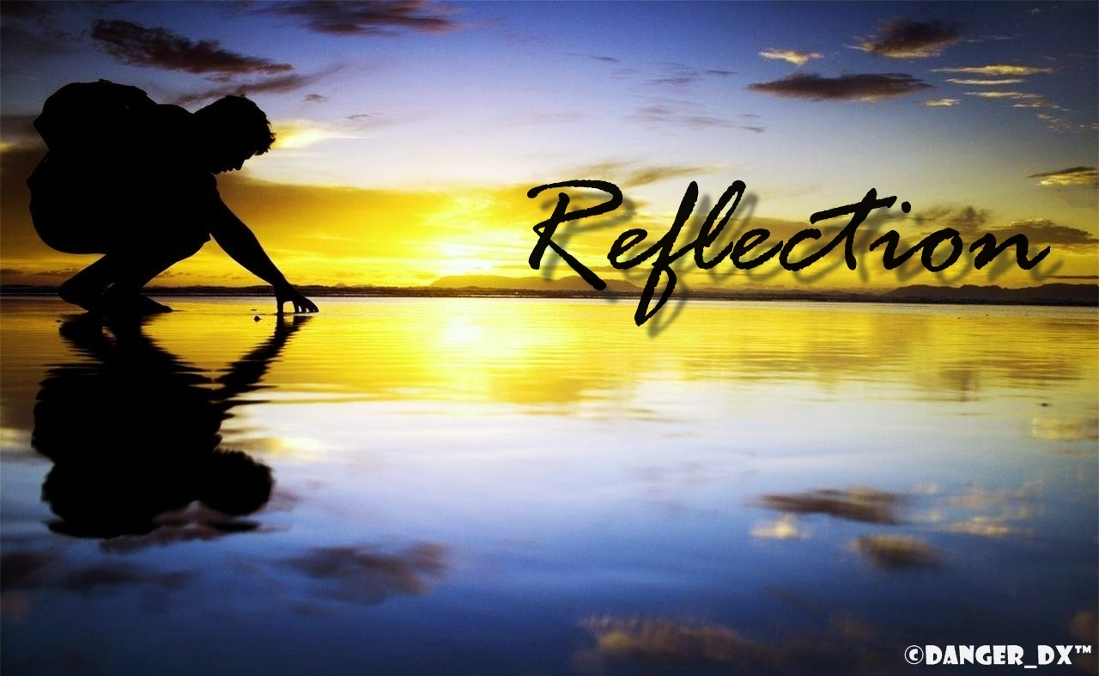

The purpose of this parable is to disturb the complacency of people who believe that following the rules of the law precisely is all they must do to guarantee salvation, regardless of their attitudes towards others or how they speak and act. The timeless parable in this text is as true today as it was in Jesus’ time. The Pharisee asks nothing of God; he is under the mistaken impression that he can fulfil all that is required of him through his own actions. He believes that adhering to the letter of the law is all that is required. Conversely, the tax collector is aware of his brokenness and opens himself to God, asking him for mercy. He rightly recognises his own sinfulness and sees that God is the only one who can fill the void within him. Again, as is common in the Gospel of Luke, it is the poor and the outcast who will be exalted. The Pharisee, who should know better, will ultimately be humbled and experience God’s dramatic reversal. (source: summit on line)

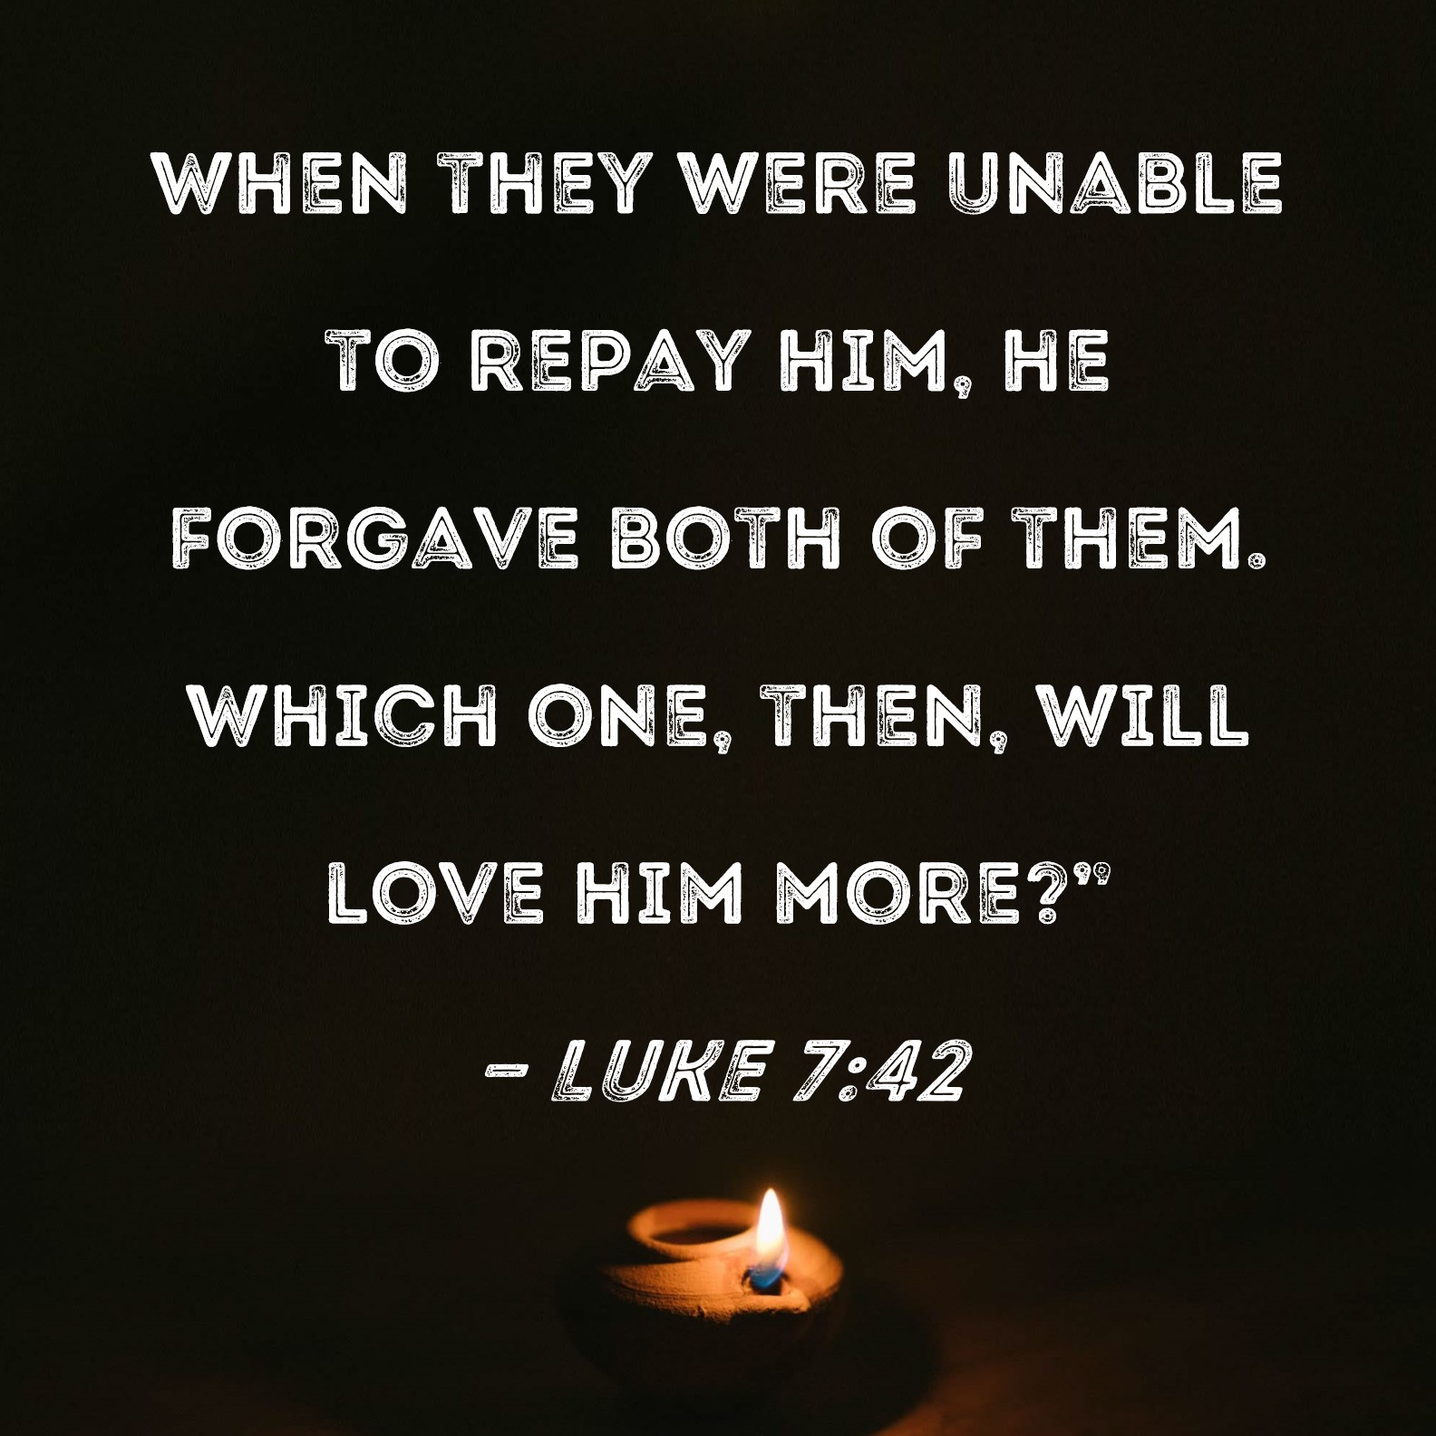

.

THE COMMEMORATION OF ALL THE FAITHFUL DEPARTED (ALL SOUL’S DAY)- year C
Sunday 2nd November, 2025

1st Reading: Wisdom 3:1–9

Responsorial Psalm: Psalms 114

2nd Reading: Romans 5: 5-11

Gospel: John 14: 1-6

Our cities are becoming more crowded yet more than ever before people are lonely. Sadly many travel on crowded trains and work in buildings full of people, yet feel left out. Jesus is telling us our role is to “reach out” even to people we don’t know and tell them they are part of our family. We are after all brothers and sisters with one Father.
If we do this then the “Kingdom is here” and Jesus is our king. If we don’t create the “kingdom “ here who can?

1st Reading: Isaiah:22:19-23; 2nd Reading: Romans 11:33-36; Gospel: Mathew 16:13-20

Responsorial Psalm: The Lord hears the cry of the poor.

Gospel Acclamation: Alleluia, Alleluia! God was in Christ, to reconcile the world to himself; and the Good News of reconciliation he has entrusted to us. Alleluia!

Holy Child Parish….

Is committed to a safe nurturing culture for all our children.
HOLY CHILD PRIMARY SCHOOL – is in the process of establishing an Alumni platform and would love to reconnect with past students. If you have attended Holy Child Primary School, please reach out to the office on 9309 1620, and we will connect you with the appropriate staff member.

.

(Names of the sick will only be printed for a month, unless the Office has been notified otherwise)

SICK: Molly Knox, Joan Lobs, Shirley Martin, Adrian Zuccato, Nguyen Thi Thin, Le Thi Quy, Dina, Jack Ward,
Lien, Connie, Miriam Smith, Florentino Casimiro, Farif Ashlaq, M. Knox.

REMEMBRANCES: Russel De Silva, Macaria Tapia, Theresa Bartolo, Johnny De Waas, Margaret Ryan, Maria Nguyen Thi Sae, Wasyl Pushhkar.

The Souls in Purgatory, departed souls, and all deceased persons mentioned in the Book of Remembrance.

RECENT DEATHS:

all departed souls, the Souls in Purgatory and all those mentioned in the Book of Remembrance.

RECENT DEATH:

PLEASE KEEP THEM IN YOUR PRAYERS
Multi-Cultural Dinner Dance - 18 June
This major fundraiser is fast approaching. Tickets on sale after Mass. Organise a table with family/friends. A great family fun evening. Donations of cash/gift items for raffle/door prizes are most welcome. Help to set up on the day/before would be greatly appreciated. Ring the Office and leave your name. Help and support your Parish. Tickets also available at the Parish Office or above Committee Members.

Mass for Expectant Mothers-The Life, Marriage & Family Office warmly invite all expectant mothers and their families to the Mass for Expectant Mothers. The Mass will be celebrated by Archbishop Denis Hart at St Patrick's Cathedral on Sunday 5 June at 11.00am. Registrations can be made online at: www.cam.org.au/lifemarriagefamily or alternatively by contacting: 9287 5587 or Lmf@cam.org.au. Please note that registration closes on Friday 27 May. Expectant mothers who register will receive a small token of recognition.

BAPTISM PREPARATION AND
BAPTISM DATES
Baptism Preparation Day
Wednesday, 5th November
Holy Family Centre.
Baptism Date:
SUNDAY, 7th December

BOOKING THE HOLY
FAMILY CENTRE
The Holy Family Centre is Available for any group or parishioners to book.
Please call the Parish Office
on 9412 8409 to make a booking.
SCHEDULING APPTS WITH FR JOE
Please note that Parishioners are encouraged to schedule an appointment with Fr Joe as walk-in meetings are not always ideal.

VOLUNTARY ASSISTED DYING AND EUTHANASIA BILLS
Parishioners are encouraged to write to their local Member of Parliament and request that they vote against the proposed revised Voluntary Assisted Dying and Euthanasia Bill.

OUR LADY OF PERPETUAL SUCCOUR – 1st NOVEMBER, 2025
Our Lady of Perpetual Succor Novena 1.30 – 4.00pm at Holy Child, Dallas. ALL WELCOME.

THERE WILL BE NO 12 NOON MASS AT MELBA VALE ON FRIDAY 7th November, 2025

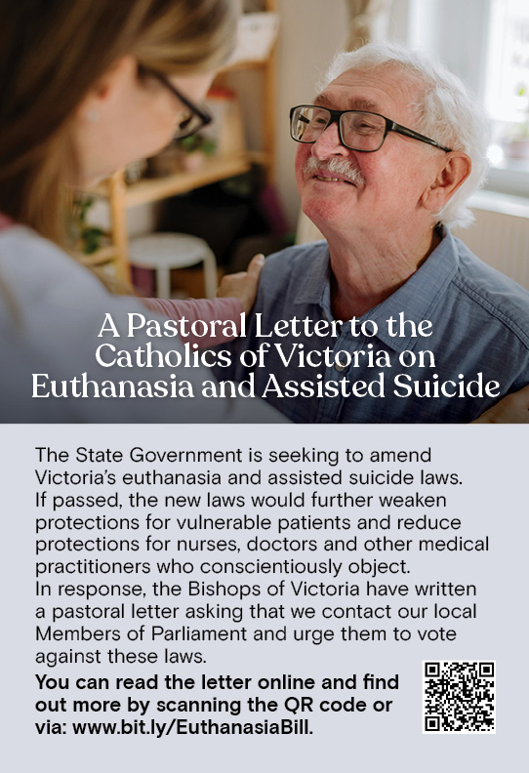

All SAINTS DAY
This year, All Saints Day falls on
Saturday, 1 November. All Saints Day Mass will be at 10 AM, Dallas, Saturday, 1 November. There will be refreshments after the 10AM Mass; please bring a plate to share.

All SOULS DAY
All Souls Day occurs on Sunday, 2 November. Parishioners are encouraged to bring photos of their deceased loved ones when attending the Vigil 6PM Mass on Saturday, 1 November, and at all other Sunday Masses.


Feast Day During the Week
28 Oct – Saints Simon, Jude, Apostles
2 Nov– the commemoration of all the faithful departed

Thanksgiving Collection
Loose: $288.5
Church (Actual): $1019
Church (Pledge): $1324.46
Presbytery (Actual): $839
Presbytery (Pledge): $950.55


Flowers Donated By

Special Collection

---------
--------



-----------------------------------------------------------------------------------------------------------------------------------------------------------------------------------------------------------------------------------------------------------------------------------------------------------------------------------

COUNTING ROSTER FOR OCT/NOV/DEC 2025
Hai, Loan, An, Mai | 28 Oct | 25 Nov
Judy, Juanita, Mele & Sr V | 4 Nov | 2 Dec
Hai, Loan, An, Mai | 11 Nov | 9 Dec
Judy, Juanita, Mele & Sr V | 18 Nov | 16 Dec

DALLAS CHURCH CLEANING ROSTER FOR NOV/DEC 2025
Group | Names | Date | Date
A | Mele &friends, Dong | 1/2 Nov | 6/7 Dec
B | Damian & Sarah Kempen, Anita Barnabas, Magina Musingarabul | 8/9 Nov | 13/14 Dec
C | Viet Legion of Mary | 15/16 Nov | 20/21 Dec
D | Sam & Vicky Buhagiar, Cynthia Juico | 22/23 Nov | 27/28 Dec
E | Van My Nguyen Family | 29/30 Nov | 3/4 Jan 2026

THIS Weekend ROSTERS: (25-26 Oct, 2025)

 | (SAT) 6.00 pm | (SUN) 9.00 am | (SUN) 11.00 am
Readers | Thien | Juanita | Tuyen Quang & Thom Nguyen
Commentators | Damian | Henry | Khanh Nguyen
Special Ministers | Vicky B | Judy | Volunteer
Money Collectors | As Per | Volunteers | At Each Mass

NEXT Weekend ROSTERS: (1-2 Nov, 2025)
 | (SAT) 6.00 pm | (SUN) 9.00 am | (SUN) 11.00 am
Readers | Sr Veronica | Judy | Anita B
Commentators | Vicky B | Henry | Lahra
Special Ministers | Tuyet Nguyen | Juanita | Mele
Money Collectors | As Per | Volunteers | At Each Mass

---------------------------------------------------------------------------------
ADVERTISEMENTS


HAI CARPORT
Specialised In:
Fencing, Carport, Verandah, All Doors, Automatic Gates, Roller Doors,
Remote Control Doors & Gates
Contact: Hai (03) 9367 5520
Mob: 0423 971 568

THE ROAST HOUSE
162 Gladstone Park Shopping Centre PH: 0468 946 704
SPECIAL
Vietnamese Roll
Chicken Schnitzel Roll
Chicken Skewer
Fried Rice
Noodles + more

ADVERTISE YOUR BUSINESS HERE FOR $50 FOR 3 MONTHS

