
 28th September,2025

The Chimes

Dallas & Meadow Heights

26th SUNDAY IN ORDINARY TIME - YEAR C
SUNDAY 28th September, 2025

1st Reading: Amos 6:1, 4-7 2nd Reading: 1 Tim 6:11-16
Gospel: Lk 16: 19-31

Parish Priest: Fr Joseph D.Truong
0415 455 845
Email: Joseph.DanhTruong@cam.org.au

Priest in Residence - Fr Fadhel Yakob
(Syriac Rites) 0433 833 647

Parish Secretary: Carol McPherson
Office hours: Tuesday & Friday
9am—5pm (other times: By appointment with
Fr Joe 0415 455 845)

CHURCH: 227 Blair St, Dallas 3047

Parish Office & Holy Family Centre:

133 Malmsbury Dr, Meadow Heights

Phone: 9412 8409
Email: dallas@cam.org.au
Website: https://www.melbcatholic.org/s/dallas

Parish House: 115 Corinella Cres. Dallas.

School Principal: Mr. Alan Smith

School Office: 9309 1620

WEEKDAY MASSES:
Dallas: Tues - Fri. 9.15 am
1st Fri. Anointing Mass: Dallas 10 am

WEEKEND MASSES:
Sat. Dallas Vigil Mass 6.00 pm
Sun. Meadow Heights 9.00 am
Dallas 11.00 am
*Note: Vietnamese Mass
2nd Sunday of the Month: 9.00 am HFC
4th Sunday of the Month: 11.00 am HFC

RECONCILIATION
Dallas Saturday 5.15 - 5.45 pm
Thursday 8.45 - 9.00 am

LEGION OF MARY
Eng. Tues after 9.15am mass – Dallas
Viet. Sat. at 9 am at Holy Family Centre

ADORATION & BENEDICTION
Of the Blessed Sacrament
Fridays 8:45am (English) Dallas
1st.Friday 9.30 am before Mass
Fridays 6.30 pm (Viet) Holy Family Centre

BAPTISMS
Contact Parish Office during office hours

WEDDINGS
Please contact Parish Office
Preferably 6 months before the wedding .


This is another text about the unexpected reversals of the kingdom of God. The situation involving the two men is described in detail. The rich man undoubtedly believed his affluence was a blessing from God, or a reward for his goodness. His only sin was his failure to see the poverty and desperate need at his doorstep. Many stories in the Gospel of Luke emphasise our responsibility to use wealth for the good of all rather than to selfishly monopolise resources for our own benefit. When the reality of the situation dawns on the rich man, he wants to warn his brothers so they do not make the same mistake. However, Jesus responds that they already have the teaching of Moses and the prophets, who repeatedly call Israel to justice and mercy. If people are prepared to ignore that call, then what difference will it make ‘even if someone should rise from the dead’. This phrase challenges Christians: do we, like the rich man, also fail to see and respond to the needs in our world? Christian faith is about more than Sunday worship; it is about living Jesus’ message every day. (Source: The Summit online)

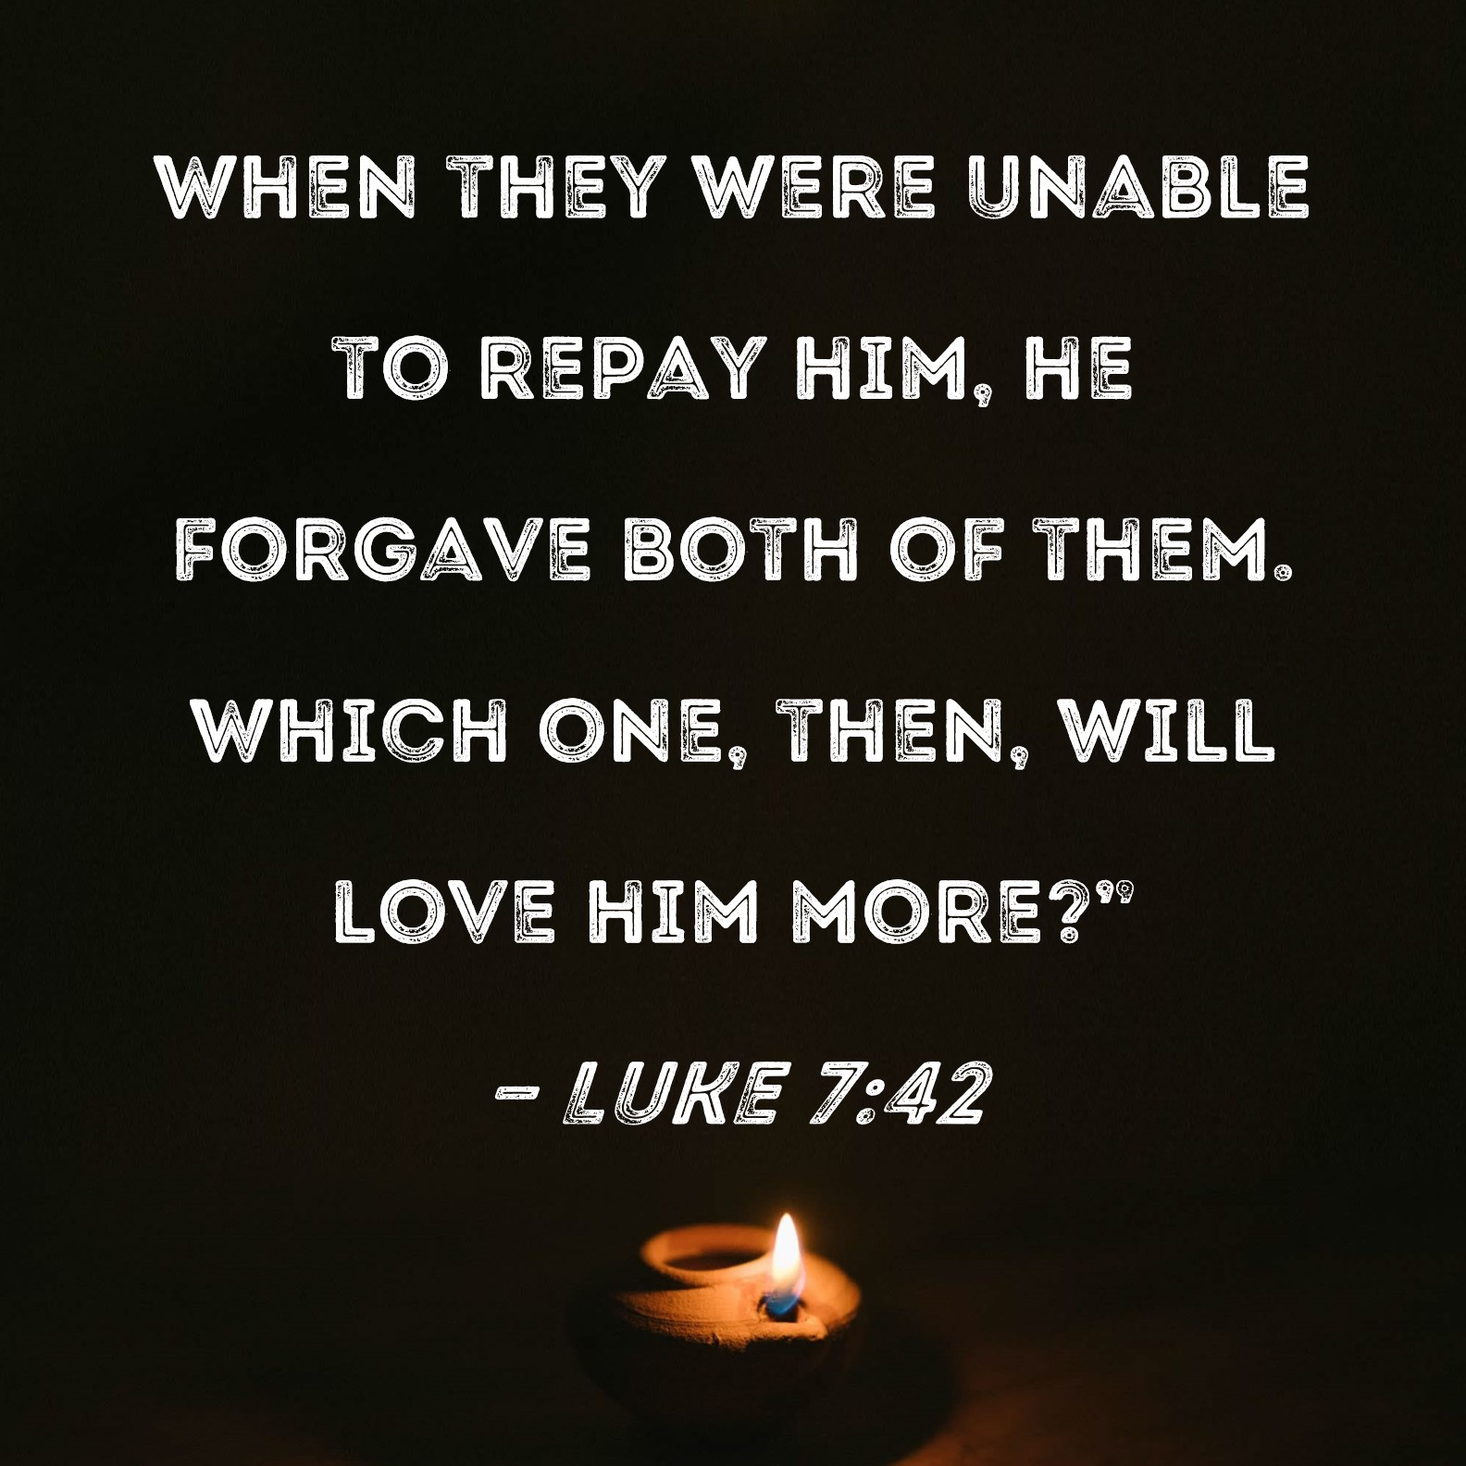

.

****PARISH DIAMOND JUBILEE CELEBRATION****

When: Saturday, October 11

Time: 5 PM Mass followed by
a Dinner Dance
(International Buffet)

NO TICKET – NO ENTRY

1st Reading: Isaiah:22:19-23; 2nd Reading: Romans 11:33-36; Gospel: Mathew 16:13-20

27th SUNDAY IN ORDINARY TIME - year C
Sunday 5th October, 2025

1st Reading: Hab1:2-3, 2:2-4

Responsorial Psalm:
Ps 94:1-2, 6-9
2nd Reading: 2 Tim 1:6-8,
13-14

Gospel: Lk 17:5-9

Our cities are becoming more crowded yet more than ever before people are lonely. Sadly many travel on crowded trains and work in buildings full of people, yet feel left out. Jesus is telling us our role is to “reach out” even to people we don’t know and tell them they are part of our family. We are after all brothers and sisters with one Father.
If we do this then the “Kingdom is here” and Jesus is our king. If we don’t create the “kingdom “ here who can?

1st Reading: Isaiah:22:19-23; 2nd Reading: Romans 11:33-36; Gospel: Mathew 16:13-20

Responsorial Psalm: Praise the Lord, my soul!

Gospel Acclamation: . Alleluia, Alleluia! Jesus Christ was rich but he became poor, to make you rich out of his poverty. Alleluia!

Holy Child Parish….

Is committed to a safe nurturing culture for all our children.
HOLY CHILD PRIMARY SCHOOL – is in the process of establishing an Alumni platform and would love to reconnect with past students. If you have attended Holy Child Primary School, please reach out to the office on 9309 1620, and we will connect you with the appropriate staff member.

.

(Names of the sick will only be printed for a month, unless the Office has been notified otherwise)

SICK: Molly Knox, Joan Lobs, Shirley Martin, Adrian Zuccato, Nguyen Thi Thin, Le Thi Quy, Dina, Jack Ward,
Lien, Connie, Miriam Smith, Florentino Casimiro.

REMEMBRANCES: Eileen Yonnon, Teresa Nguyen, Angela Nardella, Therese, Terry Thomson, Isidro Songcuita Jr, Jessica De Guzman, Margie O’Leary, Mollie Hyland, Aldo Budini, John Dinley, Luigi, Jose Exposto, Alpinolo Carniel, Lucy Ciantar, Gery Ranelone, Alan Anthony, Jaoilo Q.Ryano, Jacinta Quezana.

The Souls in Purgatory, departed souls, and all deceased persons mentioned in the Book of Remembrance.

RECENT DEATHS:

all departed souls, the Souls in Purgatory and all those mentioned in the Book of Remembrance.

RECENT DEATH:

PLEASE KEEP THEM IN YOUR PRAYERS
Multi-Cultural Dinner Dance - 18 June
This major fundraiser is fast approaching. Tickets on sale after Mass. Organise a table with family/friends. A great family fun evening. Donations of cash/gift items for raffle/door prizes are most welcome. Help to set up on the day/before would be greatly appreciated. Ring the Office and leave your name. Help and support your Parish. Tickets also available at the Parish Office or above Committee Members.

Mass for Expectant Mothers-The Life, Marriage & Family Office warmly invite all expectant mothers and their families to the Mass for Expectant Mothers. The Mass will be celebrated by Archbishop Denis Hart at St Patrick's Cathedral on Sunday 5 June at 11.00am. Registrations can be made online at: www.cam.org.au/lifemarriagefamily or alternatively by contacting: 9287 5587 or Lmf@cam.org.au. Please note that registration closes on Friday 27 May. Expectant mothers who register will receive a small token of recognition.

SCHEDULING APPTS WITH FR JOE
Please note that Parishioners are encouraged to schedule an appointment with Fr Joe as walk-in meetings are not always ideal.
BOOKING THE HOLY
FAMILY CENTRE
The Holy Family Centre is Available for any group or parishioners to book.
Please call the Parish Office
on 9412 8409 to make a booking.

BAPTISM PREPARATION AND
BAPTISM DATES
Baptism Preparation Day
Wednesday, 1st October
Holy Family Centre.
Baptism Date:
SUNDAY, 2nd November

**PAYMENT FOR PARISH FEAST DAY TICKETS**
If anyone who has NOT yet paid for the parish feast day ticket, please do so by
Thursday 25th September to Fr Joe or Sarah Kempen.

OUR LADY OF PERPETUAL SUCCOUR – 4TH OCTOBER, 2025
Our Lady of Perpetual Succour will not be going ahead next
Saturday 4TH October.

FIRST FRIDAY 5th OCTOBER, 2025 – ANOINTING OF THE SICK
Morning Mass at 10.00 am at Holy Child, Dallas.
Refreshments afterwards, please bring a plate to share.
12.00pm Mass at Melba Vale. All are invited.

DIRECT DEBIT & CREDIT CARD CONTRIBUTORS
If you notice anything unusual on your bank statement related to your pledge to our parish, please contact the parish office promptly. We will investigate the matter for you. Thank you!

CHAIR OF PASTORAL COUNCIL
Damian Kempen will finish his term as chair of the Pastoral Council on
12th October, 2025

MASS OFFERING ENVELOPES
A very gentle reminder – Please do not put mass offering envelopes in the collection bags. Please give them directly to Fr Joe.
Thank you!

DONATIONS
IF YOU WISH TO DONATE RAFFLE ITEMS FOR THE PARISH DIAMOND JUBILEE CELEBRATIONS FOR SATURDAY 11/10/25.
PLEASE DROP THEM OFF IN THE NOMINATED BOX AT HFC.


Feast Day During the Week
29 Sept – Saints Michael, Gabriel & Raphael, Archangelsa
30 Sept – St Jerome
1 Oct – St Therese of the Child Jesus
2 Oct – The Holy Guardian Angels
4 Oct - St Francis of Assisi

Thanksgiving Collection
Loose: $344.05
Church (Actual): $977
Church (Pledge): $1324.46
Presbytery (Actual): $664
Presbytery (Pledge): $950.55


Flowers Donated By

--------

Special Collection

---------
--------




-----------------------------------------------------------------------------------------------------------------------------------------------------------------------------------------------------------------------------------------------------------------------------------------------------------------------------------

COUNTING ROSTER FOR SEPT/NOV 2025
Hai, Loan, An, Mai | 30 Sept | 28 Oct
Judy, Juanita, Mele & Sr V | 7 Oct | 4 Nov
Hai, Loan, An, Mai | 14 Oct | 11 Nov
Judy, Juanita, Mele & Sr V | 21 Oct | 18 Not

DALLAS CHURCH CLEANING ROSTER FOR SEPT/NOV 2025
Group | Names | Date | Date
A | Mele & friends, Dong | ------ | 1/2 Nov
B | Damian & Sarah Kempen, Anita Barnabas, Magina Musingarabul | 4/5 Oct | 8/9 Nov
C | Viet Legion of Mary | 11/12 Oct | 15/16 Nov
D | Sam & Vicky Buhagiar, Cynthia Juico | 18/19 Oct | 22/23 Nov
E | Van My Nguyen Family | 25/26 Oct | 29/30 Nov

THIS Weekend ROSTERS: (27-28 Sept, 2025)

 | (SAT) 6.00 pm | (SUN) 9.00 am | (SUN) 11.00 am
Readers | Thien | Judy | Thuy Nguyen & Bach Van
Commentators | Vicky B | Henry | Ngoc Tuyet
Special Ministers | Tuyet Nguyen | Taafoanga | Volunteer
Money Collectors | As Per | Volunteers | At Each Mass

NEXT Weekend ROSTERS: (4-5 Oct, 2025)
 | (SAT) 6.00 pm | (SUN) 9.00 am | (SUN) 11.00 am
Readers | Sr Veronica | Veronica S | Anita B
Commentators | Hanh Nguyen | Judy | Cynthia
Special Ministers | Vicky B | Juanita | Mele
Money Collectors | As Per | Volunteers | At Each Mass

---------------------------------------------------------------------------------
ADVERTISEMENTS
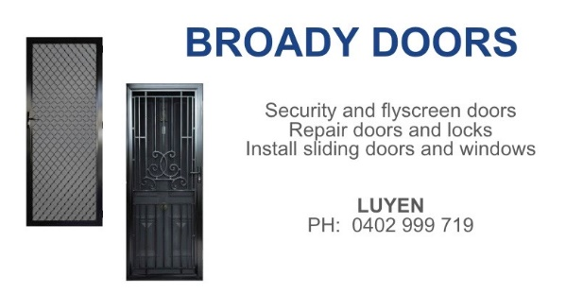

HAI CARPORT
Specialised In:
Fencing, Carport, Verandah, All Doors, Automatic Gates, Roller Doors,
Remote Control Doors & Gates
Contact: Hai (03) 9367 5520
Mob: 0423 971 568

THE ROAST HOUSE
162 Gladstone Park Shopping Centre PH: 0468 946 704
SPECIAL
Vietnamese Roll
Chicken Schnitzel Roll
Chicken Skewer
Fried Rice
Noodles + more

ADVERTISE YOUR BUSINESS HERE FOR $50 FOR 3 MONTHS

