
 4th May,2025

The Chimes

Dallas & Meadow Heights

THIRD SUNDAY OF EASTER -YEAR C

1st Reading: Acts 5: 27-32, 40-41 2nd Reading: Rev 5: 11-14

Gospel: Jn 21: 1-19

Parish Priest: Fr Joseph D.Truong
0415 455 845
Email: Joseph.DanhTruong@cam.org.au

Priest in Residence - Fr Fadhel Yakob
(Syriac Rites) 0433 833 647

Parish Secretary: Carol McPherson
Office hours: Tuesday & Friday
9am—5pm (other times: By appointment with
Fr Joe 0415 455 845)

CHURCH: 227 Blair St, Dallas 3047

Parish Office & Holy Family Centre:

133 Malmsbury Dr, Meadow Heights

Phone: 9412 8409
Email: dallas@cam.org.au
Website: https://www.melbcatholic.org/s/dallas

Parish House: 115 Corinella Cres. Dallas.

School Principal: Mr. Alan Smith

School Office: 9309 1620

WEEKDAY MASSES:
Dallas: Tues - Fri. 9.15 am
1st Fri. Anointing Mass: Dallas 10 am

WEEKEND MASSES:
Sat. Dallas Vigil Mass 6.00 pm
Sun. Meadow Heights 9.00 am
Dallas 11.00 am
*Note: Vietnamese Mass
2nd Sunday of the Month: 9.00 am HFC
4th Sunday of the Month: 11.00 am HFC

RECONCILIATION
Dallas Saturday 5.15 - 5.45 pm
Thursday 8.45 - 9.00 am

LEGION OF MARY
Eng. Tues after 9.15am mass – Dallas
Viet. Sat. at 9 am at Holy Family Centre

ADORATION & BENEDICTION
Of the Blessed Sacrament
Fridays 8:45am (English) Dallas
1st.Friday 9.30 am before Mass
Fridays 6.30 pm (Viet) Holy Family Centre

BAPTISMS
Contact Parish Office during office hours

WEDDINGS
Please contact Parish Office
Preferably 6 months before the wedding .


As we continue to meditate on the mysteries of the Resurrection during the Easter Season, we hear St. John’s account of Jesus’s third appearance after his Resurrection. This is a favourite passage of scripture, because in John 21:12, Jesus says to the disciples, “Come, have breakfast.” In the Acts of the Apostles, the apostles fearlessly preach the Resurrection of Jesus, the Christ. In Revelation, St. John gives us a glimpse of Heaven. In the first portion of St. John’s Gospel, we see the bountiful generosity of our Lord. In the second portion, included in the long form, we see Jesus allowing St. Peter to make reparation–to make amends–for his three-fold denial of Jesus at the Crucifixion.

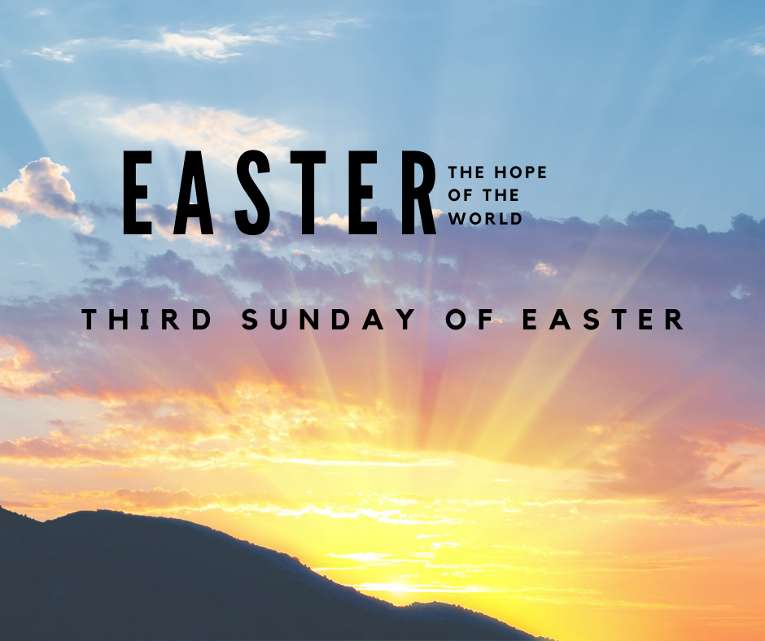

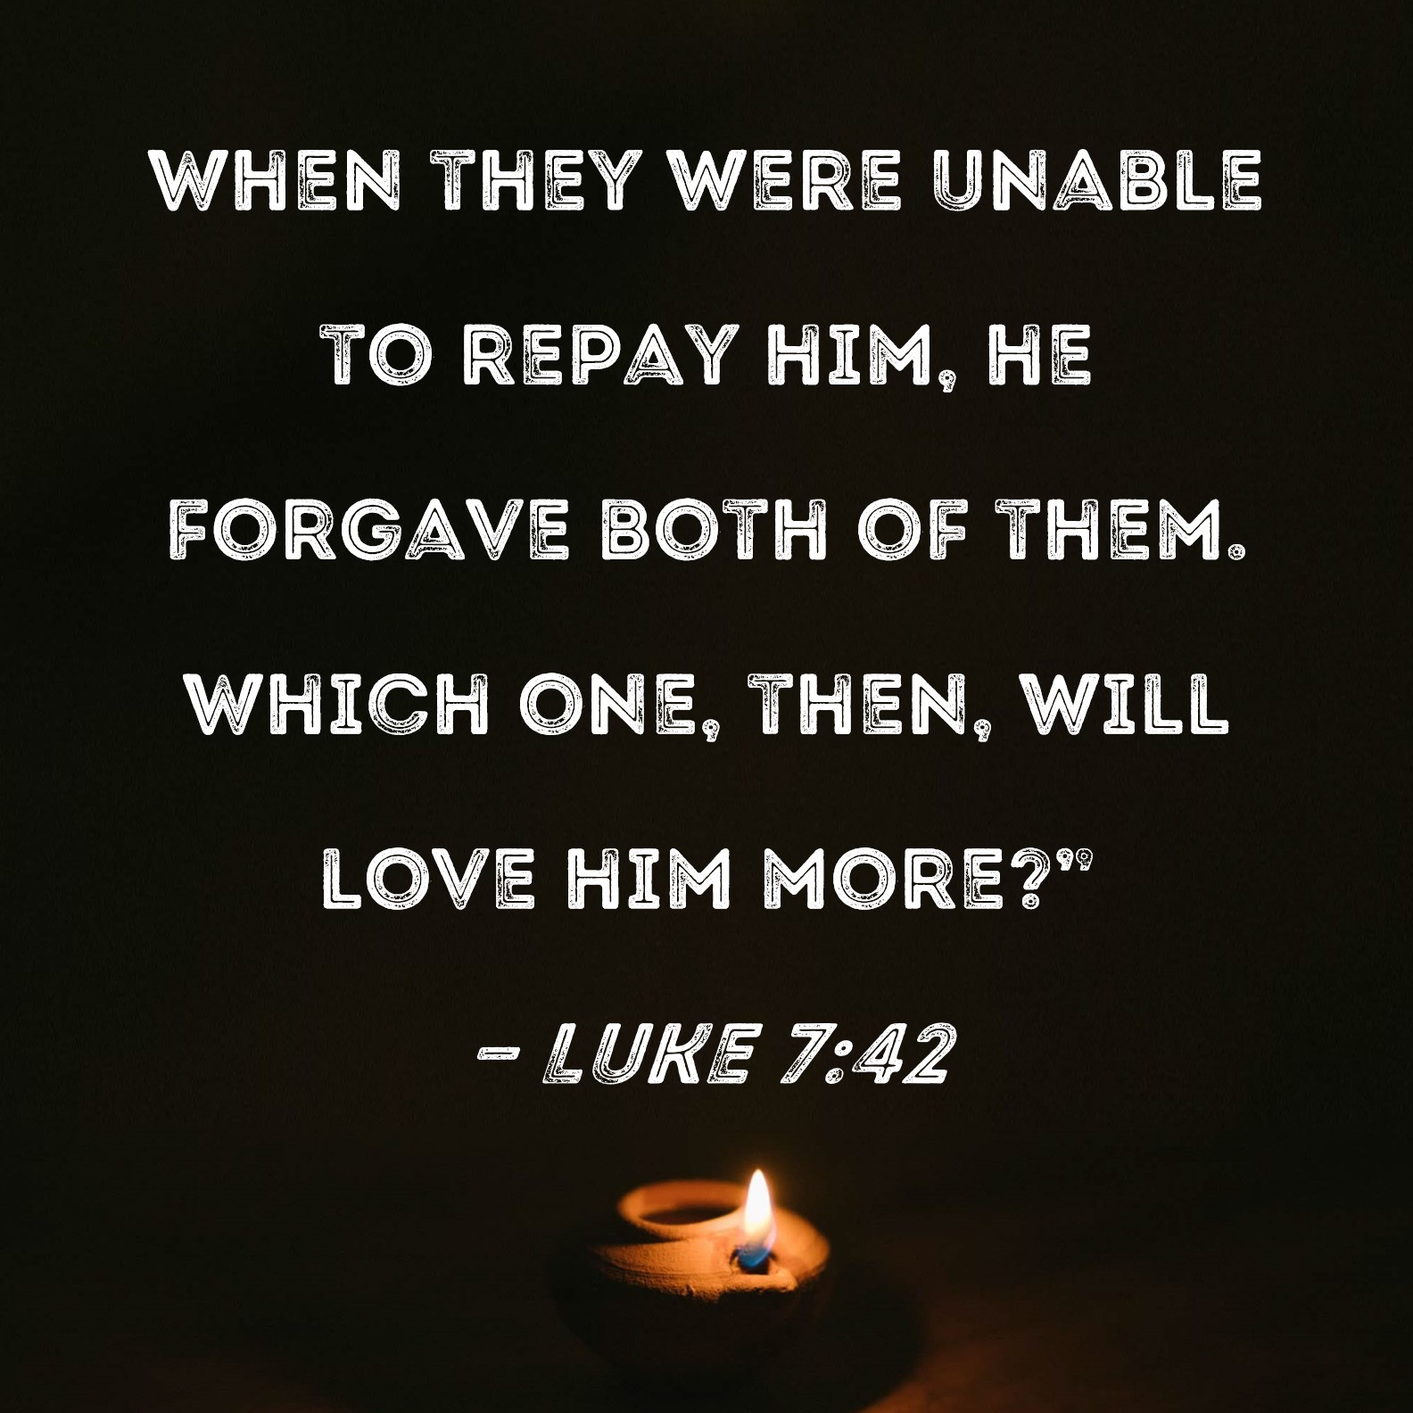

.

FOURTH SUNDAY OF EASTER
YEAR C – Sunday 11TH MAY 2025

1st Reading: Acts13: 14,43-52
Responsorial Psalm:
Ps 99:1-3, 5
2nd Reading: Rev 7: 9, 14-17
Gospel:
Jn 10: 27-30

Our cities are becoming more crowded yet more than ever before people are lonely. Sadly many travel on crowded trains and work in buildings full of people, yet feel left out. Jesus is telling us our role is to “reach out” even to people we don’t know and tell them they are part of our family. We are after all brothers and sisters with one Father.
If we do this then the “Kingdom is here” and Jesus is our king. If we don’t create the “kingdom “ here who can?

1st Reading: Isaiah:22:19-23; 2nd Reading: Romans 11:33-36; Gospel: Mathew 16:13-20

Entrance Antiphon: Cry out with joy to God, all the earth; O sing to the glory of his name. O render him glorious praise, Alleluia”.
Responsorial Psalm: I will praise you, Lord, for you have rescued me.

Gospel Acclamation: Alleluia, Alleluia! Christ is risen, the Lord of all creation; he has shown pity on all people. Alleluia!

HOLY CHILD PRIMARY SCHOOL – is in the process of establishing an Alumni platform and would love to reconnect with past students. If you have attended Holy Child Primary School, please reach out to the office on 9309 1620, and we will connect you with the appropriate staff member.

.
Holy Child Parish….

Is committed to a safe nurturing culture for all our children.

PLEASE KEEP THEM IN YOUR PRAYERS
Multi-Cultural Dinner Dance - 18 June
This major fundraiser is fast approaching. Tickets on sale after Mass. Organise a table with family/friends. A great family fun evening. Donations of cash/gift items for raffle/door prizes are most welcome. Help to set up on the day/before would be greatly appreciated. Ring the Office and leave your name. Help and support your Parish. Tickets also available at the Parish Office or above Committee Members.

Mass for Expectant Mothers-The Life, Marriage & Family Office warmly invite all expectant mothers and their families to the Mass for Expectant Mothers. The Mass will be celebrated by Archbishop Denis Hart at St Patrick's Cathedral on Sunday 5 June at 11.00am. Registrations can be made online at: www.cam.org.au/lifemarriagefamily or alternatively by contacting: 9287 5587 or Lmf@cam.org.au. Please note that registration closes on Friday 27 May. Expectant mothers who register will receive a small token of recognition.

(Names of the sick will only be printed for a month, unless the Office has been notified otherwise)

SICK: Molly Knox, Joan Lobs, Shirley Martin, Adrian Zuccato, Nguyen Thi Thin, Le Thi Quy, Dina, Jack Ward, Lien, Connie
REMEMBRANCES: Stella Sultana, Liberata Busuttil, Michael Rahme, Margaret Brown, Doreen Newman, Tartzea Scarri, Pearl Oakes, Peter Nang Nguyen, Peter Thong Nguyen, Peter Thai Nguyen, Robertus Suhendro, Trisno, Albina Da Costa, Alfredo M Pires, Julieta Pires, Carminda De Oliveira, Maria Marcal, Almeiro Marcal, Justino Marcal, Domingas Ferrera, Amelia Espiritu, Vince Bazzani.

The Souls in Purgatory, departed souls, and all deceased persons mentioned in the Book of Remembrance.

RECENT DEATHS: Pope Francis

all departed souls, the Souls in Purgatory and all those mentioned in the Book of Remembrance.

RECENT DEATH:

COLLECTIONS
With our change to envelopes for the collection of money to support our Church and Presbytery, we will now revert back to only one collection during Mass. Loose money will be divided up between Church and Presbytery, but we need a couple more weeks to work out what percentage of the loose money goes to Church or Presbytery.
Revert to one collection will start on the WEEKEND OF 10TH-11TH MAY.
If you have any questions, please speak to any member of the Finance Committee.

PARISH OFFICE CLOSED
Parish Office will be closed on
Thursday 15th May (all day) as office staff will be at an administrator meeting.

VOLUNTEERS FOR COUNTING PROJECT COMPASSION MONEY
We are looking for volunteers to help count project compassion money on
Thursday 8th May 2025 at 12.00pm

ST MARK’S CHURCH FAWKNER
Solemn Memorial Mass at St Mark’s Church for Pope Francis on Wednesday 7th May at 7.00pm.
All are welcome.

SCHEDULING APPTS WITH FR JOE
Please note that Parishioners are encouraged to schedule an appointment with Fr Joe as walk-in meetings are not always ideal.

CHURCH BOOKING (DALLAS)
Thursday 8th May 2025 at 5.30pm at Holy Child Church (Dallas)
Information evening for parents and children preparing for Reconciliation.

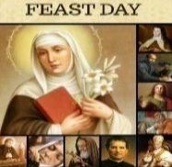
Thanksgiving Collection
Church Offering Loose: $603.10
Presbytery Loose: $609.00

Church (Actual): $865.00
Church (Pledge): $1033.36
Presbytery (Actual): 635.70
Presbytery (Pledge): 723.06
Feast Day During the Week
10th May – St John De Avila

EASTER RAFFLE TICKET FUNDRAISER TOTAL RAISED $5,260






BAPTISM PREPARATION AND
BAPTISM DATES
Baptism Preparation Day
Wednesday, 7th May, 2025 at 4.00pm
Holy Family Centre.
Baptism Ceremony
Sunday, 8th June, 2025 at 12:15pm, Holy Child, Dallas
Please contact the Parish office.
BOOKING THE HOLY
FAMILY CENTRE
The Holy Family Centre is Available for any group or parishioners to book.
Please call the Parish Office on 9412 8409 to make a booking.
Flowers Donated By

Angela Pieris

COUNTING ROSTER FOR MAY/JULY 2025
EASTER RAFFLE 2025 (BOOKLETS)
Easter Raffle tickets are now available to purchase singly
or booklets of 5 at $5 per ticket. GREAT PRIZES! Please pick up your booklets after each weekend mass…..and Happy Selling!!

Judy, Juanita & Sr V | 6 May | 10 June
Hai, Loan, Mele | 13 May | 17 June
Judy, Juanita & Sr V | 20 May | 24 June
Hai, Loan, Mele | 27 May | 1 July
Judy, Juanita & Sr V | 3 June | 8 July

DALLAS CHURCH CLEANING ROSTER FOR MAY/JULY 2025
Group | Names | Date | Date
A | Fr Joe, Mele &friends, Thu, Dong | 10/11 May | 14/15 June
B | Damian & Sarah Kempen, Anita Barnabas, Magina Musingarabul | 17/18 My | 21/22 June
C | Viet Legion of Mary | 24/25 May | 28/29 June
D | Sam & Vicky Buhagier, Cynthia Juico | 31 May/1 June | 5/6 July
E | Van My Nguyen Family | 7/8 June | 12/13 July
THIS Weekend ROSTERS: (3-4 May, 2025)

 | (SAT) 6.00 pm | (SUN) 9.00 am | (SUN) 11.00 am
Readers | Damian | Henry | Bach Van
Commentators | Vicky Buhagiar | Juanita | Hai Nguyen
Special Ministers | Tuyet Nguyen | Taafoanga | Thuy Nguyen
Money Collectors | As Per | Volunteers | At Each Mass
NEXT Weekend ROSTERS: (10-11 May 2025)
 | (SAT) 6.00 pm | (SUN) 9.00 am | (SUN) 11.00 am
Readers | Thien Nguyen | Thuy Pell | Anita Barnabas
Commentators | Lily | Phuong Loan | Cecilia Yong
Special Ministers | Vicky Buhagiar | Tuyet Quang | Lahra Stewart
Money Collectors | As Per | Volunteers | At Each Mass

----------------------------------------------------------------------------------
ADVERTISEMENTS
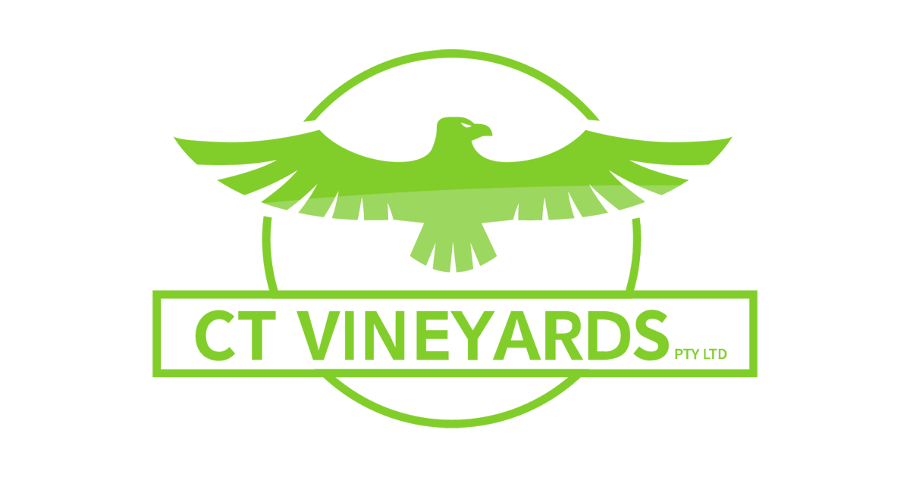
Exporter of Australian Grapes 218B Main Rd,
PH: 0428 126 982 East St Albans
PH: 9356 0555

Ian Webb
Melmarsh Plumbing
Fully Licenced Plumber
PH: 0407 599 599

Dr Tammy Nguyen
Braybrook Dental Group
Ph: 9078 1019



THE ROAST HOUSE
162 Gladstone Park Shopping Centre PH: 0468 946 704
SPECIAL
Vietnamese Roll
Chicken Schnitzel Roll
Chicken Skewer
Fried Rice
Noodles + more



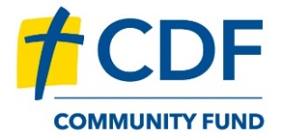
Save with CDF Community Fund – it’s in everyone’s best interest.

By opening a savings account or Term Investment, not only will you receive a competitive financial return, but your savings will also help build parishes, classrooms, hospital wings, aged care homes and social service facilities. With competitive interest rates available across a range of savings accounts, including 5.10% p.a.* on a 6-month Term Investment, it’s a way to save while doing good. To find out more, visit www.catholicdevelopmentfund.org.au/communityfund/offer, scan the QR code, or speak to us on 1800 134 135.
*Interest rates subject to change. View current rates on the CDF website.

