
 5th October,2025

The Chimes

Dallas & Meadow Heights

27th SUNDAY IN ORDINARY TIME - YEAR C
SUNDAY 5th October, 2025

1st Reading: Hab1: 2-3, 2:2-4 2nd Reading: 2 Tim 1:6-8, 13-14
Gospel: Lk 17:5-9

Parish Priest: Fr Joseph D.Truong
0415 455 845
Email: Joseph.DanhTruong@cam.org.au

Priest in Residence - Fr Fadhel Yakob
(Syriac Rites) 0433 833 647

Parish Secretary: Carol McPherson
Office hours: Tuesday & Friday
9am—5pm (other times: By appointment with
Fr Joe 0415 455 845)

CHURCH: 227 Blair St, Dallas 3047

Parish Office & Holy Family Centre:

133 Malmsbury Dr, Meadow Heights

Phone: 9412 8409
Email: dallas@cam.org.au
Website: https://www.melbcatholic.org/s/dallas

Parish House: 115 Corinella Cres. Dallas.

School Principal: Mr. Alan Smith

School Office: 9309 1620

WEEKDAY MASSES:
Dallas: Tues - Fri. 9.15 am
1st Fri. Anointing Mass: Dallas 10 am

WEEKEND MASSES:
Sat. Dallas Vigil Mass 6.00 pm
Sun. Meadow Heights 9.00 am
Dallas 11.00 am
*Note: Vietnamese Mass
2nd Sunday of the Month: 9.00 am HFC
4th Sunday of the Month: 11.00 am HFC

RECONCILIATION
Dallas Saturday 5.15 - 5.45 pm
Thursday 8.45 - 9.00 am

LEGION OF MARY
Eng. Tues after 9.15am mass – Dallas
Viet. Sat. at 9 am at Holy Family Centre

ADORATION & BENEDICTION
Of the Blessed Sacrament
Fridays 8:45am (English) Dallas
1st.Friday 9.30 am before Mass
Fridays 6.30 pm (Viet) Holy Family Centre

BAPTISMS
Contact Parish Office during office hours

WEDDINGS
Please contact Parish Office
Preferably 6 months before the wedding .


The conversation in this text occurs as Jesus is journeying towards Jerusalem, after he has already informed his disciples that he will endure great suffering there (Luke 9:44–45). In the verses just before this text, Jesus told the disciples that they must constantly forgive the wrongs committed against them. It is little wonder that the disciples are confused and beg Jesus to increase their faith. They want to believe in him, but some of his teachings are difficult to comprehend. Jesus explains that even a little faith can work miracles. The second part of this text can also be confusing to understand. The servant in question is probably grateful that he has a field to plough, or sheep to tend, and a home to which he can return. He depends utterly on the master—and it would be a disorder if the master served the servant! We also depend on God, who provides for all our needs; in return, our task is to serve faithfully. When we have done our best in this, we have done our duty. (source: summit on line)

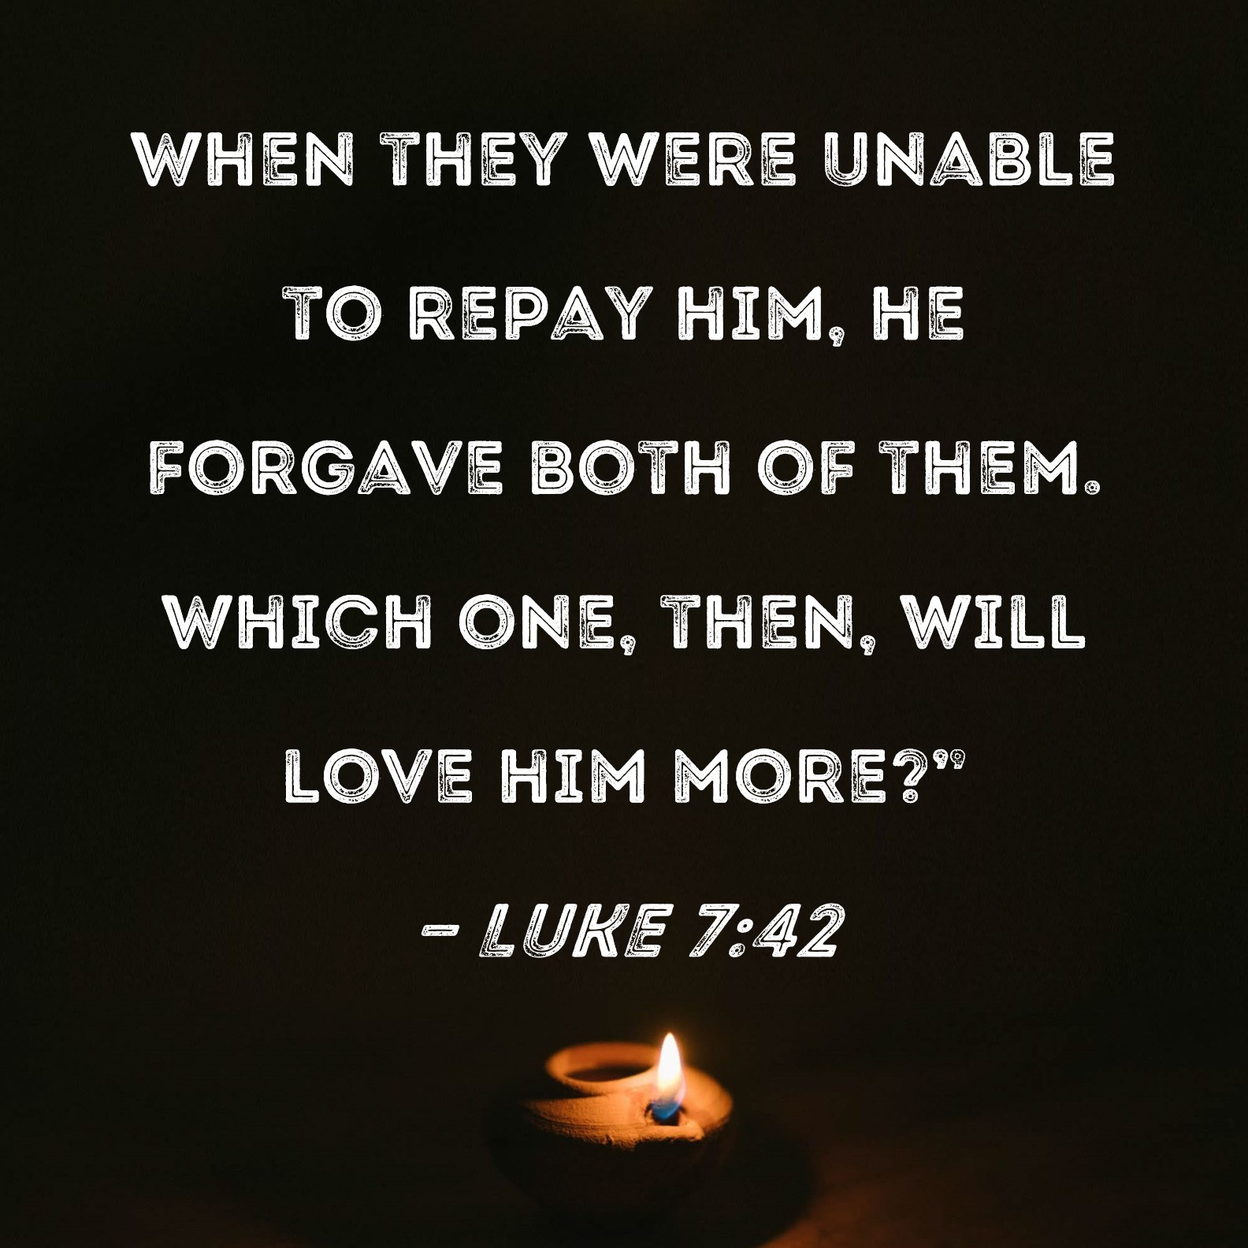

.

****PARISH DIAMOND JUBILEE CELEBRATION****

When: Saturday, October 11

Time: 5 PM Mass followed by
a Dinner Dance
(International Buffet)

NO TICKET – NO ENTRY

1st Reading: Isaiah:22:19-23; 2nd Reading: Romans 11:33-36; Gospel: Mathew 16:13-20

28th SUNDAY IN ORDINARY TIME - year C
Sunday 12th October, 2025

1st Reading: 2 Kg 5:14-17

Responsorial Psalm:
Ps 97: 1- 4
2nd Reading: 2 Tim 2: 8-13

Gospel: Lk 17:11-19

Our cities are becoming more crowded yet more than ever before people are lonely. Sadly many travel on crowded trains and work in buildings full of people, yet feel left out. Jesus is telling us our role is to “reach out” even to people we don’t know and tell them they are part of our family. We are after all brothers and sisters with one Father.
If we do this then the “Kingdom is here” and Jesus is our king. If we don’t create the “kingdom “ here who can?

1st Reading: Isaiah:22:19-23; 2nd Reading: Romans 11:33-36; Gospel: Mathew 16:13-20

Responsorial Psalm: If today you hear his voice, harden not your hearts.

Gospel Acclamation: . Alleluia, Alleluia! The word of the Lord stands for ever; it is the word given to you, the Good News. Alleluia!

Holy Child Parish….

Is committed to a safe nurturing culture for all our children.
HOLY CHILD PRIMARY SCHOOL – is in the process of establishing an Alumni platform and would love to reconnect with past students. If you have attended Holy Child Primary School, please reach out to the office on 9309 1620, and we will connect you with the appropriate staff member.

.

(Names of the sick will only be printed for a month, unless the Office has been notified otherwise)

SICK: Molly Knox, Joan Lobs, Shirley Martin, Adrian Zuccato, Nguyen Thi Thin, Le Thi Quy, Dina, Jack Ward,
Lien, Connie, Miriam Smith, Florentino Casimiro, Farif Ashlaq.

REMEMBRANCES: Josephine Camilleri, Regina Perenne, Albina Da Costa, Suzanne Nyssen, Rose Azzopardi, Shashi & Donis Patel, Evelyn Foote, Gladys & Paul LaBouchardiere, Oscar Fullinfaw, Jelsua Fullinfaw, Bob Habart, Zarina Habart, Robert & Retha Hurley, Colleen Madeire, Chris & Vivienne Andrews, Maggie & Andrea Braganza, Stephen, Liza & Irene Fernandes, Jennifer Clzerd, Madeleine Dullard, Gordon & Paget Dullard, Francis Grech, Joseph Galea, Anna, Antonia Salanitri, Antonia Pirotta, Jean Daniel Bonno,.

The Souls in Purgatory, departed souls, and all deceased persons mentioned in the Book of Remembrance.

RECENT DEATHS:

all departed souls, the Souls in Purgatory and all those mentioned in the Book of Remembrance.

RECENT DEATH:

PLEASE KEEP THEM IN YOUR PRAYERS
Multi-Cultural Dinner Dance - 18 June
This major fundraiser is fast approaching. Tickets on sale after Mass. Organise a table with family/friends. A great family fun evening. Donations of cash/gift items for raffle/door prizes are most welcome. Help to set up on the day/before would be greatly appreciated. Ring the Office and leave your name. Help and support your Parish. Tickets also available at the Parish Office or above Committee Members.

Mass for Expectant Mothers-The Life, Marriage & Family Office warmly invite all expectant mothers and their families to the Mass for Expectant Mothers. The Mass will be celebrated by Archbishop Denis Hart at St Patrick's Cathedral on Sunday 5 June at 11.00am. Registrations can be made online at: www.cam.org.au/lifemarriagefamily or alternatively by contacting: 9287 5587 or Lmf@cam.org.au. Please note that registration closes on Friday 27 May. Expectant mothers who register will receive a small token of recognition.

BAPTISM PREPARATION AND
BAPTISM DATES
Baptism Preparation Day
Wednesday, 5th November
Holy Family Centre.
Baptism Date:
SUNDAY, 7th December

SCHEDULING APPTS WITH
FR JOE
Please note that Parishioners are encouraged to schedule an appointment with Fr Joe as walk-in meetings are not always ideal.
BOOKING THE HOLY
FAMILY CENTRE
The Holy Family Centre is Available for any group or parishioners to book.
Please call the Parish Office
on 9412 8409 to make a booking.

DIRECT DEBIT & CREDIT CARD CONTRIBUTORS
If you notice anything unusual on your bank statement related to your pledge to our parish, please contact the parish office promptly. We will investigate the matter for you. Thank you!

CHAIR OF PASTORAL COUNCIL
Damian Kempen will finish his term as chair of the Pastoral Council on
12th October, 2025

DONATIONS
IF YOU WISH TO DONATE RAFFLE ITEMS FOR THE PARISH DIAMOND JUBILEE CELEBRATIONS FOR SATURDAY 11/10/25.
PLEASE DROP THEM OFF IN THE NOMINATED BOX AT HFC.

MASS OFFERING ENVELOPES
A very gentle reminder – Please do not put mass offering envelopes in the collection bags. Please give them directly to Fr Joe.
Thank you!


Feast Day During the Week
6 Oct – St Bruno
7 Oct – Our Lady of the Rosary
1 Oct – St Therese of the Child Jesus
9 Oct – St Denis & Companions, St John Leonardi
11 Oct – St John XXIII, Pope/Blessed Virgin Mary

Thanksgiving Collection
Loose: $351.65
Church (Actual): $932
Church (Pledge): $1324.46
Presbytery (Actual): $577
Presbytery (Pledge): $950.55


Flowers Donated By

--------

Special Collection

---------
--------




-----------------------------------------------------------------------------------------------------------------------------------------------------------------------------------------------------------------------------------------------------------------------------------------------------------------------------------

COUNTING ROSTER FOR SEPT/NOV 2025
Hai, Loan, An, Mai | ------- | 28 Oct
Judy, Juanita, Mele & Sr V | 7 Oct | 4 Nov
Hai, Loan, An, Mai | 14 Oct | 11 Nov
Judy, Juanita, Mele & Sr V | 21 Oct | 18 Not

DALLAS CHURCH CLEANING ROSTER FOR SEPT/NOV 2025
Group | Names | Date | Date
A | Mele &friends, Dong | ------ | 1/2 Nov
B | Damian & Sarah Kempen, Anita Barnabas, Magina Musingarabul | ----- | 8/9 Nov
C | Viet Legion of Mary | 11/12 Oct | 15/16 Nov
D | Sam & Vicky Buhagiar, Cynthia Juico | 18/19 Oct | 22/23 Nov
E | Van My Nguyen Family | 25/26 Oct | 29/30 Nov

THIS Weekend ROSTERS: (4-5 Oct, 2025)

 | (SAT) 6.00 pm | (SUN) 9.00 am | (SUN) 11.00 am
Readers | Sr Veronica | Veronica S | Anita B
Commentators | Hanh Nguyen | Judy | Cynthia
Special Ministers | Vicky B | Juanita | Mele
Money Collectors | As Per | Volunteers | At Each Mass

NEXT Weekend ROSTERS: (11-12 Oct, 2025)
 | (SAT) 6.00 pm | (SUN) 9.00 am | (SUN) 11.00 am
Readers | Special Roster | Hai Vu | Lahra
Commentators | Special Roster | Thuy Pell | Adorabella
Special Ministers | Special Roster | Volunteer | Jacinto Juico
Money Collectors | As Per | Volunteers | At Each Mass

---------------------------------------------------------------------------------
ADVERTISEMENTS
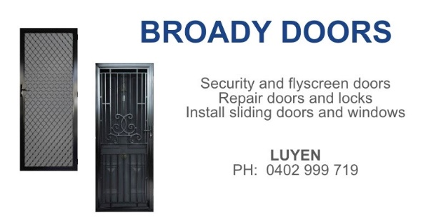

HAI CARPORT
Specialised In:
Fencing, Carport, Verandah, All Doors, Automatic Gates, Roller Doors,
Remote Control Doors & Gates
Contact: Hai (03) 9367 5520
Mob: 0423 971 568

ADVERTISE YOUR BUSINESS HERE FOR $50 FOR 3 MONTHS

