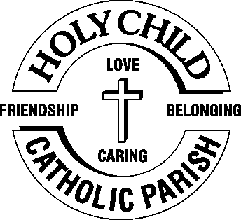
 9TH November,2025

The Chimes

Dallas & Meadow Heights

32ND SUNDAY IN ORDINARY TIME - YEAR C
SUNDAY 9TH NOVEMBER, 2025
THE DEDICATION of the LATERAN BASILICA

1st Reading: Ezek 47:1-2, 8-9, 12 2nd Reading: 1 Cor 3: 9-11, 16-17
Gospel: Jn 2: 13-22

Parish Priest: Fr Joseph D.Truong
0415 455 845
Email: Joseph.DanhTruong@cam.org.au

Priest in Residence - Fr Fadhel Yakob
(Syriac Rites) 0433 833 647

Parish Secretary: Carol McPherson
Office hours: Tuesday & Friday
9am—5pm (other times: By appointment with
Fr Joe 0415 455 845)

CHURCH: 227 Blair St, Dallas 3047

Parish Office & Holy Family Centre:

133 Malmsbury Dr, Meadow Heights

Phone: 9412 8409
Email: dallas@cam.org.au
Website: https://www.melbcatholic.org/s/dallas

Parish House: 115 Corinella Cres. Dallas.

School Principal: Mr. Alan Smith

School Office: 9309 1620

WEEKDAY MASSES:
Dallas: Tues - Fri. 9.15 am
1st Fri. Anointing Mass: Dallas 10 am

WEEKEND MASSES:
Sat. Dallas Vigil Mass 6.00 pm
Sun. Meadow Heights 9.00 am
Dallas 11.00 am
*Note: Vietnamese Mass
2nd Sunday of the Month: 9.00 am HFC
4th Sunday of the Month: 11.00 am HFC

RECONCILIATION
Dallas Saturday 5.15 - 5.45 pm
Thursday 8.45 - 9.00 am

LEGION OF MARY
Eng. Tues after 9.15am mass – Dallas
Viet. Sat. at 9 am at Holy Family Centre

ADORATION & BENEDICTION
Of the Blessed Sacrament
Fridays 8:45am (English) Dallas
1st.Friday 9.30 am before Mass
Fridays 6.30 pm (Viet) Holy Family Centre

BAPTISMS
Contact Parish Office during office hours

WEDDINGS
Please contact Parish Office
Preferably 6 months before the wedding .
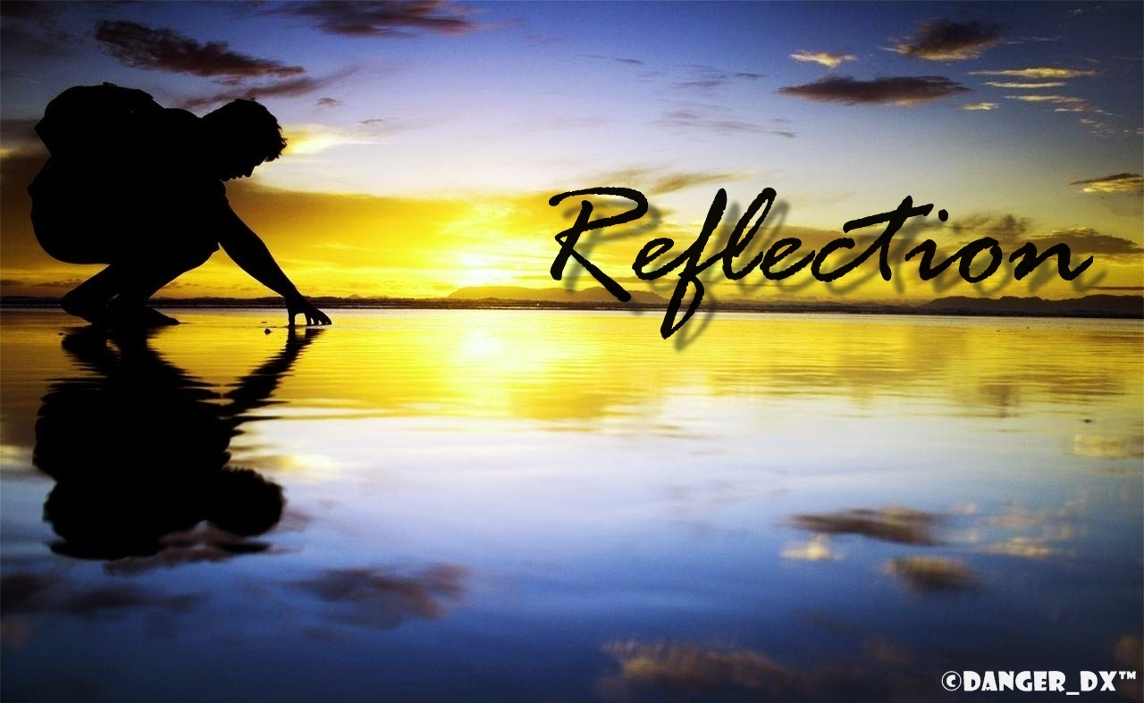

Here, the Gospel of John records one of Jesus’ most outrageous statements. To understand the significance of it, however, we would have to understand the significance the Temple held for ancient Jews. It has been said that the architecture of a city reveals its underlying philosophy: a modern cityscape of metal and glass, for example, where the tallest buildings are banks and datacentres, reveals something important about the concerns we prioritise — function, efficiency, economy. For ancient Jews, the absolute centre of their social, religious, and political existence was the Temple. Everything revolved around it. The Temple was a microcosm of the whole cosmos: not only the place of sacrifice and atonement, but it was meant to be the place where God’s presence dwelt among his people. It was the place where heaven and earth met. The presence of God had not dwelt there for some time, however; around 591 BC, the prophet Ezekiel saw the glory of the Lord depart from them, an event that sent Israel into turmoil. To have Jesus of Nazareth, the Word made flesh, walk into the Temple was astounding enough, since it represented the return of God’s presence, though they didn’t recognise it. The fact that he also scattered the money changers and drove the animals away added something else to the equation: the old system of temple sacrifice was coming to an end. A new age was coming, where worship would revolve around a new temple: the crucified and risen Christ, the one in whom humanity and divinity, heaven and earth, fully embraced.
(source: the summit on-line)

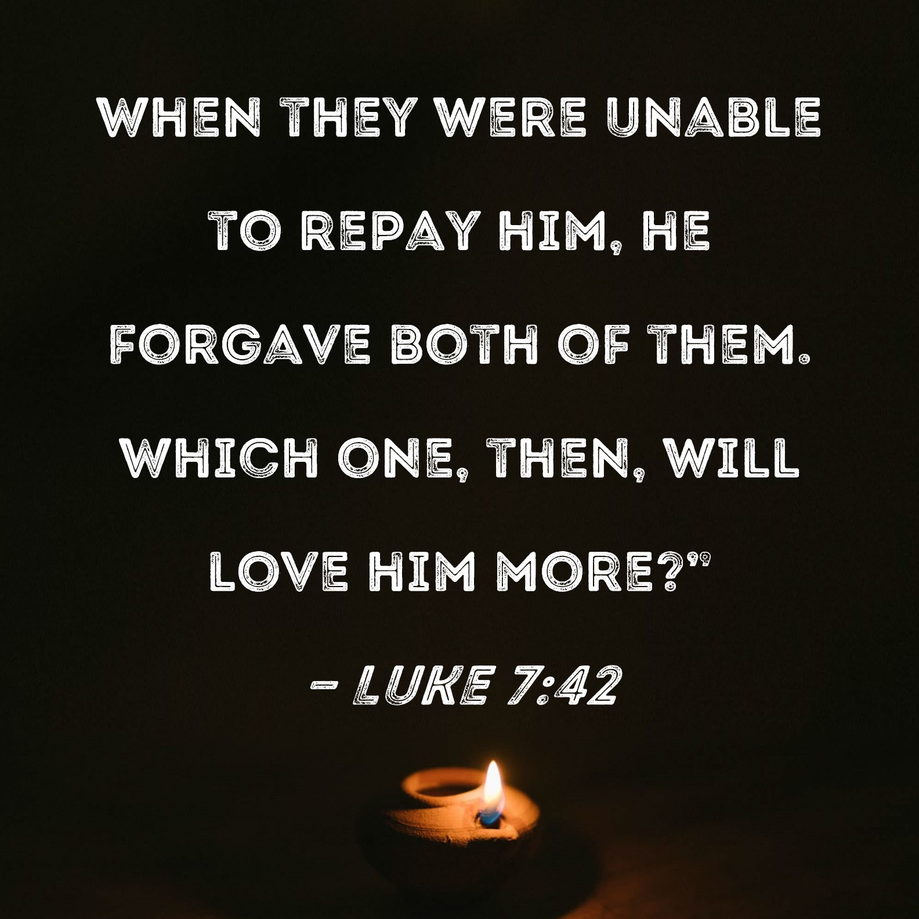

.

33RD SUNDAY IN ORDINARY TIME- year C
Sunday 16TH November, 2025

1st Reading: Mal 3:19-20

Responsorial Psalm: Ps 97: 5-9

2nd Reading: 2 Thess 3: 7-12

Gospel: Lk 21: 5-19

Our cities are becoming more crowded yet more than ever before people are lonely. Sadly many travel on crowded trains and work in buildings full of people, yet feel left out. Jesus is telling us our role is to “reach out” even to people we don’t know and tell them they are part of our family. We are after all brothers and sisters with one Father.
If we do this then the “Kingdom is here” and Jesus is our king. If we don’t create the “kingdom “ here who can?

1st Reading: Isaiah:22:19-23; 2nd Reading: Romans 11:33-36; Gospel: Mathew 16:13-20

Responsorial Psalm: The waters of the river gladden the city of God.

Gospel Acclamation: Alleluia, Alleluia! I have chosen and sanctified this house, says the Lord, that my name may remain in it for all time. Alleluia!

Holy Child Parish….

Is committed to a safe nurturing culture for all our children.
HOLY CHILD PRIMARY SCHOOL – is in the process of establishing an Alumni platform and would love to reconnect with past students. If you have attended Holy Child Primary School, please reach out to the office on 9309 1620, and we will connect you with the appropriate staff member.

.

(Names of the sick will only be printed for a month, unless the Office has been notified otherwise)

SICK: Joan Lobs, Shirley Martin, Adrian Zuccato, Nguyen Thi Thin, Le Thi Quy, Dina, Jack Ward,
Lien, Connie, Miriam Smith, Florentino Casimiro, Farif Ashlaq.

REMEMBRANCES: Frank Bartley, Esme Senn, Edward Pipe, Erica Shine, George Ziegleaar, Carmel Bonello, Franceska Bonello, Wasyl Pushkar, Emanuel Camilleri, Barbara McLoone, Maria Nguyen, Aslem, William Crossin, Jose De Melo, Antonio Oricchio, Rose & Alphonse Azzopardi, Fernando & Serfina Caling, Leonardo Caling, Paul Azzopardi, Victor & Joe Xerri, Rodolfo Ragusante, Wilma Pate, Manuel & Serendidad Javier, Nereus Javier, Fernando Caling Jr, Fernando Caling III, Andrew Francis, Gladys Francis, Monica Francis, Sonny, Francis, Farida Hanna, Albert Hanna, Afifa Hamaway, George Manaway, Marie Hanna, Gallil Hanna.

RECENT DEATHS: Molly Knox (Sr Veronica’s sister)

all departed souls, the Souls in Purgatory and all those mentioned in the Book of Remembrance.

RECENT DEATH:

PLEASE KEEP THEM IN YOUR PRAYERS
Multi-Cultural Dinner Dance - 18 June
This major fundraiser is fast approaching. Tickets on sale after Mass. Organise a table with family/friends. A great family fun evening. Donations of cash/gift items for raffle/door prizes are most welcome. Help to set up on the day/before would be greatly appreciated. Ring the Office and leave your name. Help and support your Parish. Tickets also available at the Parish Office or above Committee Members.

Mass for Expectant Mothers-The Life, Marriage & Family Office warmly invite all expectant mothers and their families to the Mass for Expectant Mothers. The Mass will be celebrated by Archbishop Denis Hart at St Patrick's Cathedral on Sunday 5 June at 11.00am. Registrations can be made online at: www.cam.org.au/lifemarriagefamily or alternatively by contacting: 9287 5587 or Lmf@cam.org.au. Please note that registration closes on Friday 27 May. Expectant mothers who register will receive a small token of recognition.

BAPTISM PREPARATION AND
BAPTISM DATES
Baptism Preparation Day
3rd December, 2025

Holy Family Centre.
Baptism Date:
(No baptisms in Jan 2026)

SCHEDULING APPTS WITH FR JOE
Please note that Parishioners are encouraged to schedule an appointment with Fr Joe as walk-in meetings are not always ideal.
BOOKING THE HOLY
FAMILY CENTRE
The Holy Family Centre is Available for any group or parishioners to book.
Please call the Parish Office
on 9412 8409 to make a booking.

VOLUNTARY ASSISTED DYING AND EUTHANASIA BILLS
Parishioners are encouraged to write to their local Member of Parliament and request that they vote against the proposed revised Voluntary Assisted Dying and Euthanasia Bill.

FR JOE’S ANNUAL LEAVE
During Fr Joe’s annual leave from 5th to 26th November, there will only be Mass in the Parish on Thursdays and Fridays. There will be NO Adoration or Benediction on Fridays.

ST VINCENT DE PAUL SOCIETY AT GOOD SHEPHERD – GLADSTONE PARK
St Vincent De Paul Society at Good Shepherd Gladstone Park have asked us to, once again donate toys for children aged baby to 12 years, for their Christmas Appeal. The “big box” will be ready for your UNWRAPPED gifts from Saturday 29th November until 12 noon Sunday 15th December (there are NO “Gift Tags” yet). – Brenda Nyssen.

NOTICE FROM PENOLA CATHOLIC COLLEGE
We would like to invite you to attend Mercy Night in the St Joseph Chapel on the Broadmeadows Campus.
Wednesday the 19th of November 6.00pm
Any question please don’t hesitate to email faithandmission@penola.vic.edu.au

Catholic Mission sincerely thanks the parish community of Holy Child for your generous and compassionate support of this year’s Propagation of the Faith Appeal. Your contribution of $1,077.35 has been gratefully received and will help provide vital care for mothers in Zambia, and empower local Church workers across more than 1,000 mission dioceses around the world.
Through your partnership, countless families will find not only practical help, but also spiritual accompaniment, hope, and dignity. Your gift is more than charity - it is a concrete act of solidarity, and a sign of God’s love reaching out to those on the margins.
Thank you for being a living witness of Christ’s mission to the world.


Feast Day During the Week
10 Nov – St Leo the Great, Pope
11 Nov– St Martin of Tours
12 Nov – St Josaphat
15 Nov – St Albert the Great/Blessed Virgin Mary

Thanksgiving Collection
Loose: $346.40
Church (Actual): $697.00
Church (Pledge): $1324.46
Presbytery (Actual): $649.60
Presbytery (Pledge): $950.55


Special Collection

Flowers Donated By

Connie and family



-----------------------------------------------------------------------------------------------------------------------------------------------------------------------------------------------------------------------------------------------------------------------------------------------------------------------------------

COUNTING ROSTER FOR OCT/NOV/DEC 2025
Hai, Loan, An, Mai | ----- | 25 Nov
Judy, Juanita, Mele & Sr V | ------ | 2 Dec
Hai, Loan, An, Mai | 11 Nov | 9 Dec
Judy, Juanita, Mele & Sr V | 18 Nov | 16 Dec

DALLAS CHURCH CLEANING ROSTER FOR NOV/DEC 2025
Group | Names | Date | Date
A | Mele & friends, Fr Joseph | ----- | 6/7 Dec
B | Damian & Sarah Kempen, Anita Barnabas, Magina Musingarabul | ------ | 13/14 Dec
C | Viet Legion of Mary | 15/16 Nov | 20/21 Dec
D | Sam & Vicky Buhagiar, Cynthia Juico | 22/23 Nov | 27/28 Dec
E | Van My Nguyen Family | 29/30 Nov | 3/4 Jan 2026

THIS Weekend ROSTERS: (8-9 Nov 2025)

 | (SAT) 6.00 pm | (SUN) 9.00 am | (SUN) 11.00 am
Readers | Damian | Kim Oanh | Cynthia
Commentators | Hanh Nguyen | Phuong Loan | Lahra
Special Ministers | Vicky B | Volunteer | Adorabella
Money Collectors | As Per | Volunteers | At Each Mass

NEXT Weekend ROSTERS: (15-16 Nov, 2025)
 | (SAT) 6.00 pm | (SUN) 9.00 am | (SUN) 11.00 am
Readers | Thien | Juanita | Elenora
Commentators | Vicky B | Judy | Cynthia
Special Ministers | Tuyet Nguyen | Taafoanga | Jacinto
Money Collectors | As Per | Volunteers | At Each Mass

---------------------------------------------------------------------------------
ADVERTISEMENTS


HAI CARPORT
Specialised In:
Fencing, Carport, Verandah, All Doors, Automatic Gates, Roller Doors,
Remote Control Doors & Gates
Contact: Hai (03) 9367 5520
Mob: 0423 971 568

THE ROAST HOUSE
162 Gladstone Park Shopping Centre PH: 0468 946 704
SPECIAL
Vietnamese Roll
Chicken Schnitzel Roll
Chicken Skewer
Fried Rice
Noodles + more

ADVERTISE YOUR BUSINESS HERE FOR $50 FOR 3 MONTHS

