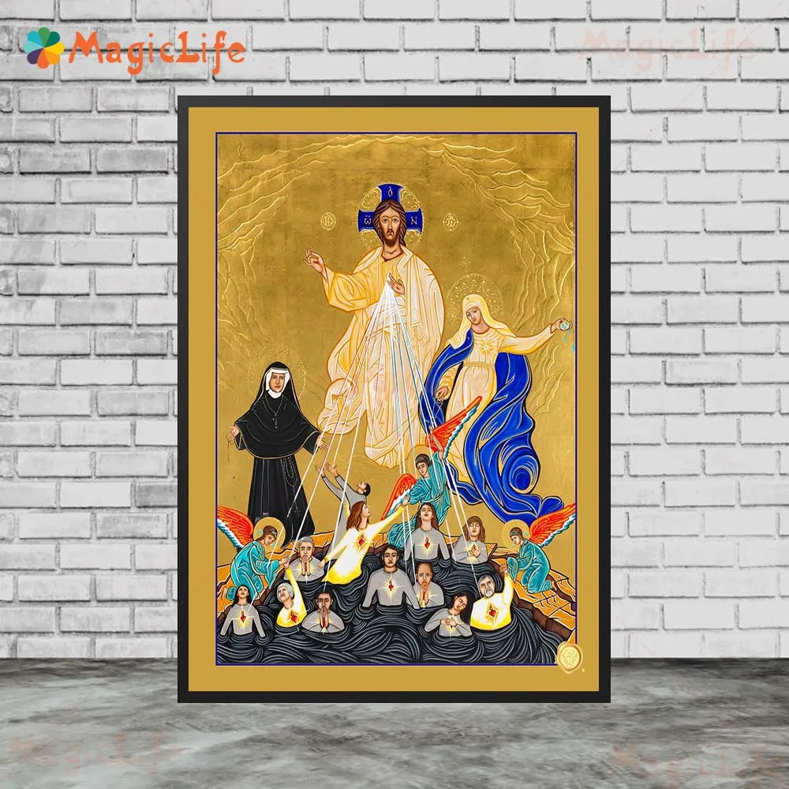

Requiem Service for the eternal repose of
.
NAME OF DECEASED PERSON
.
TIME
DATE

ST KEVIN’S CATHOLIC CHURCH
HAMPTON PARK

Words of RemembErance –
Photo tribute
ENTRANCE HYMN –
GREETING
Priest: + In the name of the Father, and of the Son, and of the Holy Spirit.
All: Amen.
Priest: The grace of our Lord Jesus Christ, and the love of God, and the communion of the Holy Spirit be with you all.
All: And with your spirit.

lighting of the Easter candle –
Sprinkling with Holy Water – priest
Placing of the Pall –
Placing of the flowers –
Placing of the photo –
placing of Rosary (Optional)-

INVITATION TO PRAYER
Priest: My brothers and sisters, we have come together to renew our trust in Christ who, by dying on the Cross, has freed us from eternal death and, by rising, has opened for us the gates of heaven. Let us pray for our sister, that she may share in Christ’s victory, and let us pray also for ourselves, that the Lord may grant us the gift of his loving consolation.

COLLECT
Priest: Let us pray.
Almighty God and Father, it is our certain faith that your Son, who died on the Cross, was raised from the dead, the first fruits of all who have fallen asleep. Grant that through this mystery, your servant NAME, who has gone to her rest in Christ, may share in the joy of his resurrection.
Through our Lord Jesus Christ, your Son, who lives and reigns with you and the Holy Spirit, one God, forever and ever.
All: Amen.

The Liturgy of the Word
FIRST READING | Ecclesiastes 3:1-11
[CHOOSE FROM OLD OR NEW TESTAMENT]
Reader: A reading from Ecclesiastes

There is a season for everything, a time for every occupation under heaven.
A time for giving birth, a time for dying.
A time for planting, a time for uprooting what has been planted.
A time for killing, a time for healing.
A time for knocking down, a time for building.
A time for tears, a time for mourning,
A time for dancing, a time for throwing stones away, a time for gathering them.
A time for embracing, a time to refrain from embracing.
A time for searching, a time for losing.
A time for keeping, a time for discarding.
A time for tearing, a time for sewing.
A time for keeping silent, a time for speaking.
A time for loving, a time for hating, a time for war, a time for peace.
What do people gain from the efforts they make? I contemplate the task that God gives humanity to labour at. All that he does is apt for its time, but although he has given us an awareness of the passage of time, we can grasp neither the beginning nor the end of what God does.
The Word of the Lord.
All: Thanks be to God.

RESPONSORIAL PSALM | Psalm 23
Reader: The Lord is my shepherd; there is nothing I shall want.
All: The Lord is my shepherd; there is nothing I shall want.
Reader: The Lord is my shepherd;
there is nothing I shall want.
Fresh and green are the pastures
where he gives me repose.
Near restful waters he leads me,
to revive my drooping spirit. R.
He guides me along the right path;
he is true to his name.
If I should walk in the valley of darkness
no evil would I fear.
You are there with your crook and your staff;
with these you give me comfort. R.
You have prepared a banquet for me
in the sight of my foes.
My head you have anointed with oil;
my cup is overflowing. R.
Surely goodness and kindness shall follow me
all the days of my life.
In the Lord’s own house shall I dwell
forever and ever. R.

GOSPEL ACCLAMATION | John 11:25-26
Reader: Alleluia, alleluia!
I am the resurrection and the life, says the Lord;
whoever believes in me will not die for ever.
Alleluia!

GOSPEL | John 14:1-6
Priest: The Lord be with you.
All: And with your spirit.
Priest: A reading from the holy Gospel according to John.
All: Glory to you, O Lord.
Priest: Jesus said to the disciples:
‘Do not let your hearts be troubled. Trust in God still, and trust in me. There are many rooms in my Father’s house; if there were not, I should have told you. I am going now to prepare a place for you, and after I have gone and prepared you a place, I shall return to take you with me; so that where I am you may be too. You know the way to the place where I am going.’
Thomas said, ‘Lord, we do not know where you are going, so how can we know the way?’ Jesus said:
‘I am the Way, the Truth and the Life. No one can come to the Father except through me.’
The Gospel of the Lord.
All: Praise to you, Lord Jesus Christ.

HOMILY Priest

PRAYERS OF THE FAITHFUL
Priest: God, the almighty Father, raised Christ his Son, from the dead; with confidence we ask him to save all his people, living and dead:
Reader: For NAME who in baptism was given the pledge of eternal life, that she may now be admitted to the company of the saints: let us pray to the Lord.
All: Lord, hear our prayer.
Reader: For our sister NAME who was nourished by the Body of Christ, the bread of life, that she may be raised up on the last day: let us pray to the Lord.
All: Lord, hear our prayer.
Reader: For all our deceased relatives and friends and for all who have helped us, that they may have the reward of their goodness: let us pray to the Lord.
All: Lord, hear our prayer.
Reader: For those who have fallen asleep in the hope of rising again, that they may see God face to face: let us pray to the Lord.
All: Lord, hear our prayer.
Reader: For the family and friends of NAME, that they may be consoled in their grief by the Lord, who wept at the death of his friend Lazarus: let us pray to the Lord.
All: Lord, hear our prayer.
Reader: For all of us assembled here to worship in faith, that we may be gathered together with all our loved ones again in God’s Kingdom: let us pray to the Lord.
All: Lord, hear our prayer.
Priest: God, our shelter and our strength, you listen in love to the sorrow of your people: hear the prayers we offer for all who have died. Cleanse them of their sins and grant them the fullness of redemption. We ask this through Christ our Lord.
All: Amen.

THE LORD’S PRAYER
Priest: At the Saviour’s command and formed by divine teaching, we dare to say:
All: Our Father….

Prayer after Communion Please Stand
Priest: Let us pray.
May the sacrifice of your Church, we pray, O Lord,
benefit the soul of your servant NAME,
so that she, who received
the Sacrament of Christ's mercy,
may enter his company, together with your Saints,
Who lives and reigns forever and ever.
All: Amen.

THE FINAL COMMENDATION
Priest: Before we go our separate ways, let us take leave of our beloved NAME. May our farewell express our affection for her; may it ease our sadness and strengthen our hope. One day we shall joyfully greet her again when the love of Christ, which conquers all things, destroys even death itself.

Priest: Saints of God, come to her aid! Come to meet her, angels of the Lord!
All: Receive her soul and present her to God the Most-High.
Priest: May Christ, who called you, take you to himself; may angels lead you to Abraham’s side.
All: Receive her soul and present him to God the Most-High.
Priest: Give her eternal rest, O Lord, and may your light shine on her for ever.
All: Receive her soul and present him to God the Most-High.

Priest: Into your hands, Father of mercies, we commend our beloved NAME in the sure and certain hope that, together with all who have died in Christ, she will rise with him on the last day. We give you thanks for the blessings which you bestowed upon NAME in this life: they are signs to us of your goodness and of our fellowship with the saints in Christ. Merciful Lord, turn towards us and listen to our prayers: open the gates of paradise to your servant and help us who remain to comfort one another with assurances of faith, until we all meet in Christ and are with you and with our sister for ever.
Through Christ our Lord.
All: Amen.

Priest: In peace let us take our sister to her place of rest.

Priest: May the angels lead you into paradise;
may the martyrs come to welcome you
and take you to the holy city,
the new and eternal Jerusalem.

RECESSIONAL HYMN –

