ST MARY OF THE ASSUMPTION PARISH
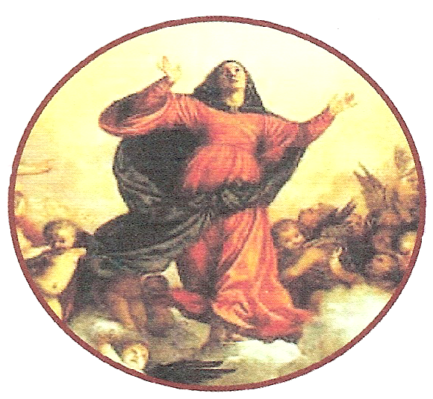

Sacrament of Baptism - 2026

- Fill in the attached Baptism Booking form

- Baptism forms may be returned by email to reception@stma.com.au mail or by delivering it personally to the Parish Office at 152 Odessa Avenue, Keillor Downs. Please call the parish office on 9364 0440 if you have any questions
- The Baptism Preparation meeting must be attended prior to the Baptism of your child.
BAPTISM MEETINGS are held at:
ADDRESS: | St. Mary MacKillop School Conference center (opposite the church)152 Odessa Ave, Keilor Down
TIME FOR MEETING: | 1pm
BAPTISM MASS TIMES: | St Mary MacKillop Church Saturday 2.30pm

Baptism are held at : St Mary Mackillop Church
BAPTISM MASS- Saturday 2.30pm | BAPTISM PREPARATION MEETING -Saturday at 1pm (Dates)
10th January 2026 | 13th December 2025
31st January 2026 | 13th December 2025
14th February 2026 | 13th December 2025
14th March 2026 | 14th February 2026
11th April 2026 | 14th February 2026
2nd May 2026 | 11th April 2026
16th May 2026 | 11th April 2026
13th June 2026 | 16th May 2026
27th June 2026 | 16th May 2026
11th July 2026 | 16th May 2026
25th July 2026 | 13th June 2026
22nd August 2026 | 13th June 2026
29th August 2026 | 13th June 2026
12th September 2026 | 25th July 2026
3rd October 2026 | 22nd August 2026
24th October 2026 | 22nd August 2026
7th November 2026 | 22nd August 2026
21st November 2026 | 22nd August 2026
5th December 2026 | 7th November 2026
19th December 2026 | 7th November 2026

ST MARY OF THE ASSUMPTION PARISH

WHAT IS BAPTISM?

Baptism is a time of special joy for your family and our parish community shares this joy with you.

Baptism is a sign, or sacrament, that Jesus gave us to show we are loved and “recreated” in God’s image.

Jesus said: “Unless a person is born through water and the Spirit, he cannot enter the kingdom of God”. (John 3.5)

This sacrament of faith is a time of cleansing and rebirth into the death and resurrection of Jesus.

WHAT IS ASKED OF YOU?

The very fact that you have chosen to have your child Baptised shows that you recognize the importance of God in your life.

As parents it is your responsibility to train your child in the practice of faith. It will be your duty to bring them up to keep God’s commandments as Jesus Christ taught us - to love God and our neighbor.

That is why at the beginning of the ceremony, you are asked if you clearly understand what you are undertaking.

If it is not a regular part of your life, you are invited to begin attending Mass each week. The Eucharist is the source and summit of the Christian life that began for you at your baptism.

Holy Communion, our most intimate union with Jesus in this life, must be received in the state of grace.

Godparents it is your duty to help these parents in their duty as Christian mother and fathers.

Without Faith and commitment baptism is only something “YOU GET DONE”.

FAITH

- The “door of faith” is always opened to us, ushering us into life of communion with God and offering entry into his church… To enter is to set out on a journey that lasts a lifetime. It begins with baptism, through which we can address God as Father, and it ends with the passage through death to eternal life, fruit of the resurrection of the Lord Jesus …

ST MARY OF THE ASSUMPTION PARISH

SACRAMENT OF BAPTISM 2026
(Celebrated at St Mary Mackillop Church)

BOOKING FORM

Note:
- Please PRINT clearly.
- complete all sections of this form, and
- return completed form to the Parish Office (by email, mail, or personal delivery) to book your requested date, and availability will be confirmed as soon as possible.

FULL NAME OF CHILD:
DATE OF BIRTH: |  |  |  |  |  | Male: [ ] Female: [ ]
NAME OF PARENTS: | Father: |  |  |  |  | Religion:
NAME OF PARENTS: | Mother: |  |  |  |  | Religion:
NAME OF PARENTS: | Mother's Maiden Name:
ADDRESS:
ADDRESS: |  |  |  |  |  |  | Postcode:
TELEPHONE: |  |  |  | Work:
MOBILE: | Father: |  |  | Mother:
EMAIL ADDRESS: | (for Booking confirmation only)
(Please Note: At least one Godparent must be Catholic)
FULL NAME OF GODFATHER/S: | 1.  Religion: |  |  |  | 2.  Religion:
FULL NAME OF GODMOTHER/S: | 1.  Religion: |  |  |  | 2.  Religion

PREPARATION MEETING DATE: |  |  |  |  | TIME: | 1pm
BAPTISM DATE: |  |  |  |  | TIME: | 2.30pm
Office Use Only:
CELEBRANT: |  |  | CONFIRMED: | Email / Phone / Verbal |  |  | DATE:
Comment:

