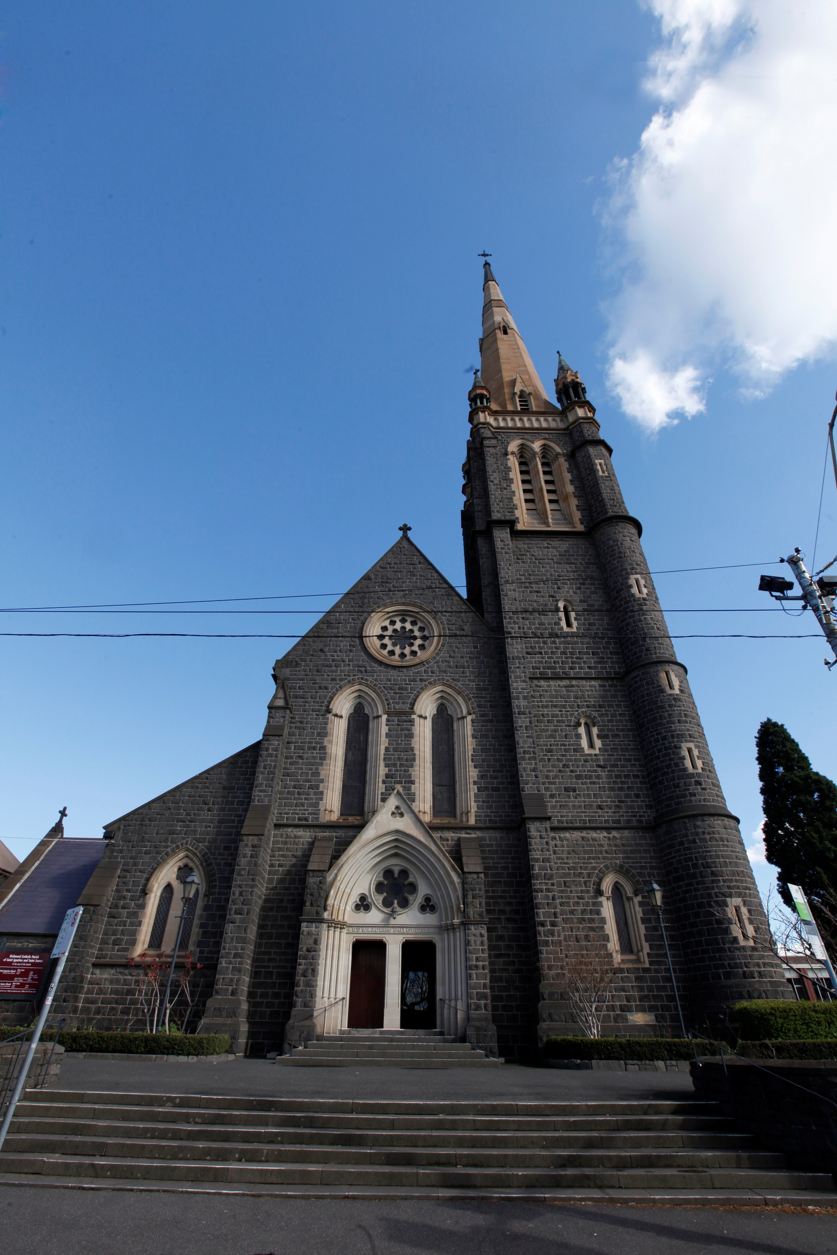
Architecture of
St Ignatius’ Church

Richmond Catholic Parish
Parish Office, 326 Church Street, Richmond VIC 3121, Australia
www.ignatius.org.au

Contents
Introduction 1
Laying the Foundation 1
Building Style 1
Materials & Dimensions 2
The Altars 2
The Statuary 2
The Paintings 2
The Organ 3
The East End 3
The East Wall 3
The North Wall 4
The Lady Chapel 5
The Chapel of St Joseph 5
The Chapel of the Sacred Heart 6
The Chapel of St Ignatius 6
Sanctuary Clerestory 7

Introduction
St Ignatius' Church in Richmond, Victoria, Australia is a fine example of nineteenth-century gothic revival.

The building occupies a commanding site on Richmond Hill, a circumstance which allows the building to be admired from many vantage points. It combines an impressive solidity with a lightness deriving from its soaring vertical lines; on the exterior the building is seen to best advantage in a strong light, when deep and sharp-cut shadow emphasises the complexities of the intersecting lines of roof, arch and buttress.

A like light shows to advantage the usual exterior sculptured features such as the capitals of the columns framing the portals.

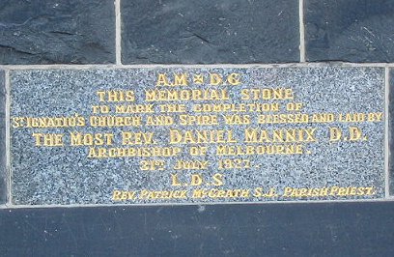
Laying the Foundation
The foundation stone of the church was blesse d and laid on 4 August 1867 by Dr John Bede Polding OSB, first bishop of the Catholic Church in Australia. The ceremonial opening of the nave, aisles and tower took place in March 1870. Building of the transept began in 1885 and was completed in 1888. Except for the spire, the church was finished in 1894 with the completion of the chancel. A memorial tablet recording the commencement of the spire was placed in 1927, and the completed spire was blessed by the Papal Legate in October 1928.

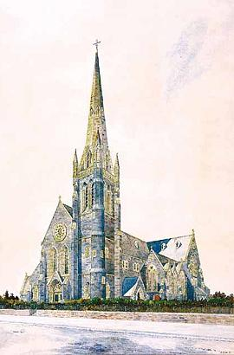
Building Style
Artist: H E Wardell
The plans for the church were drawn by the celebrated architect
W W Wardell (1823 - 1899). Amongst other magnificent buildings, Wardell designed St Patrick's Cathedral in Melbourne, and St Mary's Cathedral in Sydney.

A fine watercolour painting of the completed St Ignatius' Church, as W W Wardell intended it to be, was executed by his son H E Wardell. A notable departure from Wardell's plan was made in the building of the spire. The architect intended a tower of eighty feet with a spire of about the same height; in fact tower and spire together reach a height of about two hundred and fifteen feet.

The church is built in the style of the French Gothic of the 13th century. It comprises a nave and aisles, transept, an apsidal sanctuary with an ambulatory surrounding it, out of which open four chapels. There is a clerestory to the nave, transept and sanctuary. The tower is situated at the end of one of the aisles, and its lower storey once formed the baptistery.

Materials & Dimensions
The church is built of basalt, or bluestone, with white Sydney stone dressings. The pillars supporting the clerestory of the sanctuary are of polished red granite, while those of the others are of Malmsbury bluestone. The spire is built of stone from quarries in Footscray and on the Hawkesbury River.

Including the walls, the dimensions of the church are: length, 206 feet; width of nave and aisles, 64 feet; length of transept, 104 feet; height from floor to ridge of roof, 65 feet.

The contractors employed in the several contracts were Bonham and lastly Corlett and Smith. The contractors for the spire were Vaughan and Lodge, the architect being Vanheems.

The Altars
The decoration of the sanctuary was carried out in 1914 through the generosity of an anonymous benefactor. The beautiful marble high altar, designed and built by Hallet of Richmond, was completed in 1924, while the lovely altar in the Lady Chapel, also by Hallet was erected in 1925. The altars in each of the Apse Chapels are also well-crafted.
Following Vatican II, a number of changes were made to the church. Although the beautiful marble high altar remains, a smaller and less ornate wooden altar was donated in 1996 by one of our oldest parishioners, Mrs Violet McNamara.

The Statuary
The Lady Chapel altar is surmounted by the Carrara marble statue of the Immaculate Conception.

The statuary in the church is of interest rather than distinction. Typical of 19th century taste in religious art, the groups representing the Guardian Angel and the Virgin lamenting the dead Christ were purchased at the Melbourne Exhibition of 1881.

The Paintings
The principal paintings in the church are those comprising the Way of the Cross. These fourteen oils were brought from Vienna in 1872 and were unveiled by Dr Goold OSA, first Catholic Archbishop of Melbourne. On a pillar in the north transept, there is a Sacred Heart painting executed by Mother M Imelda FCJ, in 1902.

In the main vestry is a large canvas representing St Thomas of Villanova distributing alms, while in the second vestry may be seen a painting of the Blessed Peter Faber, commissioned from Vincenzo Pacelli in 1874 on the occasion of the subject's beatification. At the north entrance to the ambulatory may be seen a fine 19th century coloured lithograph of Ignatius Loyola, for whom the church is named.

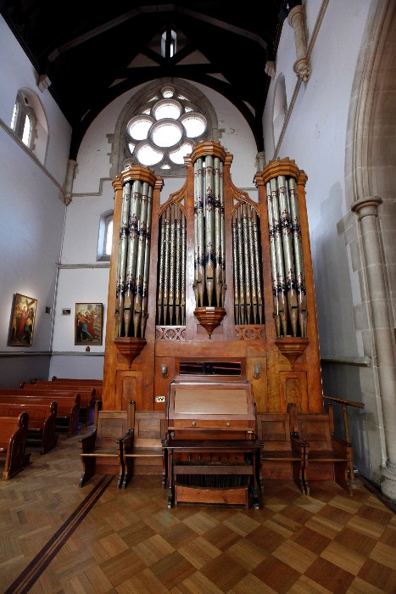
The Organ
The organ was built in 1874 by George Fincham and was originally installed in the Melbourne Exhibition Buildings for the Colonial Exhibition of 1875, for which Fincham was awarded a Gold Medal.

After the Exhibition, the organ was removed and installed in the gallery of the church, and an inaugural recital was given on it by Herr Gerlach on 20 August 1876. The organ was moved from the gallery to the rear of Our Lady's Chapel in 1897. Following Herr Gerlach, Signor Zelman was appointed organist in 1890 and Miss Boxham in 1898. In 1989 the organ was moved to its present position.

The East End
Architecturally, the interior of the church is notably handsome, and should be admired from a number of perspectives. The fineness of the workmanship is everywhere evident. Although the windows are incomplete, there is in the church some fine glass of local manufacture by Montgomery of Melbourne.
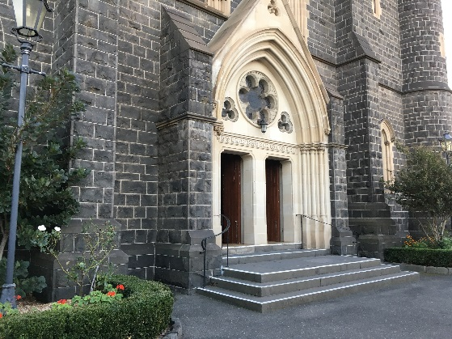
Immediately above the main door are three small windows. Here the central motif is a monogram of the Holy Name of Jesus. With the surmounting cross and the three nails of the crucifixion, the monogram formed, in part, the original seal of the Society of Jesus. Definition is given to this area by the surrounding crown of thorns, while the background consists, in a fine tracery of vines and grapes, a Eucharistic motif. Supporting this central design are six semi-circular bays in each of which is represented a passionflower. To the left and right of the central window, two small trifoliate windows, the glass showing simple roses, give balance to the whole.

The East Wall
High in the east wall is the most richly-coloured window in the church. It represents Christ in majesty, bearing the symbols of kingship. Christ is surrounded, in twelve small bays, by the twelve Apostles, each identified by a traditional symbol.

Beneath are two lancet windows (erected in 1898 and 1899), one of St Ignatius Loyola, founder of the Society of Jesus, the other of St Francis Xavier, his friend and early associate. The St Ignatius window (on the viewer's left) represents the saint dressed in priestly vestments with his hand on the book of the Constitutions of the Order he founded, the page being inscribed 'Ad Majorem Dei Gloriam' meaning 'For the Greater Glory of God'. Beneath the standing figure of the saint is a representation of his being struck down at the battle of Pamplona in 1521, an event which led to his conversion.

The companion window represents St Francis Xavier in his role of missionary to the East, the small window below showing his death alone on the desolate island of Sancian off the China coast in 1552.

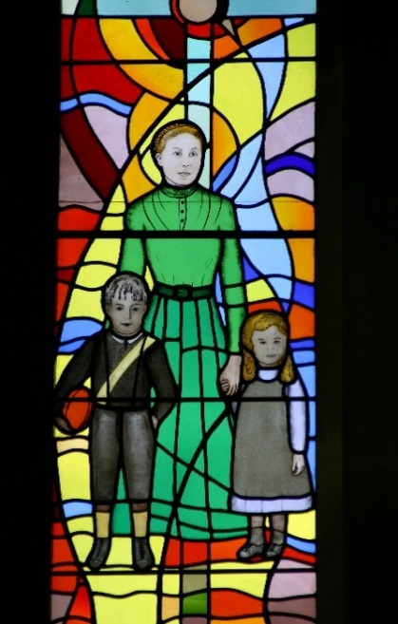
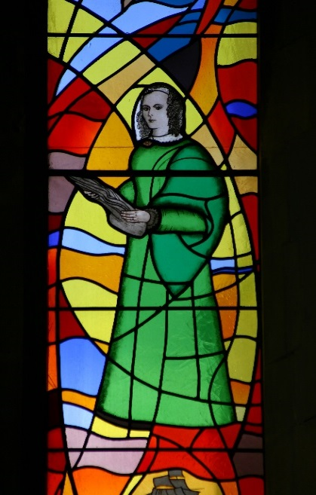
The North Wall
In the eastern section of the north wall two lancet windows featuring Mary MacKillop and Caroline Chisholm were installed in 1994. The stained glass window on the viewer's left depicts the life of Mary MacKillop, co-founder of the Sisters of St Joseph, and symbolises her continuing presence in Richmond. The window on the viewer's right shows the life of Caroline Chisholm, tireless worker for the welfare of immigrants to Australia, especially females, in the 1800s.

At the rear of Our Lady's Chapel is a window erected in 1898. It consists of two lancets with a small tracery above. The tracery represents a monogram of the Blessed Virgin Mary, surrounded by traditional lilies.

The window on the viewer's left represents St Joseph, the Virgin's husband. He carries the lily, traditional symbol of chastity. On the viewer's right is the Virgin Mary, represented as the Immaculate Conception. The Virgin stands on the crescent moon, an item of Immaculate Conception representation popularised by Murillo.

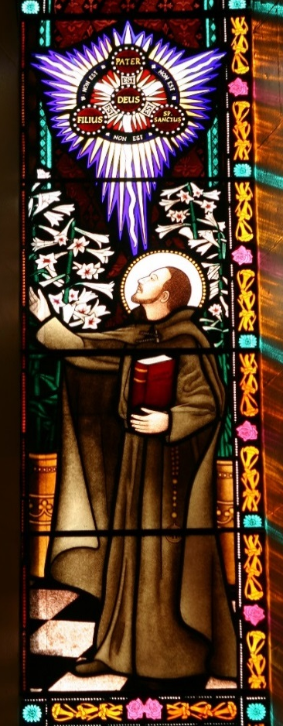
In 2001, two stained glass windows were installed close to Our Lady's altar, in memory of a well-known Melbourne florist, Mr Kevin O'Neill. Set in the small Church of Santa Maria degli Astalli in Rome, the windows describe a period in the life of St Ignatius when he was struggling for clarity in the framing of the Constitutions of the Society of Jesus.

At this time he spent many hours in childlike prayer to Mary, his advocate, whose ancient and venerated painting, 'Madonna della Strada', was displayed in the church and was so dear to his heart. A reproduction of that painting is the focus of the scene in the left lancet and is the image to which Ignatius is directing himself.

The chapel has been adorned with lilies but in this case they are Lilium gigantum, a plant nurtured and grown successfully by Kevin O'Neill at Mt Macedon and occasionally seen on display in the church.

At the time of the setting, Ignatius was also revealed visions of the Blessed Trinity and above his head, in the right lancet, is shown an ancient doctrine explaining God in relation to the Trinity. This symbol is depicted as a flash of illumination utilising all the shimmering, ethereal qualities that only stained glass can provide and the Latin text is easily readable for the observer.

The borders and canopies of the lancets are embellished with trails and arrangements of strongly-coloured flowers in purples, pinks, oranges and reds, the bold colours with which Kevin O'Neill's name became associated to great acclaim. Dedication panels have been provided at the bottom of each lancet.
The windows are constructed from mouthblown antique glass, painted, stained and kiln fired in the traditional manner to the highest standards of craftsmanship. The colours of the windows splash into the Lady Chapel and move across the floor each day with the passage of the sun.

The Lady Chapel
Above the Lady altar, the glass (placed in 1914) is dedicated to the Virgin Mary under the title of Our Lady of Lourdes. In the small tracery window is seen the above-ground basilica built over the site of the apparitions at Lourdes, France.

The two lancet windows together represent the apparition of the Virgin to the young peasant girl, St Bernadette Soubirous. The lower portion of each window represents clients of the Virgin at the scene of the apparitions. The background of the panel on the viewer's left shows crutches left hanging in the grotto in token of cure, while the right-hand lower panel shows attendants encouraging the sick to faith.
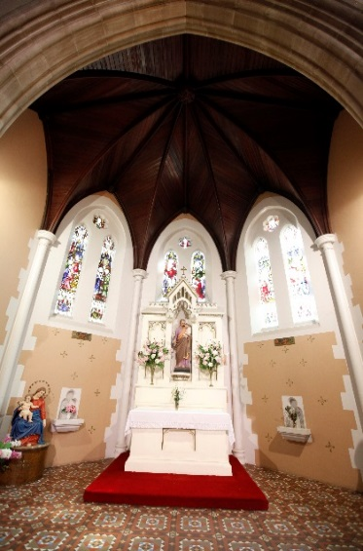
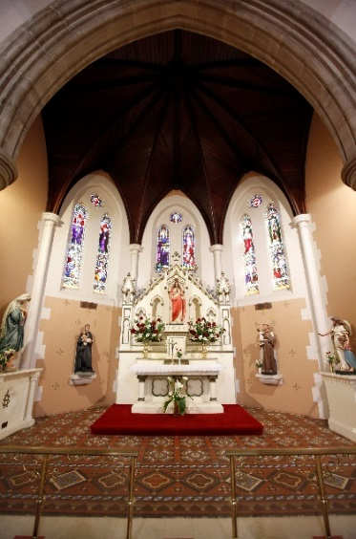
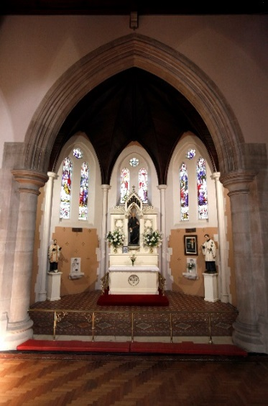

The Chapel of St Joseph
Most of the glass is concentrated in the apse chapels, which occupy the west end of the building. Proceeding around the ambulatory from the Lady Chapel, one comes first to that of St Joseph. Here the glass was placed in 1910. As in each of the apse chapels, the glass here consists of three paired lancet windows with a tracery medallion above.

From the viewer's left, the medallions represent Faith, Charity and Hope; the lower portions of the longer windows are filled with figures representing Foresight, Righteousness, Fortitude and Moderation.

In the central pair of windows, St Joseph figures are separated from the group of clients by the motto, God sent me before you that you might increase upon the Earth. The reference is to the Joseph of the Old Testament.

The remaining windows represent scenes in the life of Joseph: the legend of the blossoming rod by which he was designated husband of the Virgin, the espousals of Mary and Joseph, the flight into Egypt, and the death of Joseph. In the window representing the flight is seen the falling of the idols, one of the many charming legends regarding the journey; and in that of the death of Joseph are seen the tools of the carpenter's trade he followed.

The Chapel of the Sacred Heart
The next chapel is that dedicated to the Sacred Heart of Jesus. The windows here were placed in 1906.

The medallions in the tracery above the windows proper are from the viewer's left to right: the Sacred Heart, the Man of Sorrows and the heart of Mary pierced with the sword of sorrow of Simeon's prophecy.

The lower portions of the four longer windows show scenes from the life of Christ, each with an appropriate text. They are: the birth of Christ, his breaking bread with the disciples at Emmaus, the crucifixion, and the faith of Thomas.

The principal parts of these windows show, from left to right of the viewer: the mediaeval St Gertrude, the Blessed Claude de la Colombier, the Good Shepherd and St John the Evangelist, bearing the legendary poisoned cup.

The central pair of windows together represent the apparition of the Sacred Heart to St Margaret Mary in the chapel of the convent at Paray le Moniel, France, in 1675.

The Chapel of St Ignatius
The last of the apse chapels is dedicated to St Ignatius Loyola, founder of the Society of Jesus to which this parish was entrusted in 1866. The glass here was placed in 1912.

The medallion above the central pair of windows reproduces the familiar monograms IHS ('Jesus') and AMDG ('For the Greater Glory of God'). The medallion on the viewer's left shows St Francis Xavier, already met with on the eastern wall; that on the right St Francis Borgia, Duke of Gandia and, after the death of his wife, third General of the Society of Jesus. As Viceroy of Catalonia he holds in one hand a coronet; in the other he holds a skull, symbol of mortality.

The four longer windows terminate in figures representative of Poverty, Chastity, Obedience and Humility.

In the central pair of windows, St Ignatius presents a group of the many Saints of his Society to Christ the Lord.

The windows on the left and right show significant events in the life of the Saint. On the viewer's extreme left is St Peter appearing to Ignatius during his convalescence after his wounding at Pamplona, represented on the east wall. With this is paired his arrest by the Inquisition, an event represented as witnessed by the young Francis Borgia.

In the first of those windows on the viewer's right we see Ignatius and his first companions binding themselves to the service of God while Peter Faber celebrated the Mass; in the other, Ignatius receives from Pope Paul III the confirmation of the Society of Jesus in 1540.

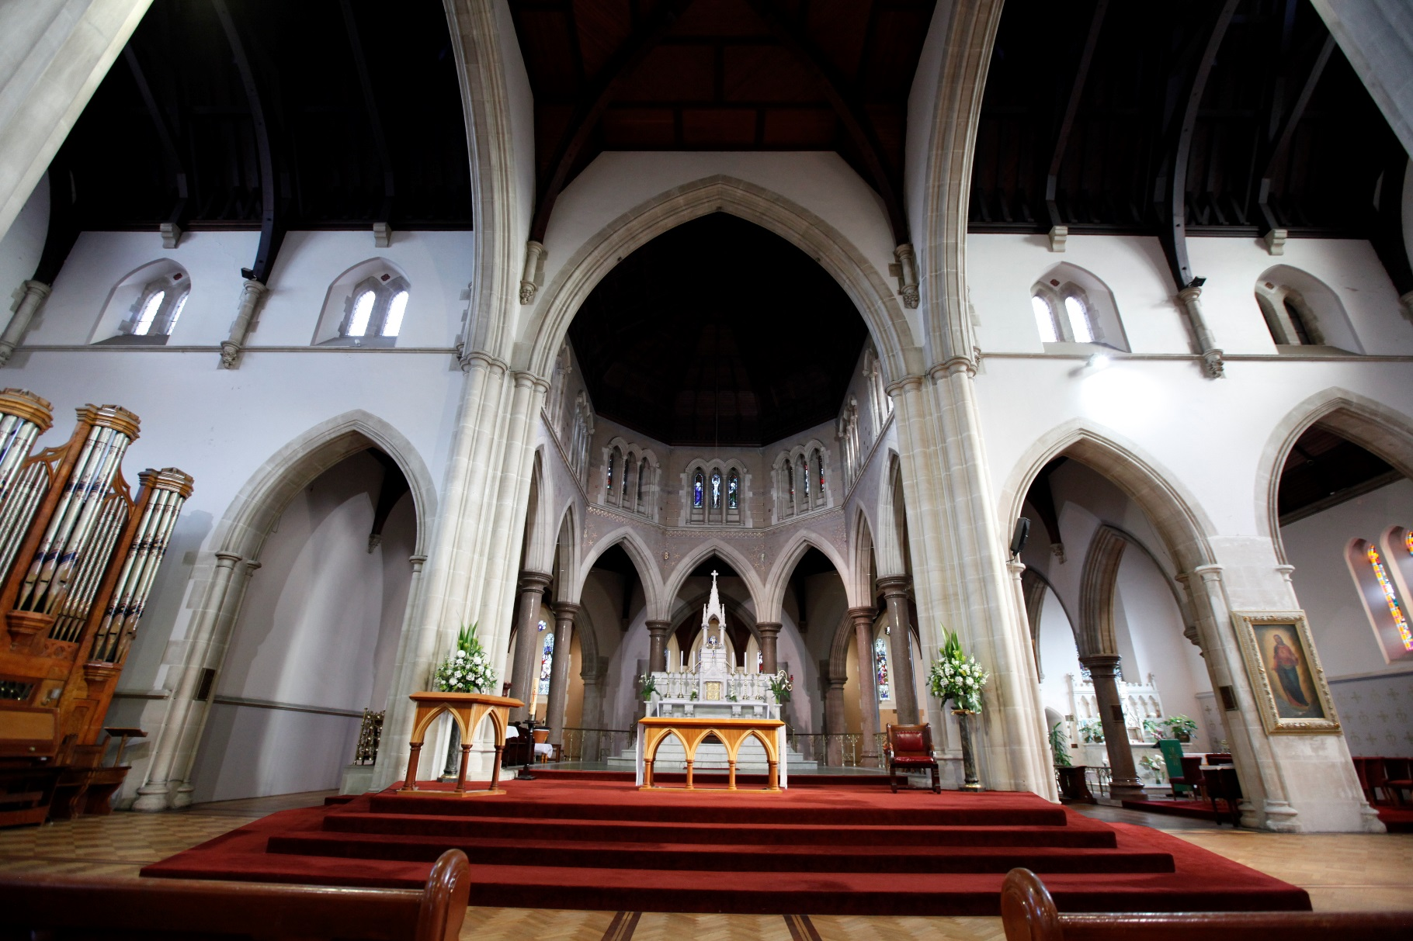
Sanctuary Clerestory
Standing in the front of the high altar, the viewer can see the beautiful glass in the sanctuary clerestory. Only three windows have been completed, and each consists of three lancets. The central window is a calvary; the central panel shows Christ crucified flanked, in the panels on either side, by the Virgin Mary and St John. The window on the viewer's left is of the birth of Christ, with a shepherd and St Joseph in attendance. On the viewer's right, the window shows the resurrection of Christ, the panels flanking the risen Lord showing the guards at the tomb reeling in astonishment.

Source: St Ignatius' Richmond Victoria by Fr Brian Moore SJ.

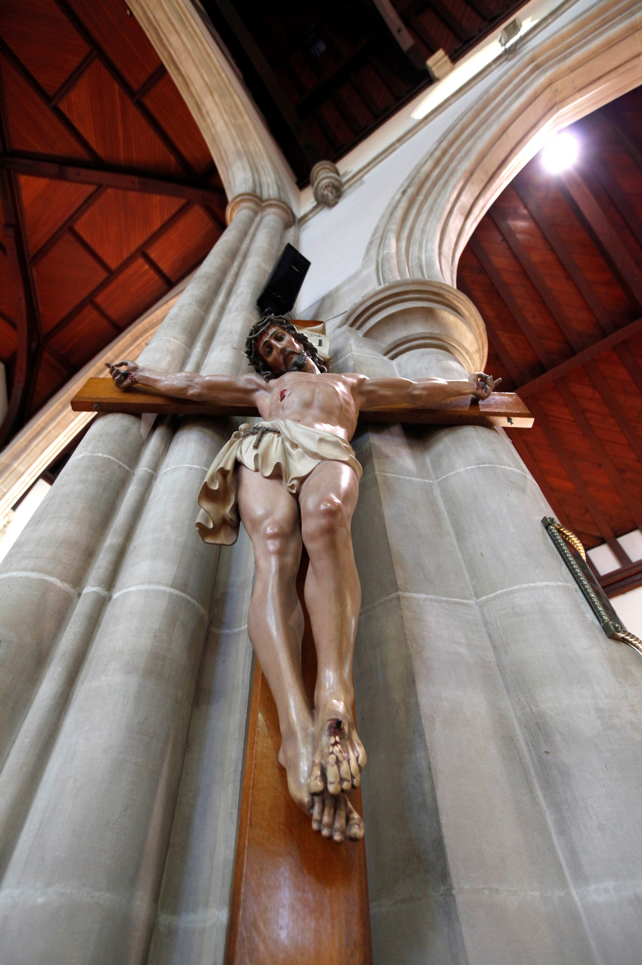
© 2020 Richmond Catholic Parish
Parish Office, 326 Church Street, Richmond VIC 3121
www.ignatius.org.au
Richmond
Catholic Parish
OF ST IGNATIUS & ST JAMES

