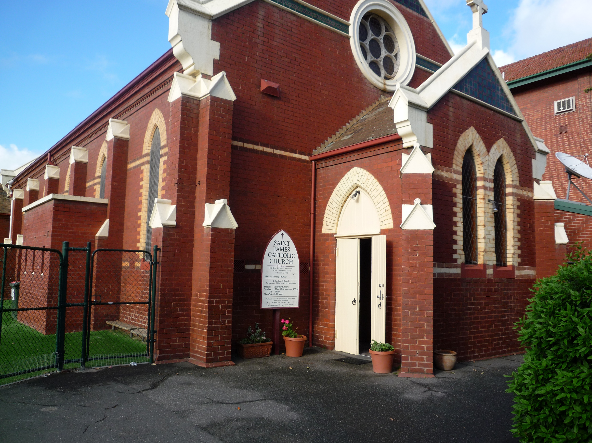
St James’
Church:
Richmond’s
Early Catholic
Church

Richmond Catholic Parish
Parish Office, 326 Church Street, Richmond VIC 3121, Australia
www.ignatius.org.au

Contents
The First St James’ Church 1
Introduction 1
Laying of the Foundation Stone 1
Opening of the Chapel-school 1
Early Richmond Catholic History 2
The Priests Serving at St James’ 2
Demolition to Make Way for a New St james’ church 3
The Second St James’ Church 3
Introduction 3
Sisters of St joseph Arrive to Teach at St James’ School 3
St James’ Becomes a Separate Parish 4
Works on the Church, Presbytery, and Josephite Convent 4
St James’ Becomes Part of the Richmond Catholic Parish 4

The First St James’ Church

Introduction
The old St James' Church on the corner of Bridge Road and Coppin Street, Richmond was demolished when St Ignatius' Church was built, but the foundation stone was preserved to become part of the second, present church...
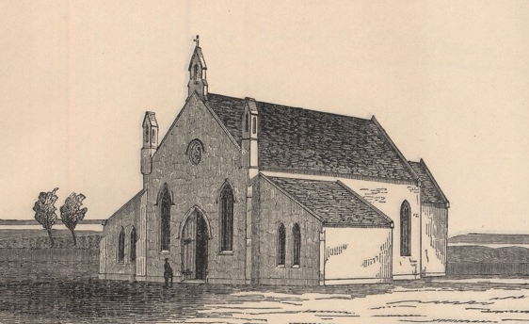
St James' Chapel School, Richmond

In 1850 a 2-acre Government grant was obtained for a Roman Catholic Church in Bridge Road, Richmond and in August 1853 Fr Madden called tenders for a brick church-school to be erected there. This block on Bridge Road was bound by Griffiths, Palmer and Coppin Streets. The trustees appointed later were Bishop Goold, Rev J J Madden, Joseph L'Estrange and William Henry Archer.

Laying of the Foundation Stone
The Herald newspaper of 26 September 1853 recorded the laying of the foundation stone:

The foundation stone of the new Roman Catholic chapel was laid at Richmond yesterday (Sunday) by the Right Rev Bishop Goold in the presence of a large concourse of people. The sight is a very picturesque one and the edifice will be dedicated to Saint James. A considerable sum was laid on the stone to forward the good work.

The church was probably named St James', because this saint was the patron saint of the first Catholic Bishop of Melbourne, James Goold and also of the first Parish Priest of Richmond, Rev James Madden.

Opening of the Chapel-school
The Catholic Directory of 1855 stated that:

The small but handsome chapel-school at Richmond was solemnly opened and dedicated to God in honour of St James on the Feast of St Agatha, 5 February, 1854.

The Herald of that same week described how the blessing was followed by the Pontifical High Mass, Rev Dr L B Shiel preached an impressive sermon and Rev W Cunningham directed the choir. Richard Fitzgerald was named the builder of this Ancient Gothic building. The total cost of the church-school and furniture was given as £2,667.3.9, of which £900 was subscribed by the people.
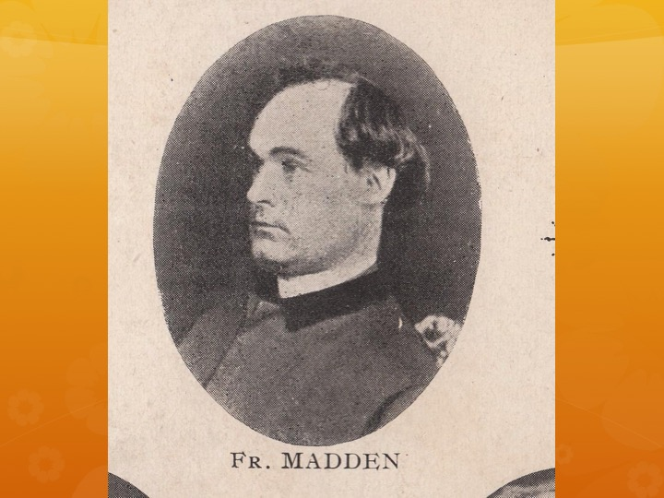
Fr James Madden

Early Richmond Catholic History
In March 1853 Bishop Goold had appointed Fr James Joseph Madden to care for the growing congregation of Richmond Hill. As there was no church in the area, Mass was celebrated for a time in the home of Mr Joseph L'Estrange at 'Erindale', a fine bluestone building near the corner of Highett Street and Bromham Place. Fr Madden's first presbytery was a house in Charlotte Street.

James Plunkett was a parishioner and conductor of the choir at St James' in the 1850s. His sister, Mary Jane, married Michael Keogh, a brother to Mrs Joseph L'Estrange. In Plunkett's diaries of the 1850s, there are several references to St James' Church and Fr Madden. (Note that 'M J' is Mary Jane Keogh, and 'M' is Michael Keogh.)

Thursday 27 December 1855 | Went with Michael to L'Estranges, Mr and Mrs Archer, Dr and Mrs Stewart, Fr Madden, Geary, M J, Dear Mother, Daley and Charley. Good fun.
Tuesday 8 January 1856 | Went to Archers with M J, Mother, Mr and Mrs Forbes, Mr and Mrs L'Estrange, Fr Madden and Daley. Charley there after we left.
Tuesday 10 March 1856 | Went with M and M J to Mrs L'Estrange's Miss Chapman, new governess there. Fr Madden also. L'Estrange gone to Van Dieman's Land.
Sunday 28 February 1858 | Conversation about a choir for Richmond.
Monday 2 August 1858 | Preliminary meeting at Fr Madden's concerning organ for Richmond.
Monday 12 September 1859 | Henry Joseph Keogh baptised by Fr Madden.

In 1859, Richard Fitzgerald constructed a two-storeyed brick presbytery on the corner of Bridge Road and Coppin Street, alongside the church. In the glass pane above the door were the words St James' House. The building cost £2300.

The Priests Serving at St James’
Fr P Smyth succeeded Fr Madden as Parish Priest in June 1864. He was assisted for a short time by Fr I J O'Callaghan. In 1865 Fr E McCarthy became the Richmond pastor for a few months. Other priests remembered at the old St James' were Frs F O'Donnell, J O'Donnell and Francis McCarthy. In April 1866 the Jesuit Fathers took over the Richmond Mission. Frs Dalton and M'Kiniry lived in St James' House.

With the increase in population over the years it became evident that a larger church was necessary on a more suitable site. Although attempts were made to set the project in motion, no movement was successful until the Jesuit Fathers arrived. Land was purchased in Church Street on the very top of the hill. The foundation stone for the new church of St Ignatius' was laid on 4 August 1867.

Demolition to Make Way for a New St james’ church
In 1876 the old St James' church-school was demolished, however the presbytery remained and was demolished as late as August 1958.

The foundation stone was preserved to be included in the new church of St James' in Kent Street which opened on 16 December 1900.

The Second St James’ Church

Introduction
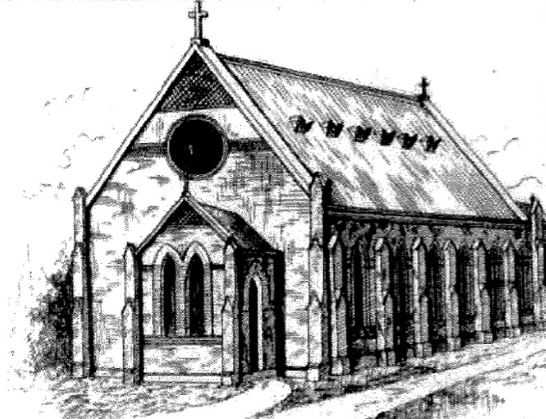
St James' Church, Richmond
The foundation stone of the first St James' Church was used as the foundation stone of the new St James' at the corner of Kent and Davison Streets, Richmond, laid by Archbishop Carr on August 26th 1900. His Grace blessed and opened this church on December 16th 1900.
There was to be one Mass each Sunday, the priest coming from St Ignatius'.

Sisters of St joseph Arrive to Teach at St James’ School
In 1920 the Jesuit Provincial asked Sr Patricia Campbell for the Sisters of St Joseph to teach at the North Richmond school of St James', in Davison Street. As a result of this request, five sisters came to teach at St James' school and its offshoot - St Louis', in Burnley.

The first convent was a substantial house with a tower at 94 Burnley Street. Edward Rowland Priestly had built this house in 1871. Priestly was a hide and leather merchant and a member of the Richmond Council in 1877 and 1878. The house had twelve rooms, including a forge, billiard room, a bathroom and a cellar.

One of the nuns who lived there in the 1930s, Sr Jeanne has described how the sisters used the house:

The tower was three storeys high, and had a reputation for being haunted. Two nuns slept in each storey. The houses over the river in Kew could be seen above the shops on the opposite side of Burnley Street. Inside the Convent was a Chapel, a Community Room, a Music Room and a Classroom. The Classroom held about 30 to 35 grade 3 children. There was a sleep-out near the front of the building which was wooden boards up to about a height of three feet, and then above the boards was wire netting. There was a garden in front with steps leading down to the iron gate opening to Burnley Street.
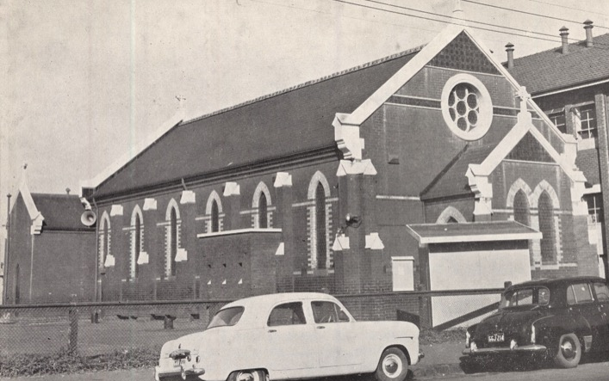

St James’ Becomes a Separate Parish
St James' was made into a separate parish with Fr Cuffe SJ as Parish Priest. The new parish recorded the first baptisms of local babies Margaret Mary Trainor and Alexander James Tropp and the first marriage - Mary Towers to John Heffler.

In March 1924 St James' School and Hall were blessed and opened. The first parish ball was held in this year. In 1931 the Jesuits handed over the parish to t he diocesan clergy in the persons of Frs John Donovan and John Carr.

St James' Mothers Club started in 1947 with Mrs Watson as first President.

Works on the Church, Presbytery, and Josephite Convent
Between 1948 and 1954 a new floor and seats were put into the church. The confessionals were added and a window with the symbols of St James' was placed over the porch - the initials S J for Saint James, the sword for his martyrdom, the crozier for his episcopacy, and the Bible for his preaching.

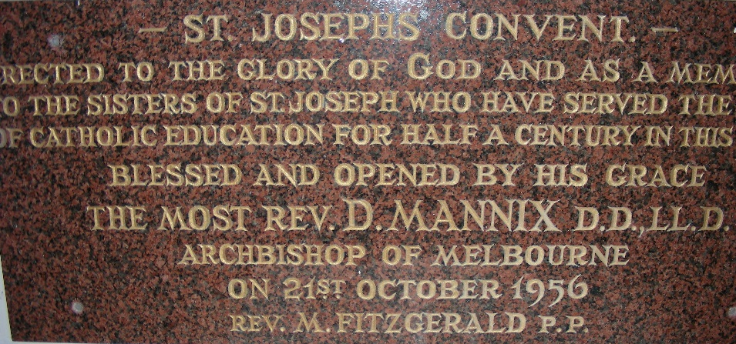
In 1956 the new convent for the Sisters of St Joseph was opened and bless ed by Archbishop Mannix. This convent had been built in Davison Street, next to St James' School. It was a two-storeyed cream brick building.

Between 1970 and 1972 the church and parish buildings were renovated and the old presbytery demolished and a new presbytery blessed.

Since then the Sanctuary has been completely renovated, and a beautiful carved wooden crucifix donated by the builder, Mr Fred Dixon, was placed over the altar.

St James’ Becomes Part of the Richmond Catholic Parish
In 1997 the Convent was declared unsafe for habitation and demolished, and in August 1998 St James' once again became the responsibility of the Jesuit Community in Richmond.

On 30 July 2005 St Ignatius’ Church amalgamated with St James' Church to form the Richmond Catholic Parish.

Source:
- The History of the First St James' Church Richmond, Sr Philomena McGuigan.
- The History of the Second St James' Church Richmond, Sr Philomena McGuigan.

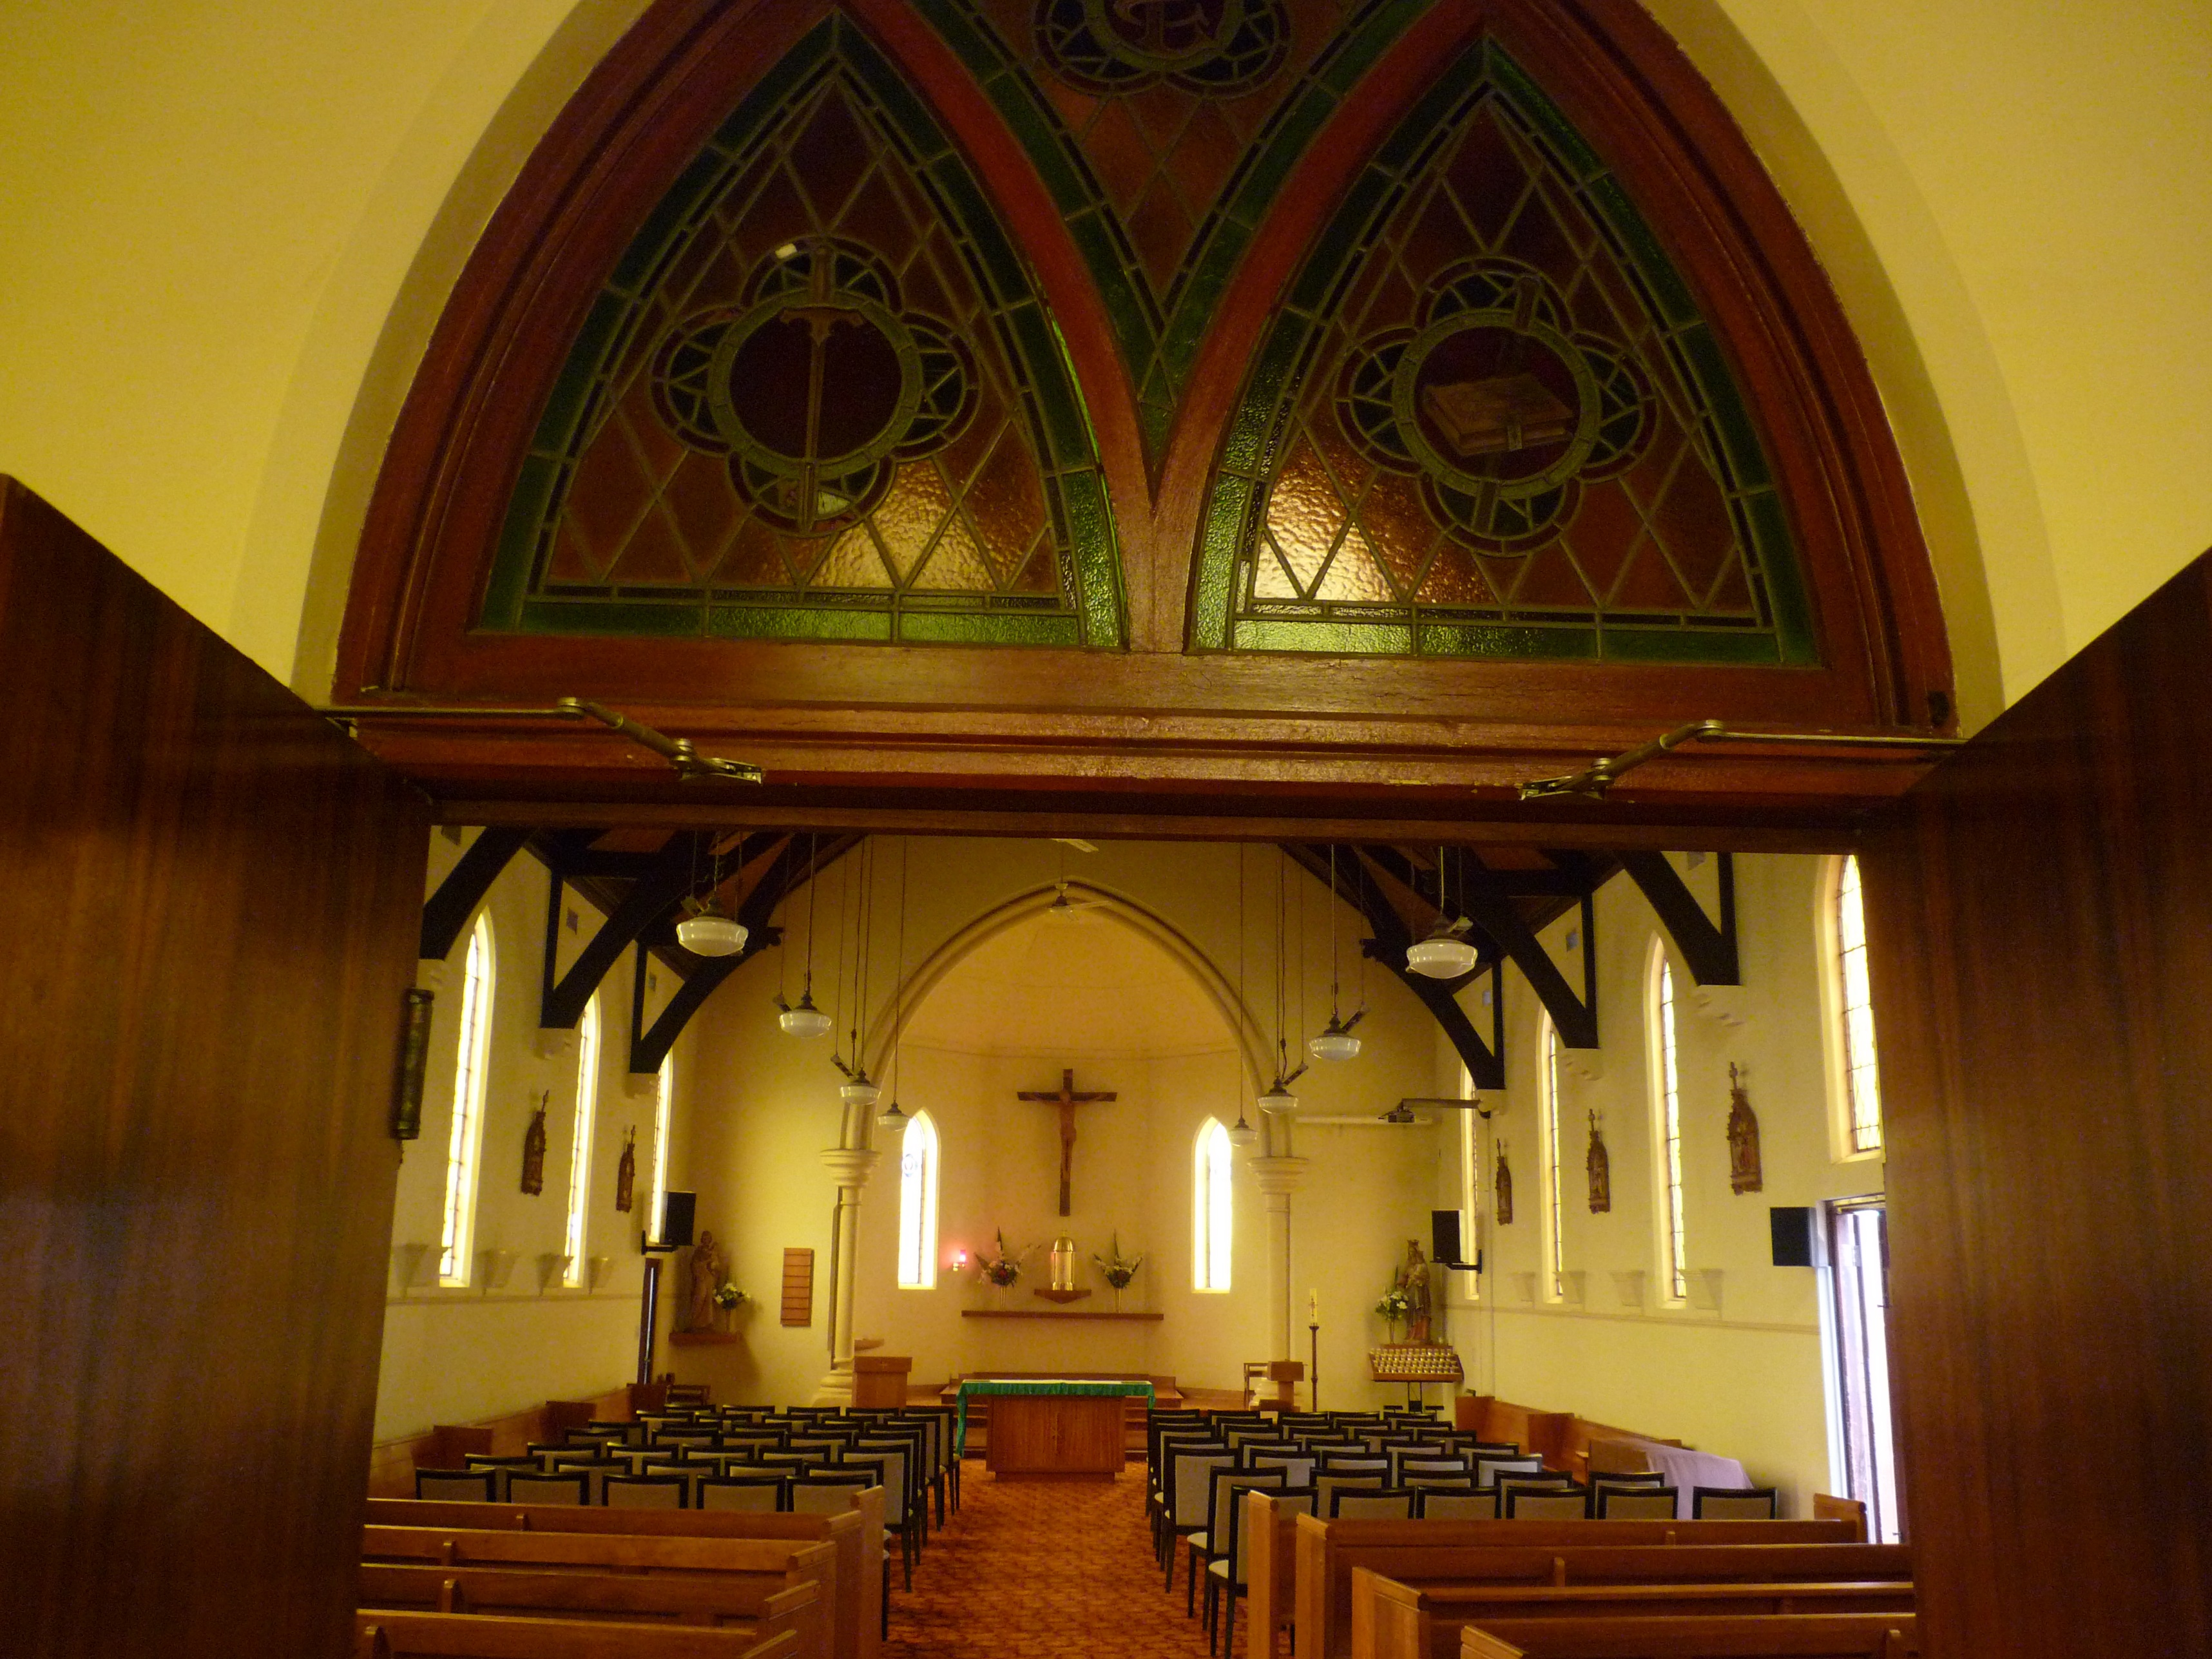
© 2020 Richmond Catholic Parish
Parish Office, 326 Church Street, Richmond VIC 3121
www.ignatius.org.au
Richmond
Catholic Parish
OF ST IGNATIUS & ST JAMES

