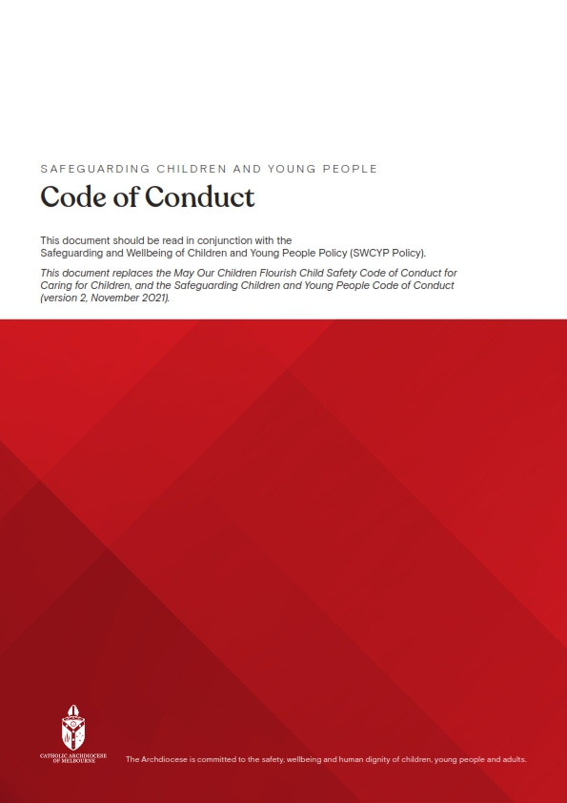
For Complete Details please follow the link Below
Code_of_conduct

