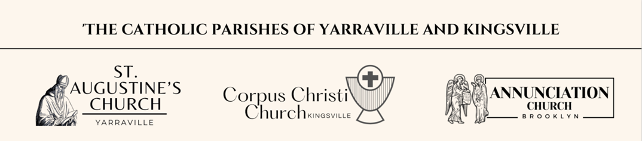

Baptism Enrolment Form
CANDIDATES DETAILS
Full Name
Date of Birth |  |  |  |  |  |  | Age
Gender | - Female |  |  | - Male |  |  | Place of Birth
Current Address
CANDIDATES PARENTS
Fathers Details
Full Name
Religion |  |  |  |  |  |  | Mobile
Email
Mothers Details
Full Name |  |  |  |  |  |  | Maiden Name
Religion |  |  |  |  |  |  | Mobile
Email
CANDIDATE’S GODPARENTS
Full Name |  |  |  |  |  |  | Religion
Full Name |  |  |  |  |  |  | Religion
Baptism Preparation |  |  | / / 2026 |  | at St Augustine’s Church, 71 Somerville Rd, Yarraville
Baptism Date |  |  | / / 2026
 |  |  | Saturday 5.00pm at St Augustine’s Church, 71 Somerville Rd, Yarraville
 |  |  | Sunday 8.00am at Annunciation Church, 4 Nolan Avenue, Brooklyn
 |  |  | Sunday 9.30am at St Augustine’s Church, 71 Somerville Rd, Yarraville
 |  |  | Sunday 11.00am at Corpus Christi Church, 376 Geelong Rd, Kingsville
Celebrants Name |  |  |  |  |  |  | Contact Number
Needed on the date of Baptism:
*Baptism Candle *white garment or stole
Baptism Offering can be made via St Augustine’s Presbytery Acc. BSB 083 347 Account 638051413
Or in an envelope clearly marked with Surname, with cash in the collection basket at Mass. It is suggested $100 minimum.

