
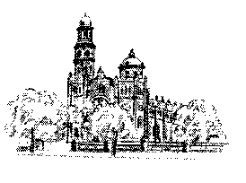
We the Parish of St Joseph's are working towards being a welcoming, supportive community, which encourages active participation in our life. Recognising and respecting the Uniqueness Of each individual, as we journey in living out Jesus’ gospel message.

JOSEPH'S
T

Parish of Benalla

A Global Gifts Poster and Order form have been posted and the Order Form is also attached here. A suggested Bulletin Notice is below.
Gifts can also be ordered online at www.caritas.org.au/globalgifts or by phoning 1800 024 413.
Make sure you order before 12th Dec to ensure they reach you before Christmas.

CHRISTMAS COLLECTION as a GLOBAL GIFT
At Christmas time, so special for our own children here in Australia, it’s appropriate that we take the opportunity to share our Christmas with children in far less privileged circumstances. Your parish may choose to change lives through a Christmas collection for CARITAS GLOBAL GIFT - bringing the gifts of food, water, health, education, peace – to children in communities around the world.

ADVENT CALENDAR
In Advent, the Jesse tree reminds us of Biblical characters and events that prepared God’s people for the birth of Jesus. Caritas has designed an Advent Calendar based on the Jesse tree to learn, pray and act with and for our partners around the world today. The calendar is available online and in PowerPoint. It is also available as an iPhone app so you can reflect, pray and act on the go! Check it out at www.caritas.org.au/advent

World Youth Day 2013: There will be a Victorian pilgrimage to World Youth Day in Rio De Janeiro, Brazil, in July 2013. This is an exciting new initiative that we believe will enable the youth of Victoria (aged 16-35) to share their faith and to be rejuvenated to spread the Gospel of Jesus Christ: and to be fired by a deep desire to “go and make disciples of all nations.” (Matthew 28:19). For details about the pilgrimage options available, visit www.cam.org.au/youth/World-Youth-Day/Packages. For further information please contact Jackson or Melissa on 5441 2544 or Isaac Demase (FCJ college)5762 1222 the parish representative for Sandhurst Parish Youth Advocates.

We acknowledge the custodians of the land of the Yorta Yorta Nation which, includes the eight clan groups.

We also acknowledge the Taungurung clan of the Kulin Nation whose lands are within our parish.
We remember their ancestors with respect and commit ourselves to a better future through reconciliation and justice.
Twenty Ninth Sunday in Ordinary Time Sunday 19 October 2025
  Readings for this week: | Exodus 17:8-13  2 Timothy 3:14-4:2  Luke 18:1-8 | Readings for next Sunday: | Sirach 35:12-14, 16-18  2 Timothy 4:6-8, 16-18  Luke 18:9-14
FIRST READING

The Amalekites came and attacked Israel at Rephidim. Moses said to Joshua, ‘Pick out men for yourself, and tomorrow morning march out to engage Amalek. I, meanwhile will stand on the hilltop, the staff of God in my hand.’ Joshua did as Moses told him and marched out to engage Amalek, while Moses and Aaron and Hur went up to the top of the hill. As long as Moses kept his arms raised, Israel had the advantage; when he let his arms fall, the advantage went to Amalek. But Moses’ arms grew heavy, so they took a stone and put it under him and on this he sat, Aaron and Hur supporting his arms, one on one side, one on the other; and his arms remained firm until sunset. With the edge of the sword Joshua cut down Amalek and his people.
RESPONSORIAL PSALM

R. Our help is from the Lord, who made heaven and earth.
I lift up my eyes to the mountains: from where shall come my help? My help shall come from the Lord who made heaven and earth. R.
May he never allow you to stumble! Let him sleep not, your guard. No, he sleeps not nor slumbers, Israel’s guard. R.

The Lord is your guard and your shade; at your right side he stands. By day the sun shall not smite you nor the moon in the night. R.
The Lord will guard you from evil, he will guard your soul. The Lord will guard your going and coming both now and for ever. R.

SECOND READING
You must keep to what you have been taught and know to be true; remember who your teachers were, and how, ever since you were a child, you have known the holy scriptures – from these you can learn the wisdom that leads to salvation through faith in Christ Jesus. All scripture is inspired by God and can profitably be used for teaching, for refuting error, for guiding people’s lives and teaching them to be holy. This is how the man who is dedicated to God becomes fully equipped and ready for any good work.
Before God and before Christ Jesus who is to be judge of the living and the dead, I put this duty to you, in the name of his Appearing and of his kingdom: proclaim the message and, welcome or unwelcome, insist on it. Refute falsehood, correct error, call to obedience – but do all with patience and with the intention of teaching.
GOSPEL ACCLAMATION
Alleluia, alleluia. The word of God is living an active; it probes the thoughts and motives of our heart. Alleluia!
GOSPEL
Jesus told his disciples a parable about the need to pray continually and never lose heart. ‘There was a judge in a certain town’ he said who had neither fear of God nor respect for man. In the same town there was a widow who kept coming to him and saying, “I want justice from you against my enemy!” For a long time he refused, but at last he said to himself “Maybe I have neither fear of God nor respect for man, but since she keeps pestering me I must give this widow her just rights, or she will persist in coming and worry me to death.”‘ And the Lord said, ‘You notice what the unjust judge has to say? Now will not God see justice done to his chosen who cry to him day and night even when he delays to help them? I promise you, he will see justice done to them, and done speedily. But when the Son of Man comes, will he find any faith on earth?’
REFLECTION
This Sunday's readings remind us of the power of perseverance in prayer and faith. In the first reading, Moses stands on a hill during battle, raising his hands in prayer. As long as his hands are raised, Israel prevails. When he tires, others support him. This teaches us that prayer is not only personal but also communal-we need others to help us remain strong in faith. The second reading encourages us to stay rooted in Scripture. Paul reminds Timothy that God's Word strengthens us and equips us to do good, even when it's hard. In times of doubt or challenge, Scripture becomes our guide and anchor. In the Gospel, Jesus tells the parable of the persistent widow. She doesn't give up until she receives justice. Jesus uses this to teach us to never lose heart in prayer. God is not like the unjust judge-He hears and responds with love. But do we keep faith and trust in His timing? Together, these readings urge us to persevere in prayer, in the Word, and in faith. Even when we're tired or waiting, God is near and faithful.
God Bless always, Fr Vijay.
Thoona Mass – Third Sunday of each month, 12 noon
REGULAR MASS TIMES
Weekend – Saturday 6pm. Sunday 9.30 am
Weekdays – Tues to Fri 9.15 am (Due to cold mornings, Weekday Mass is now in the Parish House)
BENEDICTION - Everyone welcome, first Friday of each month at 6pm.

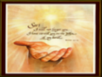


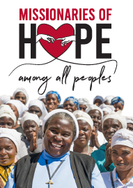
CHRISTMAS PARTY
PRAYERS FOR
RECENT DEATHS: Bernie O’Brien, Allison Smith nee Corboy, Silvano Bruzzese and Joe Ryan (brother of Margaret McCrohan)
ANNIVERSARIES: Kath Firth, Phillip McConville, Margaret Quinlan, Graeme Elliot, Kathleen Davon, Diane Purcell,
Dmytro Mazurak, Thomas O’Brien, Mary(Nell) Hernan, Roy Laity,Robyn Hinsley and Faith Hicks
WE PRAY FOR THOSE WHO ARE SICK: Skyler Levy, Susan Fitzgerald, Tracey Welsh, Elizabeth Waters, Anne Ryan,
Brigid Chalmers, Duncan Carradice and Margaret McCrohan
7th December
5.30 – 7.30pm
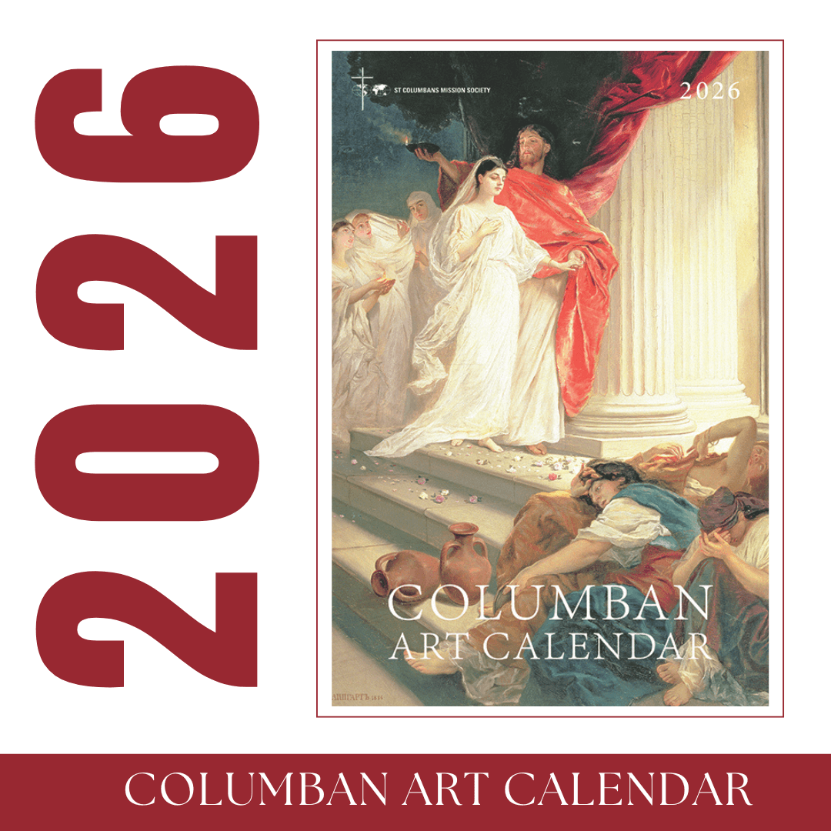
Columban Calendars are now available from either the Piety Store or Parish House at $15 each.
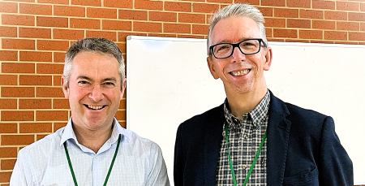

Reflection on the Diocesan Formation Gathering in Shepparton Last Weekend
At the Diocesan Formation Gathering, Dr Chris Cotter, Director of Mission and Pastoral Life, was struck by the profound simplicity of Fr Jake Mudge’s insight: building communities of belonging is ultimately all about love. Fr Jake’s words set the tone for the gathering, which explored practical ways parishes can welcome, invite and support people in their journey of faith and connection. Dr Chris Cotter said, In his address opening our gathering in Shepparton last Saturday, Fr Jake Mudge noted that having regular diocesan formation events and gatherings was a high priority for the Sandhurst Mission and Pastoral Council. Fr Jake also observed that the theme of the gathering, Building Communities of Belonging was all about love. I was struck by the profound simplicity of Fr Jake’s observation. Building Communities of Belonging speaks to both our human need to be loved and the heart of the Christian understanding of God.
Subscribe and receive parish bulletin & updates about upcoming events: Subscribe by using the QR Code.


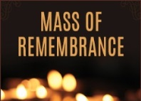
Photo above - Fr Jake Mudge (left) and Dr Chris Cotter (right)

The Commemoration Of All The Faithful Departed (All Souls)
The Bereavement Mass will be held early this year, due to Fr Vijay going away in November. All Parishioners are invited to this year’s Bereavement Mass that will be on
Saturday 25th October 10am at the Benalla Cemetery.

BAPTISM PREPARATION Parents wishing to have their child baptised are encourage to attend one of information sessions. We will be conducting a preparation session on 23rd October at 7pm, for approx. 45 minutes, at the St Joseph’s Parish House. Enquires please call 5762 2060 or email benalla@sandhurst.catholic.org.au
St Joseph’s Parish is a Child Safe Parish, and we are committed to the wellbeing and dignity of all children and vulnerable adults.
The Diocese of Sandhurst Safeguarding Committee is part of the structure under the National Catholic Safeguarding Standards, which is designed to be implemented by Catholic entities across Australia. Any questions, queries, comments or suggestions are welcomed by the Safeguarding team who can be contacted through the Parish House by phone or email. St Joseph’s Parish Child Safe Officers - Xavier O’Kane and Cath Duncombe 0423 203 154
WEEKEND VOLUNTEER ROSTER
Date |  | Laptop | Commentator | Reader | Eucharist | Offertory
18 Oct | 6.00pm | Ryan Miguel | Cath Duncombe | Sr Liz | Suleena Chacko | Charlee & Kevin
19 Oct | 9.30am | Max Rankin | Paddy O’Brien | James Flynn | Julia O’Brien | T & N Pelly
25 Oct | 6.00pm | Sr Liz | Anna Wise | Vince Brannigan | Kunchacko Chacko | K & S Chacko
26 Oct | 9.30am | Adrian Daw | Anne McLeod | Wendy Rettke | Joan Berry | W Rettke

